Answers to Study Guide Questions

# Chapter 1: Thinking Like a Researcher

## Answer Key

### Exercise 1.1

There are no right or wrong answers. Rather, the goal is for you to practice thinking critically and thinking like a researcher.

### Exercise 1.2

1. Nonmaleficence
2. Beneficence
3. Anonymity
4. Confidentiality
5. Informed consent; debriefing
6. Withdraw
7. Deception; debriefing
8. a. Deception

b. Debriefed

c. Nonmaleficence

d. Withdraw

### Exercise 1.3

1. The ethical principle of nonmaleficence was violated because the experiment harmed the participants (or you might have framed this as a violation of beneficence). Additionally, the study violated the principle of respect (which is named slightly differently across the different ethics codes, e.g., APA names this “respect for people’s rights and dignity,” whereas AAA names this “responsibility to people”).
2. Although the classmate may not have violated the ethical standard of confidentiality, she is violating the ethical principle of respect because she is not treating the interviewee and his or her data with care and respect because she is disparaging the interviewee’s answers. You might also have said that the potential for the interviewee to find out about the disrespectful comments is a violation of the principle of nonmaleficence.
3. a. How does this research advance disciplinary knowledge and how might it benefit individuals or society? A study must have some merit for it to be ethical.

b. Will the researcher interact with individuals on the social media site or will it be purely observational? If it is a completely unobtrusive observation of an open social media site, the researcher does not need to obtain informed consent or debrief participants. However, if the researcher plans to interact with those on the social media site, then informed consent and debriefing are likely required.

c. If the researcher interacts with individuals, will there be deception? For example, will the researcher pretend to be someone that he or she is not? If deception is used, the researcher must be sure to avoid causing emotional distress and debrief as soon as possible.

d. How does the researcher plan to handle data? The social media site is anonymous, but the members might still reveal personal or identifying information that the researcher must keep confidential.

1. a. How does this research advance disciplinary knowledge and how might it benefit individuals or society?

b. What safeguards are in place to minimize emotional distress? How will the researcher debrief participants to address the potential negative effects of recalling violent events?

c. How will the researcher obtain informed consent from participants?

d. How will the researcher maintain the confidentiality of the participants?

e. Will the researcher provide any incentives for participation, and if yes, how will the researcher ensure that the incentives are not coercive and that the participant receives the incentive even if he or she withdraws from the study?

1. a. Deception is the primary ethical issue in this study and the participants might experience emotional distress if they were to find out that the researcher was actually a woman who lied to obtain personal information from the clients. Moreover, the clients had not agreed to be part of a research study (there was no informed consent), and a therapy group would be considered a private space.

b. It is unlikely that an IRB would approve this study because the risks to participants are not justified by the benefits.

c. Although there is still some deception, the researcher in this case is in a public space and is not interacting with participants. If the researcher can demonstrate that the deception is justified and she maintains the confidentiality of those she observes, this study is ethically acceptable.

### Exercise 1.4

1. The steps in the scientific method are:

Step 1: Identify a topic

Step 2: Find, read, and evaluate past research

Step 3: Refine topic and develop a hypothesis

Step 4: Design the study

Step 5: Carry out the study

Step 6: Analyze the data

Step 7: Communicate results

2. False

3. Experimental

4. Descriptive

5. Correlational

6. Testable hypothesis

7. Independent; assigned; dependent

### Exercise 1.5

1. The following studies can be examined with an experiment:

b. Can political campaigns raise more money using negative campaign ads?

c. Are attractive people perceived as more or less intelligent than not-so-attractive people?

h. Can daily statements of gratitude improve one’s well-being?

Note that technically, ecould be made into an experiment, but it would not be ethical to expose someone to violence if it is expected to increase heart disease.

1. b. The IV is the type of campaign ad (negative ad vs. one or more comparison ads), the DV is the amount of money participants say they would donate or the actual amount of money raised.

c. The IV is attractiveness (attractive person vs. one or more comparisons), the DV is the rating of intelligence.

h. The IV is gratitude (daily gratitude vs. one or more comparisons), and the DV is well-being.

1. a. Do student athletes study more or less than nonathletes?

Correlational

d. How do individuals perceive their local police department?

Descriptive

e. Does exposure to violence increase risk of heart disease?

Correlational

f. Are people who take a lot of “selfies” narcissistic?

Correlational

g. Is humanity becoming more or less violent?

Descriptive

### Exercise 1.6

Student 1: This is *plagiarism*. Student 1 correctly cited the source and thus credited Cash and Whittingham (2010) for the ideas. However, because he or she copied the excerpt word for word and did not use quotation marks, the student is passing Cash and Whittingham’s words off as his or her own.

Student 2: This is *not plagiarism*. Student 2 correctly gave Cash and Whittingham (2010) credit for the ideas but the student used his own words to summarize those ideas.

Student 3: This is *plagiarism*. Student 3 used quotation marks for the phrases that belong to Cash and Whittingham (2010) but did not credit those authors for the words or the ideas by including a citation.

Student 4: This is *plagiarism*. Like Student 1, Student 4 cited the source but copied phrases directly from Cash and Whittingham (2010). In this case, Student 4 substituted a few words, but that is not enough to avoid plagiarism.

### Exercise 1.7

1. No. A single study can never prove a result. A single study can only examine one part of a population in a very specific way, so it remains unclear whether the results will hold true for other participants, methods, and settings.
2. No, even a body of research that consistently finds that mindfulness is effective cannot prove that that will be true 100% of the time.
3. If research consistently finds that mindfulness training is an effective stress-reduction strategy, we could say with some confidence that there is a good chance that mindfulness training will work.
4. Answers will vary, but you might suggest examining for whom mindfulness training is most effective, if mindfulness training is more or less effective for certain types of stressors, if the exact type or length of training matters, and so on.
5. Science helps us understand a phenomenon when multiple studies find similar results, and then the process of science can help us identify and answer increasingly complex and in-depth questions about that phenomenon.

Answers to Questions in the Text

# Chapter 3: The Cornerstones of Good Research: Reliability and Validity

## Practice Data Set

**From Desc Stats HW S’10**

1.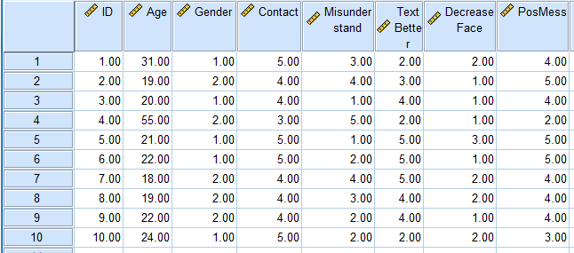

2. Recode #2 (misunderstand) and #4 (decrease face).

3. The TotalText score consists of adding scores on contact, TextBetter, PossMess, and the recoded scores of MisunderstandR and DecreaseFaceR.

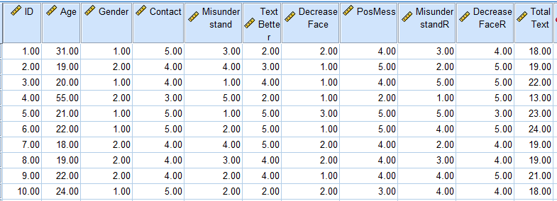

|  |  |
| --- | --- |
| **Reliability Statistics** | |
| Cronbach’s α | *N* of Items |
| .585 | 5 |

4.

|  |  |  |  |  |
| --- | --- | --- | --- | --- |
| **Item-Total Statistics** | | | | |
|  | Scale Mean if Item Deleted | Scale Variance if Item Deleted | Corrected Item-Total Correlation | Cronbach's αif Item Deleted |
| Consistent contact | 15.3000 | 7.789 | .419 | .517 |
| Text better | 16.0000 | 5.333 | .494 | .428 |
| Positive messages | 15.6000 | 5.822 | .684 | .341 |
| Easily MisunderstandR | 16.3000 | 4.900 | .529 | .399 |
| Decrease FaceR | 15.2000 | 10.844 | −.328 | .751 |

Cronbach’s α for the survey (α = .58) is below .70 which is the standard required for internal reliability of a scale. If the item “texting decreases face-to-face contact with my partner” is deleted, then the new 4-item scale would be reliable.