**ATC 1-1**

**a. The information described in the table is primarily managerial accounting information, as much of it refers to nonfinancial measures. The disclosures are not restricted by GAAP or other regulation. The information about revenues, total assets, and earnings are financial in nature, although they are also useful for managerial accounting purposes.**

**b. Other examples** **of managerial information include operating data such as sales generated per country, number of different products sold, and the revenue generated from each of these. Financial information would include financial statements, footnotes to financial statements, and the auditor’s opinion.**

**c. Starbucks’ 2017 fiscal year appears better than 2016 because in 2017 it had higher revenues and net earnings.**

**d. Starbucks had more employees and had more sales in 2017 than in 2016, which suggest it was larger, and therefore, appears better.**

**e. Starbucks had more revenue and earnings in 2017 than in 2016, but it also had more employees, 277,000 versus 254,000. It also had more property, 6,322 thousand square feet in 2017 versus 6,277 thousand in 2016. If we calculate “revenue per employee” and “earnings per employee” for each year, we get:**

**2017 2016**

**Revenue per employee $80,819 $83,921**

**Earnings per employee 10,415 11,094**

**If we calculate “revenue per thousand square feet of property” and “earnings per thousand square feet of property” for each year, we get:**

**2017 2016**

**Revenue per thousand feet $3,541 $3,396**

**Earnings per thousand feet 456 449**

## **ATC 1-1 (continued)**

## **These numbers suggest the company used its employees less efficiently in 2017 than in 2016, but it is using its property more efficiently.**

## **ATC 1-2**

**a.**

**1. Cost of goods sold**

|  |  |
| --- | --- |
| **Raw materials** | **$ 720,000** |
| **Utilities1** | **96,000** |
| **Labor** | **880,000** |
| **Depreciation on manufacturing equipment2** | **1,000,000** |
| **Setup cost** | **80,000** |
| **Total product cost** | **$2,776,000** |

**Cost of goods sold = $2,776,000 ÷ 69,400 units = $40 per unit**

**Cost of goods sold = $40 per unit x 60,000 units = $2,400,000**

**2. Upstream Costs**

**Note: The $10,000 of accrued engineer’s salaries is an upstream cost. However, it would not be used in the computation of net income because it applies to the previous accounting period.**

|  |  |
| --- | --- |
| **Utilities1** | **$ 16,000** |
| **Salaries** | **390,000** |
| **Redesign cost** | **186,000** |
| **Insurance expense3** | **16,000** |
| **Total** | **$608,000** |

**3. Downstream Costs**

|  |  |
| --- | --- |
| **Advertising** | **$ 70,000** |
| **Utilities1** | **48,000** |
| **Salaries ($658,000 + $16,000)** | **674,000** |
| **Insurance expense3** | **32,000** |
| **Total** | **$824,000** |

ATC 1-2 (continued)

**1Allocation Rate for Utilities = $160,000 ÷ 100,000 = $1.60 per square foot.**

|  |  |  |  |  |  |
| --- | --- | --- | --- | --- | --- |
| Research and development | 10,000 | x | $1.60 | = | $ 16,000 |
| Manufacturing | 60,000 | x | $1.60 | = | 96,000 |
| Selling and administrative | 30,000 | x | $1.60 | = | 48,000 |
| Total | 100,000 | x | $1.60 | = | $160,000 |

**2Depreciation on manufacturing equipment = ($10,000,000 − $2,000,000) ÷ 8 = $1,000,000**

**3Amount of prepaid insurance to recognize as expense**

**= ($72,000 ÷ 12 months) x 8 months = $48,000**

**Rate for insurance expense = $48,000 ÷ 12 = $4,000 per employee.**

|  |  |  |  |  |  |
| --- | --- | --- | --- | --- | --- |
| Research and development | 4 | x | $4,000 | = | $16,000 |
| Selling and administrative | 8 | x | $4,000 | = | 32,000 |
| Total | 12 | x | $4,000 | = | $48,000 |

**b. Income Statement**

|  |  |
| --- | --- |
| **Revenue (60,000 x $70)** | **$4,200,000** |
| **Cost of goods sold** | **(2,400,000)** |
| **Gross margin** | **1,800,000** |
| **Upstream expense** | **(608,000)** |
| **Downstream expenses** | **(824,000)** |
| **Net income** | **$ 368,000** |

**ATC 1-3**

**a. The company’s annual report provides little detail regarding the individual costs incurred to manufacture its products. This annual report, like those of all public companies, is designed primarily to meet the needs of external not internal users.**

**b. Snap-on includes shipping and handling costs in cost of goods sold. Therefore, these costs are being treated as a product cost.**

**c. Snap-on reports that advertising and promotion costs are “expensed when incurred.” Therefore, these costs are being treated as a period cost.**

**d. The company reports the balances in three separate inventory accounts: Finished goods, Work in process, and Raw materials.**

**e. As of December 31, 2017, the balance in the Land account was $24.5 million and the balance in machinery, equipment, and software was $889.2 million (gross). Accumulated depreciation was not broken down between buildings and improvements, versus machinery, equipment, and software.**

**ATC 1-4**

**Each letter prepared by the students will be unique. Accordingly, there is no single solution. However, student’s letters should include some discussion of at least a few of the following ideas: (1) competition, (2) benchmarking, (3) value-added assessment, (4) best practices, and (5) continuous improvement.**

## **ATC 1-5**

a. Ms. Emerson apparently believes that the number of units produced will be greater than the number of units sold. Under these circumstances, some of the start-up costs would be included in the inventory account on the balance sheet, rather than being recognized as an expense on the income statement. This would increase assets and net income; Ms. Emerson would receive a higher bonus.

b. As discussed in *part a*, misclassifying the start-up costs would present a more favorable representation of the company’s financial condition (i.e., assets and net income are overstated) than actually exists. Accordingly, investors or creditors may be lured into making an investment in or loan to the company that they otherwise would have avoided.

c. The overstatement of income would result in the overpayment of taxes. This would be detrimental to the owners of the business.

d. Ms. Emerson has a secret problem (i.e., financing her daughter’s education). She engaged in rationalization (i.e., her boss was being unfairly overpaid because of a family relationship with the owner). Finally, Ms. Emerson has the opportunity (i.e., no competent authority is available to disapprove her decision to misclassify the start-up costs).ATC 1-5 (continued)

e. Ms. Emerson violated many of the ethical principles some of which included the failure to (1) perform professional duties in accordance with relevant laws, regulations, and technical standards, (2) prepare complete and clear reports and recommendations after appropriate analysis of relevant and reliable information, (3) avoid actual or apparent conflicts of interest and advise all appropriate parties of any potential conflict, (4) refrain from engaging in any activity that would prejudice their ability to carry out their duties ethically, (5) communicate information fairly and objectively, (6) disclose fully all relevant information that could reasonably be expected to influence an intended user’s understanding of the reports, comments, and recommendations presented. It is important to note that Ms. Emerson’s conduct is beyond the boundaries of mere ethics. Her actions constitute deliberate fraud that could lead to incarceration.

# f. According to the Sarbanes-Oxley Act, the maximum penalty for an intentional misrepresentation of financial statements includes a fine of up to $5 million and imprisonment of up to 20 years.

# g. This fraud could have been prevented by separating the duties associated with cost classification. Specifically, Ms. Emerson decision regarding the classification of the start-up cost should have required the approval of her boss. Had her boss been knowledgeable, the fraud would have required collusion between Ms. Emerson and her boss. Since collusion between these two parties would have been highly unlikely, the fraud would probably have been prevented. Unfortunately, Ms. Emerson’s boss was not properly trained thereby negating a proper separation of duties. Such lapses of proper internal control create an atmosphere that encourages fraud.

**ATC 1-6**

**Screen capture with cell values:**

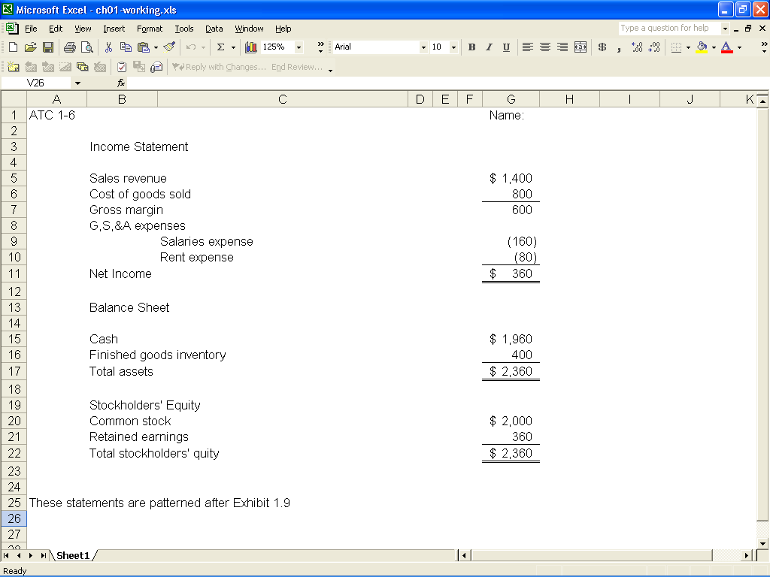

**ATC 1-6 (continued)**

**Screen capture of cell formulas:**

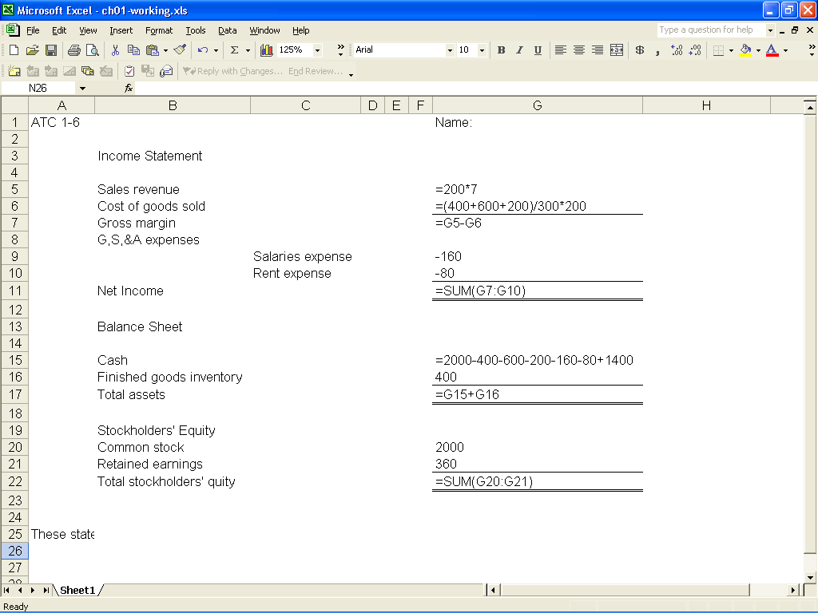

**ATC 1-7**

**Screen capture of cell values:**

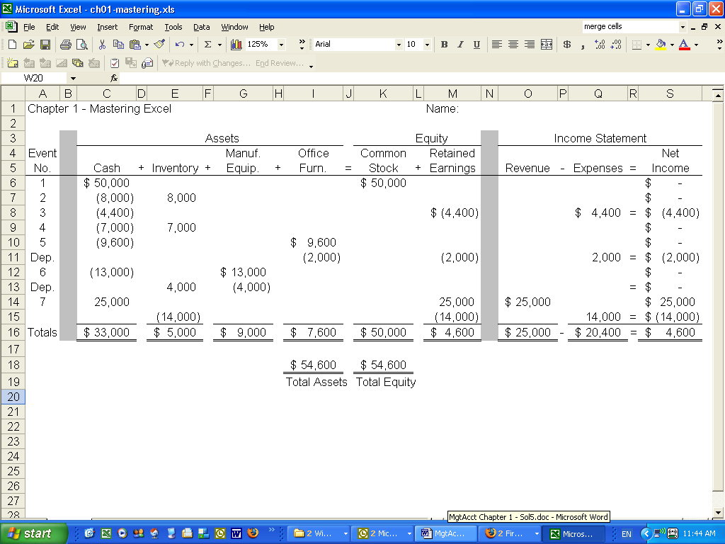

**ATC 1-7 (continued)**

**Screen capture of cell formulas:**

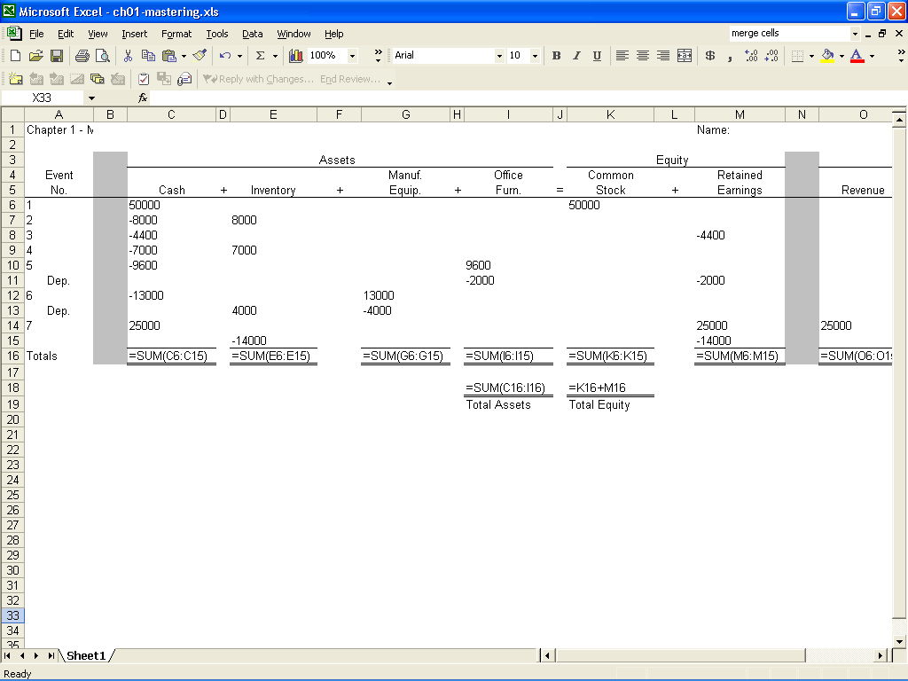

**ATC 1-7 (continued)**

**Screen capture of cell formulas:**

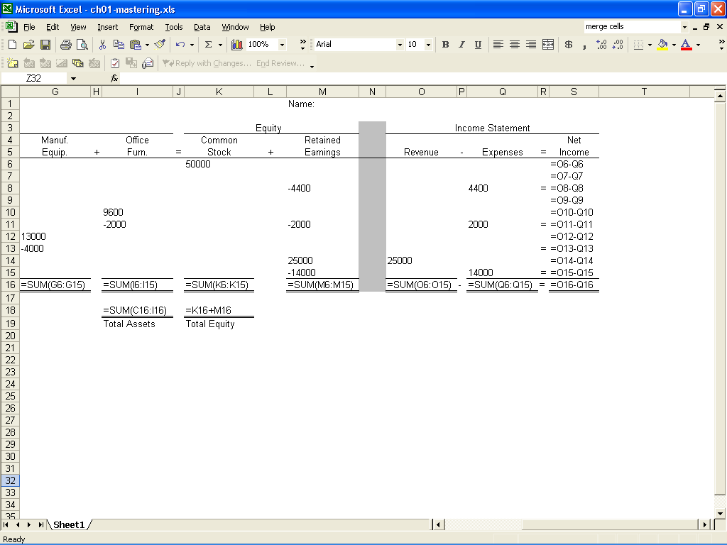

***Chapter 1 Comprehensive Problem***

|  |  |  |  |  |  |  |  |  |  |  |  |  |  |  |  |  |  |  |  |  |
| --- | --- | --- | --- | --- | --- | --- | --- | --- | --- | --- | --- | --- | --- | --- | --- | --- | --- | --- | --- | --- |
| **Requirement a** | | | |  | |  |  |  |  |  |  |  | | |  |  |  |  |  |  |
|  |  |  | **Assets** |  | |  |  |  | = | **Equity** |  |  | | |  |  |  | **Income Statement** |  |  |
|  |  |  |  |  | |  |  |  |  |  |  |  | | |  |  |  |  |  |  |
| Event |  |  |  |  | | Manuf. |  | Office |  | Common |  | Retained | | |  |  |  |  |  |  |
| Number | Cash | + | Inventory | + | | Equip. | + | Equip. | = | Stock | + | Earnings | | |  | Rev. | - | Exp | = | Net Inc. |
| 1. | 750,000 | + |  | + | |  | + |  | = | 750,000 | + |  | | |  |  | - |  | = |  |
| 2a. | (270,000) | + |  | + | | 270,000 | + |  | = |  | + |  | | |  |  | - |  | = |  |
| 2b. |  | + | 60,000 | + | | (60,000) | + |  | = |  | + |  | | |  |  | - |  | = |  |
| 3. | (200,000) | + | 200,000 | + | |  | + |  | = |  | + |  | | |  |  | - |  | = |  |
| 4. | (125,000) | + | 125,000 | + | |  | + |  | = |  | + |  | | |  |  | - |  | = |  |
| 5. | (20,000) | + | 20,000 | + | |  | + |  | = |  | + |  | | |  |  | - |  | = |  |
| 6. | (50,000) | + | 50,000 | + | |  | + |  | = |  | + |  | | |  |  | - |  | = |  |
| 7a. | 600,000 | + |  | + | |  | + |  | = |  | + | 600,000 | | |  | 600,000 | - |  | = | 600,000 |
| 7b. |  | + | (455,000) | + | |  | + |  | = |  | + | (455,000) | | |  |  | - | 455,000 | = | (455,000) |
| 8. | (30,000) | + |  | + | |  | + |  | = |  | + | (30,000) | | |  |  | - | 30,000 | = | (30,000) |
| 9a. | (39,000) | + |  | + | |  | + | 39,000 | = |  | + |  | | |  |  | - |  | = |  |
| 9b. |  | + |  | + | |  | + | (12,000) | = |  | + | (12,000) | | |  |  | - | 12,000 | = | (12,000) |
| 10. | (71,950) | + |  | + | |  | + |  | = |  | + | (71,950) | | |  |  | - | 71,950 | = | (71,950) |
| Total | 544,050 | + | 0 | + | | 210,000 | + | 27,000 | = | 750,000 | + | 31,050 | | |  | 600,000 | - | 568,950 | = | 31,050 |
| **Requirement b** | | | |  | |  |  |  |  |  |  |  | | |  |  |  |  |  |  |
|  | **Income Statement** | | | | | |  |  |  | **Balance Sheet** | | | | | | | | | | |
|  | Sales revenue | | |  | $600,000 | |  |  |  | Assets: |  |  | | |  |  |  |  |  |  |
|  | Cost of goods sold | | |  | (455,000) | |  |  |  | Cash |  |  | | |  |  |  |  |  | $544,050 |
|  | Gross margin | | |  | 145,000 | |  |  |  | Manufacturing equipment, net of acc. depreciation | | | | | | | | |  | 210,000 |
|  | Sales commission | | |  | (30,000) | |  |  |  | Office equipment, net of acc. depreciation | | | | | | | | |  | 27,000 |
|  | Depreciation expense | | |  | (12,000) | |  |  |  | Total assets | | | | |  |  |  |  |  | $781,050 |
|  | Administrative expense | | |  | (71,950) | |  |  |  |  | | | |  |  |  |  |  |  |  |
|  | Net income | |  |  | $ 31,050 | |  |  |  |  | | |  |  |  |  |  |  |  |  |
|  |  |  |  |  |  | |  |  |  | Equity: | | |  |  |  |  |  |  |  |  |
|  |  |  |  |  |  | |  |  |  | Common stock | | | |  |  |  |  |  |  | $750,000 |
|  |  |  |  |  |  | |  |  |  | Retained earnings | | | | |  |  |  |  |  | 31,050 |
|  |  |  |  |  |  | |  |  |  | Total equity | | |  |  |  |  |  |  |  | $781,050 |

**Exercise 1-1A**

|  |  |  |
| --- | --- | --- |
|  | **Managerial Accounting** | **Financial Accounting** |
| **a.** |  | **X** |
| **b.** | **X** |  |
| **c.** |  | **X** |
| **d.** |  | **X** |
| **e.** | **X** |  |
| **f.** |  | **X** |
| **g.** | **X** |  |
| **h.** | **X** |  |
| **i.** |  | **X** |
| **j.** | **X** |  |

**Exercise 1-2A**

|  |  |  |
| --- | --- | --- |
|  | **Product Cost** | **Selling, General, and Administrative Cost** |
| **a.** | **X** |  |
| **b.** | **X** |  |
| **c.** |  | **X** |
| **d.** |  | **X** |
| **e.** |  | **X** |
| **f.** | **X** |  |
| **g.** |  | **X** |
| **h.** |  | **X** |
| **i.** |  | **X** |
| **j.** |  | **X** |

**Exercise 1-3A**

|  |  |  |
| --- | --- | --- |
| **Cost Category** | **Product /**  **SG&A** | **Asset /**  **Expense** |
| **Wages of production workers** | Product | Asset |
| **Advertising costs** | **SG&A** | **Expense** |
| **Promotion costs** | **SG&A** | **Expense** |
| **Production supplies** | Product | Asset |
| **Depreciation on administration building** | **SG&A** | **Expense** |
| **Depreciation on manufacturing equipment** | **Product** | **Asset** |
| **Research and development costs** | **SG&A** | **Expense** |
| **Cost to set up manufacturing equipment** | Product | Asset |
| Utilities used in manufacturing facility | Product | Asset |
| **Cars for sales staff** | **SG&A** | **Asset** |
| **Real estate tax levied on a factory** | **Product** | **Asset** |
| **General office supplies** | **SG&A** | **Asset** |
| **Raw materials used in the manufacturing process** | Product | Asset |
| **Costs to rent office equipment** | **SG&A** | **Expense** |

**Exercise 1-4A**

|  |  |  |  |  |  |  |  |  |  |  |  |  |  |
| --- | --- | --- | --- | --- | --- | --- | --- | --- | --- | --- | --- | --- | --- |
|  |  | **Assets** | **=** | **Liab.** | **+** | **Equity** |  | **Rev.** | **–** | **Exp.** | **=** | **Net Inc.** |  |
| **1.** |  | **NA** |  | **I** |  | **D** |  | **NA** |  | **I** |  | **D** |  |
| **2.** |  | **I** |  | **I** |  | **NA** |  | **NA** |  | **NA** |  | **NA** |  |

**Exercise 1-5A**

|  |  |  |  |  |  |  |  |  |  |  |  |  |  |  |  |  |  |  |
| --- | --- | --- | --- | --- | --- | --- | --- | --- | --- | --- | --- | --- | --- | --- | --- | --- | --- | --- |
|  |  | ***Assets*** | | | | | | | **=** | ***Equity*** | | |  | **Income Statement** | | | | |
| **Event** |  |  |  |  |  | ***Manuf.*** |  | ***Office*** |  | ***Com.*** |  | ***Ret.*** |  |  |  |  |  |  |
| **No.** |  | ***Cash*** | **+** | ***Inventory*** | **+** | ***Equip.*** | **+** | ***Furn.*** | **=** | ***Stk.*** | **+** | ***Ear.*** |  | **Rev.** | **–** | **Exp.** | **=** | **Net Inc.** |
| **1.** |  | NA |  | **NA** |  | **NA** |  | **D** |  | NA |  | **D** |  | **NA** |  | **I** |  | **D** |
| **2.** |  | NA |  | **I** |  | **D** |  | **NA** |  | NA |  | **NA** |  | **NA** |  | **NA** |  | **NA** |
|  |  |  |  |  |  |  |  |  |  |  |  |  |  |  |  |  |  |  |

# Exercise 1-6A

a. Payroll costs that would be classified as selling, general, and administrative expense include the following:

|  |  |
| --- | --- |
| Salary of the company president | $ 75,000 |
| Salary of the chief financial officer | 42,000 |
| Salary of the vice president of marketing | 40,000 |
| Salaries of administrative secretaries | 60,000 |
| Commissions paid to sales staff | 146,000 |
| Total | $363,000 |
|  |  |

b. Payroll costs that would be classified as product cost include the following:

|  |  |
| --- | --- |
| Salary of the vice president of manufacturing | $ 50,000 |
| Salary of middle managers in manufacturing plant | 147,000 |
| Wages of production workers | 703,500 |
| Salaries of engineers and maintenance crew | 133,500 |
| Total | $1,034,000 |
|  |  |

**Since 4,000 units of 5,000 finished products were sold, 80% (*i.e.* 4,000 ÷ 5,000) of the product cost would be classified as cost of goods sold. Therefore, the payroll cost that would be included in cost of goods sold is determined as follows:**

**$1,034,000 x 80% = $827,200**

**Alternatrive computation for the same result follows :**

**($1,034,000 ÷ 5,000) X 4,000 = $827,200**

**Exercise 1-7A**

|  |  |  |  |  |  |  |  |  |  |  |  |  |  |  |  |  |  |  |
| --- | --- | --- | --- | --- | --- | --- | --- | --- | --- | --- | --- | --- | --- | --- | --- | --- | --- | --- |
|  |  | ***Assets*** | | | | | | | **=** | ***Equity*** | | |  | **Income Statement** | | | | |
| **Event** |  |  |  |  |  | ***Manuf.*** |  | ***Office*** |  | ***Com.*** |  | ***Ret.*** |  |  |  |  |  |  |
| **No.** |  | ***Cash*** | **+** | ***Inventory*** | **+** | ***Equip.*** | **+** | ***Furn.*** | **=** | ***Stk.*** | **+** | ***Ear.*** |  | **Rev.** | **–** | **Exp.** | **=** | **Net Inc.** |
| **1.** |  | I | **+** | **NA** | **+** | **NA** | **+** | **NA** | **=** | **NA** | **+** | I |  | I | **–** | **NA** | **=** | I |
| **2.** |  | **NA** | **+** | D | **+** | **NA** | **+** | **NA** | **=** | **NA** | **+** | D |  | **NA** | **–** | I | **=** | D |
| **3.** |  | I | **+** | **NA** | **+** | **NA** | **+** | **NA** | **=** | I | **+** | **NA** |  | **NA** | **–** | **NA** | **=** | **NA** |
| **4.** |  | D | **+** | I | **+** | **NA** | **+** | **NA** | **=** | **NA** | **+** | **NA** |  | **NA** | **–** | **NA** | **=** | **NA** |
| **5.** |  | D | **+** | I | **+** | **NA** | **+** | **NA** | **=** | **NA** | **+** | **NA** |  | **NA** | **–** | **NA** | **=** | **NA** |
| **6.** |  | D | **+** | **NA** | **+** | **NA** | **+** | **NA** | **=** | **NA** | **+** | D |  | **NA** | **–** | I | **=** | D |
| **7.** |  | **NA** | **+** | I | **+** | D | **+** | **NA** | **=** | **NA** | **+** | **NA** |  | **NA** | **–** | **NA** | **=** | **NA** |
| **8.** |  | **NA** | **+** | **NA** | **+** | **NA** | **+** | D | **=** | **NA** | **+** | D |  | **NA** | **–** | I | **=** | D |

# Exercise 1-8A

**a.**

|  |  |
| --- | --- |
| Raw materials purchased and used | $ 6,200 |
| Wages of production workers | 7,400 |
| Depreciation on manufacturing equipment | 4,400 |
| Total product cost | $18,000 |
|  |  |

**b. Cost of inventory per unit = $18,000 ÷ 3,000 = $6.00**

**Ending inventory in units = 3,000 – 2,400 = 600**

**Cost of ending inventory = $6.00 x 600= $3,600**

**c. Cost of goods sold = $6.00 x 2,400 = $14,400**

**Exercise 1-9A**

|  |  |  |  |
| --- | --- | --- | --- |
| **Item** | **Upstream** | **Midstream** | **Downstream** |
| **Direct materials** |  | **x** |  |
| **Research and development** | **x** |  |  |
| **Product design** | **x** |  |  |
| **Manufacturing overhead** |  | **x** |  |
| **Sales salaries** |  |  | **x** |
| **Cost of delivering merchandise to customers** |  |  | **x** |
| **Cost to create a copyright** | **x** |  |  |
| **Salaries of product engineers** | **x** |  |  |
| **Salaries of production line workers** |  | **x** |  |
| **Direct labor** |  | **x** |  |
| **Cost of heating the manufacturing plant** |  | **x** |  |
| **Advertising expenses** |  |  | **x** |
| **Patent filing fees** | **x** |  |  |
| **Salary of company president** |  |  | **x** |
| **Depreciation on manufacturing equipment** |  | **x** |  |
| **Depreciation on office equipment** |  |  | **x** |

**Exercise 1-10A**

**a. The $8,000,000 of research and development cost is an upstream cost while packaging, shipping, and sales commissions are downstream costs.**

**b. Cost of goods sold: $45 x 400,000 = $18,000,000**

**Ending inventory: $45 x 40,000 = $1,800,000**

c.

|  |  |
| --- | --- |
| Upstream cost per unit, $8,000,000 ÷ 2,000,000 | $ 4.00 |
| Manufacturing cost per unit | 45.00 |
| Downstream costs per unit | 8.00 |
| Total cost | 57.00 |
| Plus: 25% profit margin, $57.00 x 25% | 14.25 |
| Price | $71.25 |

**d.**

|  |  |
| --- | --- |
| Income Statement | |
| Sales revenue ($71.25 X 400,000) | $ 28,500,000 |
| Cost of goods sold | (18,000,000) |
| Gross margin | 10,500,000 |
| Research and development | (8,000,000) |
| Selling expenses ($8 x 400,000) | (3,200,000) |
| Net income (Loss) | $ (700,000) |
|  |  |

e. The upstream cost of research and development is required by GAAP to be expensed in the period that it is incurred. However, the R&D is expected to result in overall sales of 2,000,000 units. The income statement for Year 1 includes the sales of only 400,000 units while recognizing the entire cost of R&D as expense. In other words, the net loss is only temporary and a result of timing difference.

# Exercise 1-11A

a. The three main components of product cost for a manufacturing entity are direct materials, direct labor, and manufacturing overhead.

b. The product cost in a merchandising company, such as a retail toy store, is relatively easy to determine. It includes vendor’s price charged on the invoice, freight cost, and other necessary costs to make the inventory available for sale. Measuring product cost for a manufacturing entity, though, requires a more complex system. First of all, the manufacturing firm has to classify its costs between product costs and period costs. The firm has to accumulate product costs such as direct materials, direct labor, and manufacturing overhead. Once the product costs have been accumulated, the firm has to classify the cost of a product that has been sold as expense, and the cost of an unsold product as inventory, an asset.

**Exercise 1-12A**

a. Event No. 1 represents the depreciation on the computers because no product inventory exists in a service organization. The cost of depreciation, thus, must be expensed.

b. The computers in a service organization must be expensed as explained in *Part a*. This transaction decreases the asset equipment and retained earnings, both balance sheet accounts. The transaction increases expense on the income statement.

The depreciation on production equipment in a manufacturing company decreases the equipment account and increases the inventory account. It does not affect the income statement until the product is completed and sold.

Exercise 1-13A

If Perez has effectively implemented a 100% just-in-time inventory system, the company can sell products without maintaining any inventory on hand. This is true if Perez instructs its suppliers to ship products directly to Perez’s customers when Perez receives customer orders.

Exercise 1-14A

a.

|  |  |
| --- | --- |
| Income Statement | |
| Sales revenue ($12 x 600) | $ 7,200 | |
| Cost of goods sold ($5 x 600) | (3,000) | |
| Gross margin | 4,200 | |
| Waste due to excess inventory ($5 x 100) | (500) | |
| Net income | $ 3,700 | |
|  |  | |

b.

|  |  |
| --- | --- |
| Income Statement | |
| Sales revenue ($12 x 700) | $8,400 | |
| Cost of goods sold ($5 x 700) | (3,500) | |
| Net income | $4,900 | |
|  |  | |

The opportunity cost of lost profit: ($12 – $5) x 100 = $700

c. If Ms. Shelton can arrange an effective JIT system, the T-shirts would be delivered by the supplier just in time for customers to purchase. To give an example of such a system, assume that the supplier sets up a simple T-shirt printing facility at Kemp School. The supplier could bring in enough generic T-shirts. When a customer wants to buy a T-shirt from Becky Shelton, the supplier could print the school’s special art design on a generic T-shirt and deliver the T-shirt to Ms. Shelton. In this JIT design, Ms. Shelton would not have to carry any inventory. The supplier would keep only generic product as inventory, which could be sold in other events.

If an effective JIT system is implemented, Ms. Shelton would not have to keep any inventory, and thus, would avoid the loss due to excessive inventory. Ms. Shelton would be able to meet all customer demand because the supplier could deliver whatever quantity of product that Ms. Shelton's customers demand. Therefore, Ms. Shelton could avoid the opportunity cost due to lost sales.

Exercise 1-15A

a. The new inventory system is an approximate just-in-time system since it does not eliminate all inventory.

b. Reduced cost of inventory: $67,000 – $17,000 = $50,000

Finance cost: $50,000 x 5% = $2,500

Total eliminated inventory holding cost: $2,500 + $9,000 = $11,500

**Exercise 1-16A**

**a. While the entire $575,000 of transportation cost should have been expensed immediately, the CFO put the $575,000 into an inventory account. Since some of the inventory was not sold, some of the transportation cost is still in the inventory account. The computations are shown below:**

|  |  |  |  |  |
| --- | --- | --- | --- | --- |
|  |  | $575,000 |  |  |
| Misclassified cost per unit | = | ––––––––– | = | $115 per microscope |
|  |  | 5,000 |  |  |

|  |  |  |  |  |
| --- | --- | --- | --- | --- |
| Number of units in ending inventory: | | | | |
| Inventory Completed |  | 5,000 |  |  |
| Less Inventory Sold |  | (4,000) |  |  |
| Ending Inventory |  | 1,000 |  |  |
|  |  |  |  |  |
| The portion of transportation cost still in ending inventory is $115,000 ($115 x 1,000 units). | | | | |

**Instead of being in the inventory account, the $115,000 should have been expensed.  As a result, assets, retained earnings (equity), and net income are overstated by $115,000.  Expenses are understated by the same amount.  Revenue and liabilities are not affected.**

**b. The maximum penalty for an intentional misrepresentation is punishable by a fine of up to $5 million and imprisonment of up to 20 years.**

**Exercise 1-17A**

**The CFO and controller violated the Statement of Ethical Professional Practice on two major items: integrity and objectivity. Regarding integrity, the officers’ personal interests conflicted with the public interest because the officers reaped a bonus that they didn’t deserve. Moreover, their actions certainly discredited the accounting profession. Regarding objectivity, the officers didn’t communicate information fairly and objectively.**

Exercise 1-18A

The process of shipping the encased speakers back to Soundwaves Company by Walton Cabinet, Inc. is nonvalue-added. This process can be eliminated if Walton ships the product to Soundwaves’ customers directly.

**Problem 1-19A**

|  |  |  |
| --- | --- | --- |
| **Information Item:** | **Financial**  **Accounting** | **Managerial**  **Accounting** |
| **Estimates of future revenue** |  | **x** |
| **GAAP-based product cost** | **x** |  |
| **Salary of the manager of a particular branch of a bank** |  | **x** |
| **Salary expense for all company employees shown in the income statement** | **x** |  |
| **Historical-based information included in financial statements** | **x** |  |
| **Reporting rules established by government authorities** | **x** |  |
| **Reports designed for the company president** |  | **x** |
| **Daily time clock reports** |  | **x** |
| **A company’s annual report to stockholders** | **x** |  |
| **Budgets** |  | **x** |
| **Information provided to investors and creditors** | **x** |  |
| **Vacation schedules for key employees** |  | **x** |
| **Customer satisfaction survey results** |  | **x** |
| **Amount of total assets shown on the balance sheet** | **x** |  |

**Problem 1-20A**

**The following horizontal financial statements model is not required in the problem. It is provided to show the process of computation.**

|  |  |  |  |  |  |  |  |  |  |  |  |  |  |  |  |  |  |  |
| --- | --- | --- | --- | --- | --- | --- | --- | --- | --- | --- | --- | --- | --- | --- | --- | --- | --- | --- |
| **Event** |  | **Assets** | | | | | | | **=** | **Equity** | | |  | **Income Statement** | | | | |
|  |  |  |  |  |  | **Office** |  | **Manuf.** |  | **Common** |  |  |  |  |  |  |  |  |
| **No.** |  | **Cash** | **+** | **Invent.** | **+** | **Furn.\*** | **+** | **Equip*.** | **=** | **Stock** | **+** | **Ret. Ear.** |  | **Rev.** | **–** | **Exp.** | **=** | **Net Inc.** |
|  |  |  |  |  |  |  |  |  |  |  |  |  |  |  |  |  |  |  |
| **1.** |  | **89,000** | **+** |  | **+** |  | **+** |  | **=** | **89,000** | **+** |  |  |  | **–** |  | **=** |  |
| **2a.** |  | **(32,000)** | **+** |  | **+** | **32,000** | **+** |  | **=** |  | **+** |  |  |  | **–** |  | **=** |  |
| **2b.** |  |  | **+** |  | **+** | **(4,000)** | **+** |  | **=** |  | **+** | **(4,000)** |  |  | **–** | **4,000** | **=** | **(4,000)** |
| **3a.** |  | **(40,000)** | **+** |  | **+** |  | **+** | **40,000** | **=** |  | **+** |  |  |  | **–** |  | **=** |  |
| **3b.** |  |  | **+** | **6,000** | **+** |  | **+** | **(6,000)** | **=** |  | **+** |  |  |  | **–** |  | **=** |  |
| **4.** |  | **(12,000)** | **+** |  | **+** |  | **+** |  | **=** |  | **+** | **(12,000)** |  |  | **–** | **12,000** | **=** | **(12,000)** |
| **5.** |  | **(21,000)** | **+** | **21,000** | **+** |  | **+** |  | **=** |  | **+** |  |  |  | **–** |  | **=** |  |
| **6.** |  | **(26,000)** | **+** | **26,000** | **+** |  | **+** |  | **=** |  | **+** |  |  |  | **–** |  | **=** |  |
| **7a.** |  | **72,000** | **+** |  | **+** |  | **+** |  | **=** |  | **+** | **72,000** |  | **72,000** | **–** |  | **=** | **72,000** |
| **7b.** |  |  | **+** | **(42,400)** | **+** |  | **+** |  | **=** |  | **+** | **(42,400)** |  |  | **–** | **42,400** | **=** | **(42,400)** |
| **Total** |  | **30,000** | **+** | **10,600** | **+** | **28,000** | **+** | **34,000** | **=** | **89,000** | **+** | **13,600** |  | **72,000** | **–** | **58,400** | **=** | **13,600** |
|  |  |  |  |  |  |  |  |  |  |  |  |  |  |  |  |  |  |  |

**\*Record accumulated depreciation as negative amounts under these columns.**

**Problem 1-20A (continued)**

**a.**

|  |  |
| --- | --- |
|  |  |
| **Direct materials** | **$26,000** |
| **Direct labor** | **21,000** |
| **Manufacturing overhead** | **6,000\*** |
| **Total product cost** | **53,000** |
| **Divided by** | **÷10,000** |
| **Average cost per unit** | **$5.30** |
|  |  |

**\* Depreciation of manufacturing equipment:**

**($40,000 − $4,000) ÷ 6 = $6,000**

**b. Cost of Goods Sold: $5.30 * 8,000 = $42,400**

**c. Ending Inventory: $5.30 * (10,000 ~~−~~ 8,000) = $10,600**

**d. $13,600**

**e. $13,600**

**f. $30,000 + $10,600 + $28,000 + $34,000 = $102,600**

Problem 1-21A

|  |  |  |  |  |  |  |  |  |  |  |  |  |  |  |  |  |  |  |  |
| --- | --- | --- | --- | --- | --- | --- | --- | --- | --- | --- | --- | --- | --- | --- | --- | --- | --- | --- | --- |
| **Event** |  | **Assets** | | | | | | | **=** | **Equity** | | |  | **Income Statement** | | | | | |
|  |  |  |  |  |  | **Manuf.** |  | **Office** |  | **Common** |  |  |  | **Rev.** | **–** | **Exp.** | **=** | | **Net Inc.** |
| **No.** |  | **Cash** | **+** | **Invent.** | **+** | **Equip.\*** | **+** | **Furn.\*** | **=** | **Stock** | **+** | **Ret. Ear.** |  |
| **1.** |  | **68,000** | **+** |  | **+** |  | **+** |  | **=** | **68,000** | **+** |  |  |  | **–** |  | **=** |  | |
| **2.** |  | **(8,700)** | **+** | **8,700** | **+** |  | **+** |  | **=** |  | **+** |  |  |  | **–** |  | **=** |  | |
| **3.** |  | **(4,500)** | **+** |  | **+** |  | **+** |  | **=** |  | **+** | **(4,500)** |  |  | **–** | **4,500** | **=** | **(4,500)** | |
| **4.** |  | **(10,000)** | **+** | **10,000** | **+** |  | **+** |  | **=** |  | **+** |  |  |  | **–** |  | **=** |  | |
| **5a.** |  | **(9,600)** | **+** |  | **+** |  | **+** | **9,600** | **=** |  | **+** |  |  |  | **–** |  | **=** |  | |
| **5b.** |  |  | **+** |  | **+** |  | **+** | **(2,000)** | **=** |  | **+** | **(2,000)** |  |  | **–** | **2,000** | **=** | **(2,000)** | |
| **6a.** |  | **(16,000)** | **+** |  | **+** | **16,000** | **+** |  | **=** |  | **+** |  |  |  | **–** |  | **=** |  | |
| **6b.** |  |  | **+** | **3,000** | **+** | **(3,000)** | **+** |  | **=** |  | **+** |  |  |  | **–** |  | **=** |  | |
| **7a.** |  | **35,000** | **+** |  | **+** |  | **+** |  | **=** |  | **+** | **35,000** |  | **35,000** | **–** |  | **=** | **35,000** | |
| **7b.** |  |  | **+** | **(14,000)** | **+** |  | **+** |  | **=** |  | **+** | **(14,000)** |  |  | **–** | **14,000** | **=** | **(14,000)** | |
| **Total** |  | **54,200** | **+** | **7,700** | **+** | **13,000** | **+** | **7,600** | **=** | **68,000** | **+** | **14,500** |  | **35,000** | **–** | **20,500** | **=** | **14,500** | |
|  |  |  |  |  |  |  |  |  |  |  |  |  |  |  |  |  |  |  | |

**\*Record accumulated depreciation as negative amounts under these columns.**

Problem 1-22A

|  |  |  |  |  |  |
| --- | --- | --- | --- | --- | --- |
|  | Gibson Company | | | | |
|  | Income Statement for Year 1 | |  | Balance Sheet as of 12/31/Year 1 | |
|  | Sales revenue | $9,000 |  | Assets |  |
|  | Cost of goods sold1 | (7,200) |  | Cash3 | $12,250 |
|  | Gross margin | 1,800 |  | Fin. goods inventory1 | 800 |
|  | Administrative expense2 | (750) |  | Total assets | $13,050 |
|  | Net income | $ 1,050 |  |  |  |
|  |  |  |  | Equity |  |
|  |  |  |  | Common stock | $12,000 |
|  |  |  |  | Retained earnings | 1,050 |
|  |  |  |  | Total equity | $13,050 |
|  |  |  |  |  |  |
|  |  |  |  |  |  |

1 The product costs include $4,700 for materials, $2,400 for labor, and $900 for overhead. Accordingly, $8,000 (*i.e.*, $4,700 + $2,400 + $900) was used to make the 400 units of product. The cost per unit is $20.00 (*i.e.* $8,000 400 units). Since 360 units were sold, ending inventory will be composed of 40 units (*i.e.* 400 units – 360 units). The amount of cost of goods sold is $7,200 (*i.e.*, $20.00 x 360 units). The balance in ending inventory would be $800 (*i.e.*, $20.00 x 40 units).

2 Administrative expenses are composed of $350 administrative salaries + $400 administrative rent = $750.

3 Cash balance: $12,000 – $4,700 – $2,400 – $900 – $350 – $400 + $9,000 = $12,250.

**Problem 1-23A**

**a. Upstream costs = $30,000 research and development + $20,000 fashion design = $50,000**

**b. Downstream costs = $25,000 advertising + $45,000 administrative costs = $70,000**

**c. Midstream costs = ($15 direct materials + $17 direct labor + $8 manufacturing overhead) x 4,000 units = $160,000**

**d. Sales price = GAAP defined product cost x 150%**

**Sales Price = ($15 direct materials + $17 direct labor + $8 manufacturing overhead) x 1.5 = $60**

|  |  |
| --- | --- |
| **Sales revenue ($60 price x 4,000 units)** | **$240,000** |
| **Cost of goods sold ($40 cost x 4,000 units)** | **(160,000)** |
| **Gross margin** | **80,000** |
| **General, selling, and administrative costs** |  |
| **Upstream costs (R&D, and Design)** | **(50,000)** |
| **Downstream costs (Administrative and Advertising)** | **(70,000)** |
| **Net loss** | **$ (40,000)** |

**e.**

**f. It appears that management failed to give appropriate consideration to upstream and downstream costs when pricing the product. Only the GAAP based product cost was used to determine the price. The total cost of making a phone case is upstream cost + midstream cost + downstream cost.**

**Total per unit costs:**

**Midstream cost = ($15 direct materials + $17 direct labor + $8 manufacturing overhead) = $40**

**Upstream cost = ($50,000 R&D and Design) / 4,000 units = $12.50**

**Downstream cost = ($70,000 Administrative and Advertising) / 4,000 units = $17.50**

**Total cost = $40 Midstream + $12.50 Upstream + $17.50 Downstream = $70.**

Note that the selling price of $60 is below the total cost per unit of $70. This explains the loss incurred by the company.

Problem 1-24A

a.

|  |  |  |  |  |  |
| --- | --- | --- | --- | --- | --- |
|  | Wang Company | | | | |
|  | Income Statement for Year 1 | |  | Balance Sheet as of 12/31/Year 1 | |
|  | Sales revenue | $88,000 |  | Assets |  |
|  | Operating expenses1 | (65,000) |  | Cash2 | $93,000 |
|  | Net income (Loss) | $23,000 |  | Total assets | $93,000 |
|  |  |  |  |  |  |
|  |  |  |  | Equity |  |
|  |  |  |  | Common stock | $70,000 |
|  |  |  |  | Retained earnings | 23,000 |
|  |  |  |  | Total equity | $93,000 |
|  |  |  |  |  |  |

1 The entire $65,000 expenditure is a period cost that is recognized as an expense.

2 The cash balance will be the same for all three scenarios. The company acquires $70,000 of capital, earns $88,000 sales revenue and spends $65,000, thereby leaving a $93,000 ending balance. Do not be confused by the fact that the $65,000 is used to pay for different things under the alternative scenarios. The cash outflow is always $65,000 regardless of what is bought.

b.

|  |  |  |  |  |  |  |
| --- | --- | --- | --- | --- | --- | --- |
|  | Wang Company | | | | |  |
|  | Income Statement for Year 1 | |  | Balance Sheet as of 12/31/Year 1 | |  |
|  | Sales revenue | $88,000 |  | Assets |  |  |
|  | Depreciation exp.1 | (13,000) |  | Cash | $ 93,000 |  |
|  | Net income | $75,000 |  | Rental equipment | 65,000 |  |
|  |  |  |  | Accumulated dep.1 | (13,000) |  |
|  |  |  |  | Total assets | $145,000 |  |
|  |  |  |  |  |  |  |
|  |  |  |  | Equity |  |  |
|  |  |  |  | Common Stock | $ 70,000 |  |
|  |  |  |  | Retained earnings | 75,000 |  |
|  |  |  |  | Total equity | $145,000 |  |
|  |  |  |  |  |  |  |

1 The $65,000 was used to purchase automobiles that had 5-year useful lives with no salvage value. The depreciation charge is $13,000 [*i.e.*, ($65,000 - 0) 5 years]. Since the solution applies to the first year of operation, the amount in the accumulated depreciation account and the amount in depreciation expense are equal.

Problem 1-24A (continued)

c.

|  |  |  |  |  |  |  |
| --- | --- | --- | --- | --- | --- | --- |
|  | Wang Company | | | | |  |
|  | Income Statement for Year 1 | |  | Balance Sheet as of 12/31/Year 1 | |  |
|  | Sales revenue | $88,000 |  | Assets |  |  |
|  | Cost of goods sold1 | (28,500) |  | Cash | $ 93,000 |  |
|  | Gross margin | 59,500 |  | Finished goods inv. | 9,500 |  |
|  | Administrative expense2 | (5,000) |  | Mfg. equipment | 30,000 |  |
|  | Net income | $54,500 |  | Accumulated dep.1 | (8,000) |  |
|  |  |  |  | Total assets | $124,500 |  |
|  |  |  |  |  |  |  |
|  |  |  |  |  |  |  |
|  |  |  |  | Equity |  |  |
|  |  |  |  | Common stock | $70,000 |  |
|  |  |  |  | Retained earnings | 54,500 |  |
|  |  |  |  | Total equity | $124,500 |  |
|  |  |  |  |  |  |  |

1 The product costs are $10,000 for materials, $20,000 for labor, and $8,000 for overhead. The overhead cost results from depreciation on the manufacturing equipment [*i.e.*, ($30,000 cost - $6,000 salvage) 3 year life]. Accordingly, total product costs amount to $38,000 (*i.e.*, $10,000+$20,000+$8,000). The cost per unit is $19 (*i.e.,* $38,000 2,000 units). Since 1,500 units were sold, ending inventory will be composed of 500 units (*i.e.,* 2,000 units - 1,500 units). The amount of cost of goods sold is $28,500 (*i.e.*, $19 x 1,500 units). The balance in ending inventory would be $9,500 (*i.e.*, $19 x 500 units).

2 Salaries of sales and administrative employees

**d. It is highly unlikely that Wang can determine the exact cost of any particular unit of product. Materials and labor usage will differ slightly between units of the same product. Cost averaging smoothes these differences across units of the same product.**

**Problem 1-25A**

**a. Annual inventory holding cost:**

**($1,200,000 x 10%) + ($8,000 x 12) = $216,000**

**b. A JIT system should enable Kenta to receive raw materials just in time for production. Therefore, it virtually eliminates the need to hold inventory. The inventory holding cost can be eliminated as well.**

**c. Establishing a most-favored customer status with reliable suppliers could assure a steady supply of raw materials even when shortages exist for other customers. Such assurance can almost eliminate the need for maintaining raw material inventories.**

**Problem 1-26A**

**CIA Review normally orders 10 % more books than expected. When the expected enrollment is 200 students, the firm would order 220 books.**

**a. 200 students enroll in the course:**

|  |  |  |
| --- | --- | --- |
| **Revenue ($2,000 x 200)** |  | **$400,000** |
| **Expenses** |  |  |
| **Cost of textbooks ($150 x 220)** | **$33,000** |  |
| **Cost of teachers** | **50,000** |  |
| **Other operating expenses** | **75,000** |  |
| **Total expenses** |  | **158,000** |
| **Net income** |  | **$242,000** |

**Cost of unused books: [(220 – 200) x $150] = $3,000.**

**b. 240 students attempt to register, but only 220 students can be accepted:**

|  |  |  |
| --- | --- | --- |
| **Revenue ($2,000 x 220)** |  | **$440,000** |
| **Expenses** |  |  |
| **Cost of textbooks ($150 x 220)** | **$33,000** |  |
| **Cost of teachers** | **50,000** |  |
| **Other operating expenses** | **75,000** |  |
| **Total expenses** |  | **158,000** |
| **Net income** |  | **$282,000** |

**If all 240 students could be** **accepted, the income statement would be as follows:**

|  |  |  |
| --- | --- | --- |
| **Revenue ($2,000 x 240)** |  | **$480,000** |
| **Expenses** |  |  |
| **Cost of textbooks ($150 x 240)** | **$36,000** |  |
| **Cost of teachers** | **50,000** |  |
| **Other operating expenses** | **75,000** |  |
| **Total expenses** |  | **161,000** |
| **Net income** |  | **$319,000** |

**The lost profit resulting from rejecting 20 additional students is $37,000 ($319,000 – $282,000).**

**Problem 1-26A (continued)**

**c. 200 students enrolled under a JIT system:**

|  |  |  |
| --- | --- | --- |
| **Revenue ($2,000 x 200)** |  | **$400,000** |
| **Expenses** |  |  |
| **Cost of textbooks ($160 x 200)** | **$32,000** |  |
| **Cost of teachers** | **50,000** |  |
| **Other operating expenses** | **75,000** |  |
| **Total expenses** |  | **157,000** |
| **Net income** |  | **$243,000** |

**The savings from eliminating the cost of excessive books exceeds the increased cost for the required number of books. Therefore, the total expenses using the JIT system are less than those under the traditional inventory system in *requirement a*. Since the revenues are the same, the JIT system results in a greater net income than the traditional system.**

**d. 240 students enrolled under the JIT system**

|  |  |  |
| --- | --- | --- |
| **Revenue ($2,000 x 240)** |  | **$480,000** |
| **Expenses** |  |  |
| **Cost of textbooks ($160 x 240)** | **$38,400** |  |
| **Cost of teacher** | **50,000** |  |
| **Other operating expenses** | **75,000** |  |
| **Total expenses** |  | **163,400** |
| **Net income** |  | **$316,600** |

**The additional revenue from 20 students who would have been turned away under the condition of *requirement b* exceeds the additional cost of books required under the JIT system. Therefore, the JIT system results in a greater net income than the traditional system*.***

**Problem 1-26A (continued)**

**e. Students who are denied enrollment may develop a negative image of CIA Review, Inc. The negative image could become widespread when the disgruntled students complain to their friends. The JIT system not only improves net income, but improves customer satisfaction by allowing everyone entry into the course.**

**Problem 1-27A**

**a. Option No. 1**

|  |  |  |  |  |  |  |
| --- | --- | --- | --- | --- | --- | --- |
|  | Campbell Manufacturing Company | | | | |  |
|  | Income Statement | |  | Balance Sheet | |  |
|  | Sales revenue | $140,000 |  | Assets |  |  |
|  | Cost of goods sold1 | (60,000) |  | Cash2 | $ 85,000 |  |
|  | Gross margin | 80,000 |  | Finished goods inv.3 | 15,000 |  |
|  | Sell., gen., & adm. exp. | (60,000) |  | Total assets | $100,000 |  |
|  | Net income | $20,000 |  |  |  |  |
|  |  |  |  |  |  |  |
|  |  |  |  |  |  |  |
|  |  |  |  |  |  |  |
|  |  |  |  | Equity |  |  |
|  |  |  |  | Common stock | $ 80,000 |  |
|  |  |  |  | Retained earnings | 20,000 |  |
|  |  |  |  | Total equity | $100,000 |  |
|  |  |  |  |  |  |  |

1**$75,000 (Total product cost) ÷ 5,000 = $15.00 per unit. $15.00 x 4,000 = $60,000.**

**2$80,000 + $140,000 - $75,000 - $60,000 = $85,000**

**3Inventory: $15.00 x 1,000 = $15,000.**

**Problem 1-27A (continued)**

**a. Option 2**

|  |  |  |  |  |  |  |
| --- | --- | --- | --- | --- | --- | --- |
|  | Campbell Manufacturing Company | | | | |  |
|  | Income Statement | |  | Balance Sheet | |  |
|  | Sales revenue | $140,000 |  | Assets |  |  |
|  | Cost of goods sold1 | (108,000) |  | Cash | $ 85,000 |  |
|  | Gross margin | 32,000 |  | Finished goods inv.2 | 27,000 |  |
|  | Sell., gen., & adm. exp. | 0 |  | Total assets | $112,000 |  |
|  | Net income | $32,000 |  |  |  |  |
|  |  |  |  |  |  |  |
|  |  |  |  |  |  |  |
|  |  |  |  |  |  |  |
|  |  |  |  | Equity |  |  |
|  |  |  |  | Common Stock | $ 80,000 |  |
|  |  |  |  | Retained earnings | 32,000 |  |
|  |  |  |  | Total equity | $112,000 |  |
|  |  |  |  |  |  |  |

**1Total product cost: $75,000 + $60,000 = $135,000. Product cost per unit: $135,000 ÷ 5,000 = $27.00**

Cost of goods sold: $27.00 x 4,000 = $108,000.

**2Inventory: $27.00 x 1,000 = $27,000.**

**Problem 1-27A (continued)**

**b. Option No. 2 results in financial statements that are more likely to leave a favorable impression on investors and creditors because the net income under option No. 2 is $12,000 greater than that under option No. 1.**

**c. President’s bonus under option No. 1: $20,000 x 20% = $4,000**

**President’s bonus under option No. 2: $32,000 x 20% = $6,400**

**Option No. 2 provides the president with a higher bonus.**

**d. Income tax expense under option No. 1:**

**$20,000 x 30% = $6,000**

**Income tax expense under option No. 2:**

**$32,000 x 30% = $9,600**

**Option No. 1 minimizes the amount of the company’s income tax expense.**

**e. Option No. 2 provides the president with a higher bonus. However, option No. 1 minimizes the amount of the company’s income tax expense. As a result, these two options reveal a conflict of interest between the company and its president. To avoid the conflict of interest, the company can offer a bonus plan that is tied to the company’s stock price instead of net income on financial statements. To the extent that the market is efficient, it will reward performance that adds value to a company by bidding up the company’s stock price. An efficient market is not deceived by accounting policies that are designed solely to manipulate financial statements.**

**Problem 1-28A**

**a. (1) Separation of duties – Ted exercised control over both purchasing and receiving functions. (2) Failure to force extended absences – Ted was always around. He never took vacations. Indeed, the embezzlement was discovered when Ted was in the hospital. It may have been discovered much earlier had Ted been required to take vacations. (3) Lack of prenumbered documents. The extent of the embezzlement could have been more easily determined had the purchase order forms been prenumbered. (4) Lack of physical control – The accounting records should have been kept under lock and key thereby preventing Ted from stealing and destroying the documents.**

**b. (1) Opportunity – Lack of internal controls described in the answer to part a. (2) Pressure – Ted had a fanatical desire to help the underprivileged children. (3) Rationalization – Ted had convinced himself that the good he was doing to help the children justified the wrong he was doing by embezzling from the company. Doing the wrong thing for the right reasons does not justify the wrong doing.**

**Problem 1-29A**

a. Value Chain

Research and development

**Ice cream shops sell the product to the public.**

Vernon advertises the ice cream.

Vernon processes the materials to make ice cream.

Distribute to ice cream shops.

**Purchase materials from a wholesale supplier.**

**b. Vernon’s competitors engage in activities similar to Vernon's for materials acquisition, product manufacturing, product distribution, and advertising. The value-added activity that Vernon has created is its research and development effort, which resulted in a new product for consumers.**

**Exercise 1-1B**

|  |  |  |
| --- | --- | --- |
|  | **Managerial Accounting** | **Financial Accounting** |
| **a.** |  | **X** |
| **b.** | **X** |  |
| **c.** |  | **X** |
| **d.** |  | **X** |
| **e.** | **X** |  |
| **f.** |  | **X** |
| **g.** |  | **X** |
| **h.** | **X** |  |
| **i.** | **X** |  |
| **j.** | **X** |  |

**Exercise 1-2B**

|  |  |  |
| --- | --- | --- |
|  | **Product Cost** | **Selling, General, and Administrative Cost** |
| **a.** | **X** |  |
| **b.** |  | **X** |
| **c.** |  | **X** |
| **d.** | **X** |  |
| **e.** |  | **X** |
| **f.** | **X** |  |
| **g.** |  | **X** |
| **h.** |  | **X** |
| **i.** | **X** |  |
| **j.** | **X** |  |

**Exercise 1-3B**

|  |  |  |
| --- | --- | --- |
| **Cost Category** | **Product /**  **SG&A** | **Asset /**  **Expense** |
| **Cost of merchandise shipped to customers** | **Product** | **Expense** |
| **Depreciation on vehicles used by salespeople** | **SG&A** | **Expense** |
| Wages of administrative building security guards | **SG&A** | **Expense** |
| **Supplies used in the plant manager's office** | **Product** | **Asset** |
| **Purchase of computers for the accounting department** | **SG&A** | **Asset** |
| **Depreciation on computers used in factory** | **Product** | **Asset** |
| **Natural gas used in the factory** | **Product** | **Asset** |
| **Cost of television commercials** | **SG&A** | **Expense** |
| **Wages of factory workers** | **Product** | **Asset** |
| **Paper and ink cartridges used in the cashier's office** | **SG&A** | **Expense** |
| **Raw material used to make products** | **Product** | **Asset** |
| **Lubricant used to maintain factory equipment** | **Product** | **Asset** |
| **Cost of a delivery truck** | **SG&A** | **Asset** |
| **Cash dividend to stockholders** | **Neither** | **Neither** |

**Exercise 1-4B**

|  |  |  |  |  |  |  |  |  |  |  |  |  |  |
| --- | --- | --- | --- | --- | --- | --- | --- | --- | --- | --- | --- | --- | --- |
|  |  | **Assets** | **=** | **Liab.** | **+** | **Equity** |  | **Rev.** | **–** | **Exp.** | **=** | **Net Inc.** |  |
| **1.** |  | **NA** |  | **I** |  | **D** |  | **NA** |  | **I** |  | **D** |  |
| **2.** |  | **I** |  | **I** |  | **NA** |  | **NA** |  | **NA** |  | **NA** |  |

**Exercise 1-5B**

|  |  |  |  |  |  |  |  |  |  |  |  |  |  |  |  |  |  |  |  |
| --- | --- | --- | --- | --- | --- | --- | --- | --- | --- | --- | --- | --- | --- | --- | --- | --- | --- | --- | --- |
|  |  | ***Assets*** | | | | | | | **=** | ***Equity*** | | |  | **Income Statement** | | | | |  |
| **Event** |  |  |  | ***Prepaid*** | | |  |  |  | ***Com.*** |  | ***Ret.*** |  |  |  |  |  |  |  |
| **No.** |  | ***Cash*** | **+** | ***Insurance*** | | | **+** | ***Inventory*** | **=** | ***Stk.*** | **+** | ***Ear.*** |  | **Rev.** | **–** | **Exp.** | **=** | **Net Inc.** |  |
| **1.** |  | NA |  |  | **D** |  |  | **NA** |  | NA |  | **D** |  | **NA** |  | **I** |  | **D** |  |
| **2.** |  | NA |  |  | **D** |  |  | **I** |  | NA |  | **NA** |  | **NA** |  | **NA** |  | **NA** |  |
|  |  |  |  |  |  |  |  |  |  |  |  |  |  |  |  |  |  |  |  |

# Exercise 1-6B

a. Depreciation costs that would be classified as selling, general, and administrative expense are the following:

|  |  |  |
| --- | --- | --- |
| Depreciation of a building for finished product display | $24,000 | |
| Depreciation of delivery trucks | 18,000 | |
| Depreciation of furniture used in the president's office | 15,000 | |
| Depreciation of elevators in administrative buildings | 20,000 | |
| Total | $77,000 | |
|  | |  |

b. Depreciation costs that would be classified as product costs are the following:

|  |  |
| --- | --- |
| Depreciation of factory buildings | $ 75,000 |
| Depreciation of computers used in manufacturing | 12,000 |
| Depreciation of forklifts used in the factory | 30,000 |
| Depreciation of factory machinery | 36,000 |
| Total | $ 153,000 |
|  |  |

**Since 2,000 units of 3,000 products finished were sold, 2/3 (2,000 ÷ 3,000) of the product cost would be included in cost of goods sold. Therefore, the total depreciation cost that would be included in cost of goods sold is:**

**$153,000 x 2/3 = $102,000**

# Exercise 1-7B

|  |  |  |  |  |  |  |  |  |  |  |  |  |  |  |  |  |  |  |  |
| --- | --- | --- | --- | --- | --- | --- | --- | --- | --- | --- | --- | --- | --- | --- | --- | --- | --- | --- | --- |
|  |  | ***Assets*** | | | | | | | **=** | ***Equity*** | | |  | **Income Statement** | | | | |  |
| **Event** |  |  |  |  |  | ***Manuf.*** |  | ***Adm.*** |  | ***Com.*** |  | ***Ret.*** |  |  |  |  |  |  |  |
| **No.** |  | ***Cash*** | **+** | ***Inventory*** | **+** | ***Equip.*** | **+** | ***Offices*** | **=** | ***Stk.*** | **+** | ***Ear.*** |  | **Rev.** | **–** | **Exp.** | **=** | **Net Inc.** |  |
| **1.** |  | I | **+** | **NA** | **+** | **NA** | **+** | **NA** | **=** | I | **+** | **NA** |  | **NA** | **–** | **NA** | **=** | **NA** |  |
| **2.** |  | D | **+** | I | **+** | **NA** | **+** | **NA** | **=** | **NA** | **+** | **NA** |  | **NA** | **–** | **NA** | **=** | **NA** |  |
| **3.** |  | D | **+** | **NA** | **+** | **NA** | **+** | **NA** | **=** | **NA** | **+** | **D** |  | **NA** | **–** | **I** | **=** | **D** |  |
| **4.** |  | D | **+** | **I** | **+** | **NA** | **+** | **NA** | **=** | **NA** | **+** | **NA** |  | **NA** | **–** | **NA** | **=** | **NA** |  |
| **5.** |  | **NA** | **+** | **NA** | **+** | **NA** | **+** | **D** | **=** | **NA** | **+** | **D** |  | **NA** | **–** | **I** | **=** | **D** |  |
| **6.** |  | **NA** | **+** | **I** | **+** | D | **+** | **NA** | **=** | **NA** | **+** | **NA** |  | **NA** | **–** | **NA** | **=** | **NA** |  |
| **7.** |  | I | **+** | **NA** | **+** | **NA** | **+** | **NA** | **=** | **NA** | **+** | I |  | I | **–** | **NA** | **=** | I |  |
| **8.** |  | **NA** | **+** | D | **+** | **NA** | **+** | **NA** | **=** | **NA** | **+** | D |  | **NA** | **–** | I | **=** | D |  |
|  |  |  |  |  |  |  |  |  |  |  |  |  |  |  |  |  |  |  |  |

**Exercise 1-8B**

**a.**

|  |  |
| --- | --- |
| Raw materials purchased and used | $ 8,100 |
| Wages of production workers | 6,500 |
| Depreciation on manufacturing equipment | 3,400 |
| Total product cost | $18,000 |
|  |  |

**b. Cost of inventory per unit = $18,000 ÷ 6,000 = $3**

**Ending inventory in units = 6,000 – 4,800 = 1,200**

**Cost of ending inventory = $3 x 1,200 = $3,600**

**c. Cost of goods sold = $3 x 4,800 = $14,400**

**Exercise 1-9B**

|  |  |  |  |
| --- | --- | --- | --- |
| **Item** | **Upstream** | **Midstream** | **Downstream** |
| **Telephone cost of a manufacturing plant** |  | **X** |  |
| **Steering wheel used to assemble a car** |  | **X** |  |
| **Wages of a manufacturing plant** |  | **X** |  |
| **Cost of product warranty** |  |  | **X** |
| **Cost of researching a cancer treatment drug** | **X** |  |  |
| **Plant manager’s salary** |  | **X** |  |
| **Sales commissions** |  |  | **X** |
| **Cost of pursuing FDA’s approval on a new drug** | **X** |  |  |
| **Cost of product advertisement** |  |  | **X** |
| **Cost of providing Internet service in a plant** |  | **X** |  |
| **Year-end bonus paid to factory foremen** |  | **X** |  |
| **Shipping manager’s salary** |  |  | **X** |
| **Cost of research and development** | **X** |  |  |
| **Depreciation on vehicles used by salespersons** |  |  | **X** |
| **Depreciation on vehicles used in a plant** |  | **X** |  |

**Exercise 1-10B**

**a. The $35,000,000 of research and development costs is an upstream cost. Packaging, shipping, and sales commissions are downstream costs.**

**b. Cost of goods sold: $20 x 600,000 = $12,000,000**

**Ending inventory: $20 x 200,000 = $4,000,000**

c.

|  |  |
| --- | --- |
| Upstream cost per unit, $35,000,000 ÷ 5,000,000 | $ 7 |
| Manufacturing cost per unit | 20 |
| Downstream costs per unit | 3 |
| Total cost | 30 |
| Plus: 40% profit margin, $30 x 40% | 12 |
| Price | $42 |
|  |  |

**d.**

|  |  |
| --- | --- |
| Income Statement | |
| Sales revenue ($42 X 600,000) | $ 25,200,000 |
| Cost of goods sold ($20 X 600,000) | (12,000,000) |
| Gross margin | 13,200,000 |
| Research and development expense | (35,000,000) |
| Selling expenses ($3 x 600,000) | (1,800,000) |
| Net income (Loss) | $(23,600,000) |
|  |  |

e. GAAP requires expensing research and development costs in the period in which they are incurred. However, Hutton expects the R&D costs to result in overall Allergone sales of 5,000,000 units in Year 1 and future years. The income statement for Year 1 recognizes revenue from selling 600,000 units while recognizing the entire R&D cost as expense. No R&D cost will be recognized on future income statements. The Year 1 net loss will be more than offset by positive net incomes from future Allergone sales.

# Exercise 1-11B

a. The three components of product cost incurred in producing cakes are direct materials such as flour, sugar, and eggs; direct labor such as Susan’s effort to mix ingredients together and bake them into cakes; and manufacturing overhead such as the cost of an oven, electric power cost, and the cost of detergent to wash pans.

b. Measuring product cost for a merchandising company, such as a retail store, is relatively easy. It includes the vendor’s invoice price, freight cost, and other costs necessary to get the inventory ready to sell. Measuring product cost for a manufacturing entity requires a more complex system. A manufacturing enterprise must classify its costs as product costs or period costs. It must accumulate product costs (direct materials, direct labor, and manufacturing overhead). It must then classify the cost of sold products as expense and unsold products as inventory, an asset.

**Exercise 1-12B**

a. Event No. 1 represents the expiration of insurance on a factory building because the recognition decreases prepaid insurance and increases inventory, both assets on the balance sheet. The expiration of insurance on a factory building does not affect the income statement until the products made in the factory are sold.

b. The cost of insuring a factory is among the costs necessary to produce inventory. The expiration of factory insurance, therefore, is an asset exchange: the asset prepaid insurance is exchanged for the asset inventory, affecting only the balance sheet. The expiration of insurance on an administrative building, however, is an asset use transaction which increases expense on the income statement. No asset that will benefit future periods is produced in the administrative building.

Exercise 1-13B

Increases in inventory without corresponding increases in sales revenue often signal increasing working capital costs and a decreasing rate of cash inflows. More cash has been invested in inventory, but the inventory has not been sold and therefore converted back into cash. With a just-in-time inventory management system (JIT system), Fargo would only acquire inventory when it is needed for sale, eliminating its costly investment in idle inventory and speeding up its cash flow.

Exercise 1-14B

a.

|  |  |
| --- | --- |
| Income Statement | |
| Sales revenue ($30 x 900) | $27,000 |
| Cost of goods sold ($20 x 900) | (18,000) |
| Gross margin | 9,000 |
| Waste due to excess inventory ($20 x 100) | (2,000) |
| Net income | $ 7,000 |
|  |  |

b.

|  |  |
| --- | --- |
| Income Statement | |
| Sales revenue ($30 x 1,000) | $30,000 |
| Cost of goods sold ($20 x 1,000) | (20,000) |
| Net income | $10,000 |
|  |  |

The opportunity cost of lost sales: ($30 – $20) x 100 = $1,000

c. If Denise could arrange to order only the number of yearbooks actually needed, the school could eliminate potential losses from either the waste attributable to unsold yearbooks or the opportunity cost of lost sales from having too few yearbooks available. For example, the yearbook staff could request that students, faculty members, and staff members who want to purchase yearbooks complete order forms 10 days in advance of the school fair day. On that day, the yearbook staff could set up a yearbook stand to receive customer payments and deliver yearbooks at the same time.

Exercise 1-15B

a. The new inventory system is an approximate just-in-time system since it does not eliminate all inventory.

b. Reduced cost of inventory: $12,000 – $2,000 = $10,000

Finance cost: $10,000 x 9% = $900

Total eliminated inventory holding cost: $5,000 + $900 = $5,900

**Exercise 1-16B**

**a. While the entire $1,500,000 of upstream research and development cost should have been expensed immediately, the CFO put the $1,500,000 into an inventory account. Since some of the inventory was not sold, some of the R&D cost is still in the inventory account. The computations are shown below:**

|  |  |  |  |  |
| --- | --- | --- | --- | --- |
|  |  | $1,500,000 |  |  |
| Misclassified cost per unit | = | ––––––––– | = | $300 per unit |
|  |  | 5,000 |  |  |

|  |  |  |  |  |
| --- | --- | --- | --- | --- |
| Number of units in ending inventory: | | | | |
| Inventory Completed |  | 5,000 |  |  |
| Less Inventory Sold |  | (4,000) |  |  |
| Ending Inventory |  | 1,000 |  |  |
|  |  |  |  |  |
| The portion of R&D cost still in ending inventory is $300,000 ($300 x 1,000 units). | | | | |

**Instead of being in the inventory account, the $300,000 should have been expensed. As a result, assets, retained earnings (equity), and net income are overstated by $300,000. Expenses are understated by the same amount. Revenue and liabilities are not affected.**

**b. The CFO’s motive was probably that he was under pressure to present an inflated amount of net income. Executive compensation is frequently tied to net income or stock price which is related by net income. Further, a strong balance sheet and income statement make borrowing money or selling stock easier, because the company appears more attractive to a potential lender or investor.**

**Exercise 1-17B**

**Had the Sarbanes-Oxley Act been in effect, HealthSouth would have been required to establish a hotline and other mechanisms for the anonymous reporting of fraudulent activities. The company also would have been prohibited from applying any form of punishment to whistleblowers such as Greg Madrid.**

Exercise 1-18B

The process of shampooing a customer's hair before cutting is nonvalue-added if the customer’s hair isn’t dirty. The barber could change shop policy to offer a reduced price haircut to customers who have just washed their hair before coming to the barbershop.

Problem 1-19B

|  |  |  |
| --- | --- | --- |
| **Information Item** | **Financial**  **Accounting** | **Managerial**  **Accounting** |
| **Cost per unit of individual products** |  | **x** |
| **Profit margin of individual products** |  | **x** |
| **Annual report filed with SEC** | **x** |  |
| **Cash flow of the company as a whole** | **x** |  |
| **Income statement prepared according to GAAP** | **x** |  |
| **Balance sheet prepared according to market-value estimates** |  | **x** |
| **Estimated profit of a new product ready to be launched** |  | **x** |
| **Footnote disclosures required by FASB** | **x** |  |
| **Cost analysis provided to production manager** |  | **x** |
| **Facility utilization report provided to company president** |  | **x** |
| **Financial figures released to press** | **x** |  |
| **Financial statements provided to creditors** | **x** |  |
| **Report on employee turnover** |  | **x** |
| **Cost of goods sold as reported according to GAAP** | **x** |  |

**Problem 1-20B**

**The following horizontal financial statements model is not required in the problem. It is provided to show the process of computation.**

|  |  |  |  |  |  |  |  |  |  |  |  |  |  |  |  |  |  |  |  |
| --- | --- | --- | --- | --- | --- | --- | --- | --- | --- | --- | --- | --- | --- | --- | --- | --- | --- | --- | --- |
| **Event** |  | **Assets** | | | | | | | **=** | **Equity** | | |  | **Income Statement** | | | | |  |
|  |  |  |  |  |  | **Office** |  | **Manuf.** |  | **Common** |  |  |  |  |  |  |  |  |  |
| **No.** |  | **Cash** | **+** | **Invent.** | **+** | **Furn.\*** | **+** | **Equip*.** | **=** | **Stock** | **+** | **Ret. Ear.** |  | **Rev.** | **–** | **Exp.** | **=** | **Net Inc.** |  |
| **1.** |  | **98,000** | **+** |  | **+** |  | **+** |  | **=** | **98,000** | **+** |  |  |  | **–** |  | **=** |  |  |
| **2a.** |  | **(28,000)** | **+** |  | **+** | **28,000** | **+** |  | **=** |  | **+** |  |  |  | **–** |  | **=** |  |  |
| **2b.** |  |  | **+** |  | **+** | **(7,000)** | **+** |  | **=** |  | **+** | **(7,000)** |  |  | **–** | **7,000** | **=** | **(7,000)** |  |
| **3a.** |  | **(58,000)** | **+** |  | **+** |  | **+** | **58,000** | **=** |  | **+** |  |  |  | **–** |  | **=** |  |  |
| **3b.** |  |  | **+** | **9,000** | **+** |  | **+** | **(9,000)** | **=** |  | **+** |  |  |  | **–** |  | **=** |  |  |
| **4.** |  | **(20,000)** | **+** |  | **+** |  | **+** |  | **=** |  | **+** | **(20,000)** |  |  | **–** | **20,000** | **=** | **(20,000)** |  |
| **5.** |  | **(27,000)** | **+** | **27,000** | **+** |  | **+** |  | **=** |  | **+** |  |  |  | **–** |  | **=** |  |  |
| **6.** |  | **(39,000)** | **+** | **39,000** | **+** |  | **+** |  | **=** |  | **+** |  |  |  | **–** |  | **=** |  |  |
| **7a.** |  | **150,000** | **+** |  | **+** |  | **+** |  | **=** |  | **+** | **150,000** |  | **150,000** | **–** |  | **=** | **150,000** |  |
| **7b.** |  |  | **+** | **(62,500)** | **+** |  | **+** |  | **=** |  | **+** | **(62,500)** |  |  | **–** | **62,500** | **=** | **(62,500)** |  |
| **Total** |  | **76,000** | **+** | **12,500** | **+** | **21,000** | **+** | **49,000** | **=** | **98,000** | **+** | **60,500** |  | **150,000** | **–** | **89,500** | **=** | **60,500** |  |
|  |  |  |  |  |  |  |  |  |  |  |  |  |  |  |  |  |  |  |  |

**\*Record accumulated depreciation as negative amounts under these columns.**

**Problem 1-20B (continued)**

**a.**

|  |  |
| --- | --- |
|  |  |
| **Direct materials** | **$39,000** |
| **Direct labor** | **27,000** |
| **Manufacturing overhead** | **9,000\*** |
| **Total product cost** | **75,000** |
| **Divided by** | **÷ 12,000** |
| **Average cost per unit** | **$6.25** |
|  |  |

**\* Depreciation of manufacturing equipment:**

**($58,000 − $4,000) ÷ 6 = $9,000**

**b. Cost of goods sold: $6.25 x 10,000 = $62,500**

**c. Ending inventory: $6.25 x (12,000 ~~−~~ 10,000) = $12,500**

**d. $60,500**

**e. $60,500**

**f. $76,000* + $12,500 + $21,000 + $49,000= $158,500**

**\*$98,000 ­­– $28,000 – $58,000 – $20,000 – $27,000 – $39,000 + ($15 x 10,000)**

**= $76,000**

Problem 1-21B

|  |  |  |  |  |  |  |  |  |  |  |  |  |  |  |  |  |  |  |  |
| --- | --- | --- | --- | --- | --- | --- | --- | --- | --- | --- | --- | --- | --- | --- | --- | --- | --- | --- | --- |
| **Event** |  | **Assets** | | | | | | | **=** | **Equity** | | |  | **Income Statement** | | | | |  |
|  |  |  |  |  |  | **Manuf.** |  | Office |  | **Com.** |  |  |  |  |  |  |  |  |  |
| **No.** |  | **Cash** | **+** | **Invent.** | **+** | **Equip*.** | **+** | Furn.* | **=** | **Stk.** | **+** | **Ret. Ear.** |  | **Rev.** | **–** | **Exp.** | **=** | **Net Inc.** |  |
| **1.** |  | **87,000** | **+** |  | **+** |  | **+** |  | **=** | **87,000** | **+** |  |  |  | **–** |  | **=** |  |  |
| **2.** |  | **(17,000)** | **+** | **17,000** | **+** |  | **+** |  | **=** |  | **+** |  |  |  | **–** |  | **=** |  |  |
| **3.** |  | **(7,000)** | **+** |  | **+** |  | **+** |  | **=** |  | **+** | **(7,000)** |  |  | **–** | **7,000** | **=** | **(7,000)** |  |
| **4.** |  | **(10,000)** | **+** | **10,000** | **+** |  | **+** |  | **=** |  | **+** |  |  |  | **–** |  | **=** |  |  |
| **5a.** |  | **(12,000)** | **+** |  | **+** |  | **+** | **12,000** | **=** |  | **+** |  |  |  | **–** |  | **=** |  |  |
| **5b.** |  |  | **+** |  | **+** |  | **+** | **(1,500)** | **=** |  | **+** | **(1,500)** |  |  | **–** | **1,500** | **=** | **(1,500)** |  |
| **6a.** |  | **(18,000)** | **+** |  | **+** | **18,000** | **+** |  | **=** |  | **+** |  |  |  | **–** |  | **=** |  |  |
| **6b.** |  |  | **+** | **3,000** | **+** | **(3,000)** | **+** |  | **=** |  | **+** |  |  |  | **–** |  | **=** |  |  |
| **7a.** |  | **58,000** | **+** |  | **+** |  | **+** |  | **=** |  | **+** | **58,000** |  | **58,000** | **–** |  | **=** | **58,000** |  |
| **7b.** |  |  | **+** | **(26,000)** | **+** |  | **+** |  | **=** |  | **+** | **(26,000)** |  |  | **–** | **26,000** | **=** | **(26,000)** |  |
| **Total** |  | **81,000** | **+** | **4,000** | **+** | **15,000** | **+** | **10,500** | **=** | **87,000** | **+** | **23,500** |  | **58,000** | **–** | **34,500** | **=** | **23,500** |  |
|  |  |  |  |  |  |  |  |  |  |  |  |  |  |  |  |  |  |  |  |

**\*Record accumulated depreciation as negative amounts under these columns.**

Problem 1-22B

|  |  |  |  |  |  |  |
| --- | --- | --- | --- | --- | --- | --- |
|  | Fuzhou Company | | | | |  |
|  | Income Statement for Year 1 | |  | Balance Sheet as of 12/31/Year 1 | |  |
|  | Sales revenue | $29,700 |  | Assets |  |  |
|  | Cost of goods sold1 | (22,000) |  | Cash3 | $50,700 |  |
|  | Gross margin | 7,700 |  | Fin. goods inventory1 | 2,000 |  |
|  | Administrative expense2 | (5,000) |  | Total assets | $52,700 |  |
|  | Net income | $2,700 |  |  |  |  |
|  |  |  |  | Equity |  |  |
|  |  |  |  | Common stock | $50,000 |  |
|  |  |  |  | Retained earnings | 2,700 |  |
|  |  |  |  | Total equity | $52,700 |  |
|  |  |  |  |  |  |  |
|  |  |  |  |  |  |  |

1 The product costs are $10,500 for materials, $8,600 for labor, and $4,900 for overhead. Accordingly, $24,000 (*i.e.*, $10,500 + $8,600 + $4,900) was used to make the 1,200 units of product. The cost per unit is $20 (*i.e.* $24,000 1,200 units). Since 1,100 units were sold, ending inventory will be composed of 100 units (*i.e.* 1,200 units - 1,100 units). The amount of cost of goods sold is $22,000 (*i.e.*, $20 x 1,100 units). The balance in ending inventory would be $2,000 (*i.e.*, $20 x 100 units).

2 Administrative expenses are composed of $2,100 administrative salaries + $2,900 administrative rent = $5,000.

3 Cash balance: $50,000 – $10,500 – $8,600 – $4,900 – $2,100 – $2,900 + $29,700 = $50,700.

**Problem 1-23B**

**a. Upstream costs = $520,000 product design + $1,800,000 research and development = $2,320,000**

**b. Downstream costs = $400,000 advertising + $250,000 administrative costs = $650,000**

**c. Midstream costs = ($450 direct materials + $180 direct labor + $300 manufacturing overhead) x 5,000 units = $4,650,000**

**d. Sales price = GAAP defined product cost x 160%**

**Sales Price = ($450 direct materials + $180 direct labor + $300 manufacturing overhead) x 1.6 = $1,488**

|  |  |
| --- | --- |
| **Sales revenue ($1,488 price x 5,000 units)** | **$7,440,000** |
| **Cost of goods sold ($930 cost x 5,000 units)** | **(4,650,000)** |
| **Gross margin** | **2,790,000** |
| **General, selling, and administrative costs** |  |
| **Upstream costs (R&D, and Design)** | **(2,320,000)** |
| **Downstream costs (Administrative and Advertising)** | **(650,000)** |
| **Net loss** | **$ (180,000)** |

**e.**

**f. It appears that management failed to give appropriate consideration to upstream and downstream costs when pricing the product. Only the GAAP based product cost was used to determine the price. The total cost of making a battery is upstream cost + midstream cost + downstream cost.**

**Total per unit costs:**

**Midstream cost = ($450 direct materials + $180 direct labor + $300 manufacturing overhead) = $930**

**Upstream cost = ($2,320,000 R&D and Design) / 5,000 units = $464**

**Downstream cost = ($650,000 Administrative and Advertising) / 5,000 units = $130**

**Total cost per unit = $930 Midstream + $464 Upstream + $130 Downstream = $1,524.**

Note that the selling price of $1,488 is below the total cost per unit of $1,524. This explains the loss incurred by the company.

Problem 1-24B

a.

|  |  |  |  |  |  |  |  |
| --- | --- | --- | --- | --- | --- | --- | --- |
|  | Financial Statements  Packer Company | | | | |  |  |
|  | Income Statement | |  | Balance Sheet | |  |  |
|  | Sales revenue | $98,000 |  | Assets |  |  |  |
|  | Operating expenses1 | (90,000) |  | Cash2 | $128,000 |  |  |
|  | Net Income | $ 8,000 |  | Total assets | $128,000 |  |  |
|  |  |  |  |  |  |  |  |
|  |  |  |  | Equity |  |  |  |
|  |  |  |  | Common stock | $120,000 |  |  |
|  |  |  |  | Retained earnings | 8,000 |  |  |
|  |  |  |  | Total equity | $128,000 |  |  |
|  |  |  |  |  |  |  |  |
|  |  |  |  |  |  |  |  |

1 The entire $90,000 expenditure is an administrative cost that is recognized as an expense.

2 The cash balance will be the same for all three scenarios. The company acquires $120,000 of capital, earns sales revenue of $98,000 and spends $90,000 thereby leaving a $128,000 ending balance. Do not be confused by the fact that the $90,000 is used to pay for different things under the alternative scenarios. The cash outflow is always $90,000 regardless of what is bought.

Problem 1-24B (continued)

b.

|  |  |  |  |  |  |  |  |
| --- | --- | --- | --- | --- | --- | --- | --- |
|  | Financial Statements  Packer Company | | | | |  |  |
|  | Income Statement | |  | Balance Sheet | |  |  |
|  | Sales revenue | $98,000 |  | Assets |  |  |  |
|  | Depreciation exp.1 | (18,000) |  | Cash | $128,000 |  |  |
|  | Net income | $80,000 |  | Trucks | 90,000 |  |  |
|  |  |  |  | Accumulated dep.1 | (18,000) |  |  |
|  |  |  |  | Total assets | $200,000 |  |  |
|  |  |  |  |  |  |  |  |
|  |  |  |  | Equity |  |  |  |
|  |  |  |  | Common stock | $120,000 |  |  |
|  |  |  |  | Retained earnings | 80,000 |  |  |
|  |  |  |  | Total equity | $200,000 |  |  |
|  |  |  |  |  |  |  |  |

1 The $90,000 was used to purchase trucks that had a zero salvage value and 5-year useful lives. The depreciation charge is $18,000 [*i.e.*, ($90,000 - 0) 5 years]. Since the solution applies to the first year of operation the amount in the accumulated depreciation account and the amount in depreciation expense are equal.

Problem 1-24B (continued)

c.

|  |  |  |  |  |  |  |  |
| --- | --- | --- | --- | --- | --- | --- | --- |
|  | Financial Statements  Packer Company | | | | |  |  |
|  | Income Statement | |  | Balance Sheet | |  |  |
|  | Sales revenue | $98,000 |  | Assets |  |  |  |
|  | Cost of goods Sold1 | (40,000) |  | Cash | $128,000 |  |  |
|  | Gross margin | 58,000 |  | Finished goods inv. 1 | 10,000 |  |  |
|  | Administrative expense2 | (2,000) |  | Mfg. equipment | 48,000 |  |  |
|  | Net income | $56,000 |  | Accumulated dep.1 | (10,000) |  |  |
|  |  |  |  | Total assets | $176,000 |  |  |
|  |  |  |  |  |  |  |  |
|  |  |  |  |  |  |  |  |
|  |  |  |  | Equity |  |  |  |
|  |  |  |  | Common stock | $120,000 |  |  |
|  |  |  |  | Retained earnings | 56,000 |  |  |
|  |  |  |  | Total equity | $176,000 |  |  |
|  |  |  |  |  |  |  |  |

1 The product costs are $18,000 for materials, $22,000 for labor, and $10,000 for overhead. The overhead cost results from depreciation on the manufacturing equipment [*i.e.*, ($48,000 cost - $8,000 salvage) 4-year life]. Accordingly, $50,000 (*i.e.*, $18,000 + $22,000 + $10,000) was used to make the 2,500 units of product. The cost per unit is $20 (*i.e.,* $50,000 2,500 units). Since 2,000 units were sold, ending inventory will be composed of 500 units (*i.e.,* 2,500 units - 2,000 units). The amount of cost of goods sold is $40,000 (*i.e.*, $20 x 2,000 units). The balance in ending inventory would be $10,000 (*i.e.*, $20 x 500 units).

2 Salaries of sales and administrative employees.

**d. It is highly unlikely that Packer can determine the exact cost of any particular unit of product. Materials and labor usage will differ slightly between product units. Cost averaging smooths these differences across units of product.**

Problem 1-25B

**a. Annual inventory holding cost:**

**($750,000 x 12%) + $80,000 = $170,000**

**b. Hanna uses a JIT system. Hanna acquires automobiles only when it has received customer orders. Therefore, Hanna does not hold inventory. Without the associated inventory holding cost, Hanna can afford to offer reduced prices to its customers.**

**Problem 1-26B**

**a. 240 hamburgers are sold:**

|  |  |
| --- | --- |
| **Revenue (240 x $4.50)** | **$1,080** |
| **Cost of hamburgers (300 x $1.50)** | **(450)** |
| **Gross margin** | **630** |
| **Selling, general, & administrative expenses** | **(130)** |
| **Net income** | **$500** |

**Cost of wasted hamburgers: [(300 – 240) x $1.50] = $90.**

**b. 360 customers attempt to buy hamburgers but 60 of them must be turned away:**

|  |  |
| --- | --- |
| **Revenue (300 x $4.50)** | **$1,350** |
| **Cost of hamburgers (300 x $1.50)** | **(450)** |
| **Gross margin** | **900** |
| **Selling, general, & administrative expenses** | **(130)** |
| **Net income** | **$ 770** |

**Had Mark’s prepared 360 hamburgers in advance, it could have made more profit:**

|  |  |
| --- | --- |
| **Revenue (360 x $4.50)** | **$1,620** |
| **Cost of hamburgers (360 x $1.50)** | **(540)** |
| **Gross margin** | **1,080** |
| **Selling, general, & administrative expenses** | **(130)** |
| **Net income** | **$ 950** |

**The lost profit resulting from insufficient supply is $90 per day ($950 ~~−~~ $770 = $180, or $3 x 60 = $180).**

**Problem 1-26B (continued)**

**c. 240 hamburgers are sold under the JIT system:**

|  |  |
| --- | --- |
| **Revenue (240 x $4.50)** | **$1,080** |
| **Cost of hamburgers (240 x $1.50)** | **(360)** |
| **Gross margin** | **720** |
| **Selling, general, & administrative expenses** | **(160)** |
| **Net income** | **$ 560** |

**Under the JIT system, the cost of excessive hamburgers can be eliminated. The reduction of hamburger cost exceeds the increase of employee payroll cost. As a result, the net income increases by $60, as compared to the net income under the original inventory system.**

**d. 360 hamburgers are sold under the JIT system:**

|  |  |
| --- | --- |
| **Revenue (360 x $4.50)** | **$1,620** |
| **Cost of hamburgers (360 x 1.50)** | **(540)** |
| **Gross margin** | **1,080** |
| **Selling, general, & administrative expenses** | **(160)** |
| **Net income** | **$ 920** |

**Under the JIT system, additional customer orders can be accepted. The additional revenue exceeds the additional employee payroll cost. Therefore, the net income increases by $150, as compared to that under the original inventory system.**

**e. The hamburgers prepared under the JIT system are fresher than those prepared hours in advance. Mark’s can also prepare hamburgers according to individual customer preferences. Consequently, customer satisfaction will increase. Better customer satisfaction will lead to more customer purchases and higher revenues. As the cost per hamburger remains stable, the higher sales revenue will result in a higher profit. In addition, Mark’s can avoid turning excess customers away, which could have a negative impact on its reputation.**

Problem 1-27B

**a. Option No. 1**

|  |  |  |  |  |  |  |  |
| --- | --- | --- | --- | --- | --- | --- | --- |
|  | Financial Statements  Briggs Company | | | | |  |  |
|  | Income Statement | |  | Balance Sheet | |  |  |
|  | Sales revenue | $160,000 |  | Assets |  |  |  |
|  | Cost of goods sold1 | (96,000) |  | Cash2 | $170,000 |  |  |
|  | Gross margin | 64,000 |  | Finished goods inv. 3 | 24,000 |  |  |
|  | Gen., sell., & adm. exp. | (20,000) |  | Total assets | $194,000 |  |  |
|  | Net income | $ 44,000 |  |  |  |  |  |
|  |  |  |  |  |  |  |  |
|  |  |  |  | Equity |  |  |  |
|  |  |  |  | Common stock | $150,000 |  |  |
|  |  |  |  | Retained earnings | 44,000 |  |  |
|  |  |  |  | Total equity | $194,000 |  |  |
|  |  |  |  |  |  |  |  |

**1$120,000 (Total product cost) ÷ 10,000 = $12 per unit. $12 * 8,000 = $96,000.**

**2Cash balance: $150,000 - $120,000 - $20,000 + $160,000 = $170,000**

**3$12 X 2,000 = $24,000.**

**a. Option 2**

|  |  |  |  |  |  |  |  |
| --- | --- | --- | --- | --- | --- | --- | --- |
|  | Income Statement | |  | Balance Sheet | |  |  |
|  | Sales revenue | $160,000 |  | Assets |  |  |  |
|  | Cost of goods sold1 | (112,000) |  | Cash | $170,000 |  |  |
|  | Gross margin | 48,000 |  | Finished goods inv. 2 | 28,000 |  |  |
|  | Gen., sell., & adm. exp. | 0 |  | Total assets | $198,000 |  |  |
|  | Net income | $ 48,000 |  |  |  |  |  |
|  |  |  |  |  |  |  |  |
|  |  |  |  |  |  |  |  |
|  |  |  |  |  |  |  |  |
|  |  |  |  | Equity |  |  |  |
|  |  |  |  | Common stock | $150,000 |  |  |
|  |  |  |  | Retained earnings | 48,000 |  |  |
|  |  |  |  | Total equity | $198,000 |  |  |
|  |  |  |  |  |  |  |  |

**1Total product cost: $120,000 + $20,000 = $140,000. Product cost per unit: $140,000 ÷ 10,000 = $14.00**

**Cost of goods sold: $14.00 x 8,000 = $112,000.**

**2Inventory: $14.00 X 2,000 = $28,000.**

**Problem 1-27B (continued)**

**b. Option No. 2 results in financial statements that are more likely to leave a favorable impression on investors and creditors because the net income under option No. 2 is $4,000 greater than that under option No. 1.**

**c. President’s bonus under option No. 1:**

**$44,000 x 10% = $4,400**

**President’s bonus under option No. 2:**

**$48,000 x 10% = $4,800**

**Option No. 2 provides the president with a higher bonus.**

**d. Income tax expense under option No. 1:**

**$44,000 x 35% = $15,400**

**Income tax expense under option No. 2:**

**$48,000 x 35% = $16,800**

**Option No. 1 minimizes the amount of the company’s income tax expense.**

**e. Option No. 2 provides the president with a higher bonus. However, option No. 1 minimizes the amount of the company’s income tax expense. As a result, these two options reveal a conflict of interest between the company and its president. To avoid the conflict of interest, the company can offer a bonus plan that is tied to the company’s stock price instead of net income on financial statements. To the extent that the market is efficient, it will reward performance that adds value to a company by bidding up the company’s stock price. An efficient market is not deceived by accounting policies that are designed solely to manipulate financial statements.**

**Problem 1-28B**

## **a. Separation of duties failed to prevent the company’s fraudulent reporting because collusion in the management team circumvented the control of separating duties.**

## **b. The entire executive team was under pressure to report inflated earnings because their bonuses depended on it. They rationalized that the fraud could keep the company’s stock price high and, thus, was good for both company management and stockholders. Furthermore, they convinced themselves that the company would perform better in the future and the earnings growth would allow them to correct fraudulent revenues they were currently reporting. The opportunity was available because company management had the power to override any internal control design.**

## **c. The Sarbanes-Oxley act charges the chief executive officer and the chief financial officer with the ultimate responsibility for the accuracy of the company’s financial statements and the accompanying notes. An intentional misrepresentation is punishable by a fine of up to $5 million and imprisonment of up to 20 years. The penalty clause would have served as a strong deterrence against this type of fraudulent reporting.**

## **d. The CFO violated the Statement of Ethical Professional Practice on two major items: integrity and objectivity. Regarding integrity, the officer’s interests conflicted with the company’s because the CFO, with other officers, reaped the bonus that he or she didn’t deserve. Moreover, their actions certainly discredited the accounting profession. Regarding objectivity, the CFO knowingly allowed unfair information to be communicated.**

**Problem 1-29B**

**a. The value-added activities include the doctor’s weighing Ms. Watson, advising her to lose weight, taking her temperature, taking a throat culture and blood test, prescribing medicine, and advising Ms. Watson to get bed rest. The nonvalue-added activities include Ms. Watson’s completing the same forms repeatedly, waiting for a long time again and again, answering the accounting clerk's unnecessary questions, and handling the billing error.**

**b. Ms. Watson’s personal information should have already been in her patient file when she walked in Dr. Holt’s office. To eliminate the unnecessary repetition of completing personal information forms, the receptionist should ask the patient whether his or her personal information has changed since the last visit. If the answer is no, no additional forms should be given to the patient.**

The office administrator should maintain a realistic schedule of patient appointments. Tight process control of a realistic schedule can reduce the time that patients must wait.

The patient file should accompany the patient to the accounting office. By consulting the personal information in the file, the accounting clerk would not have to ask the same personal questions that the patient has been asked repeatedly.

**If the doctor hires qualified employees, trains them well, and establishes proper accounting controls, billing errors can be reduced or eliminated.**

# Answers to Questions

**1. Financial accounting deals with regulated, historical, financial information that pertains to the whole company and is designed primarily to meet the information needs of outsiders. Managerial accounting is concerned with unregulated financial, economic, and nonfinancial data, which pertains more to the sub-units of the organization, that is current and future oriented, and that is designed primarily to meet the information needs of insiders.**

**2. The value-added principle means that management accountants are free to engage in any information gathering and reporting activity so long as the activity adds value in excess of its cost. Estimates of future product costs are permissible in managerial accounting reports for budgeting and product costing but would not be allowed by financial regulations in financial accounting.**

**3. The two dimensions of the TQM program are: (1) management should follow a continuous, systematic problem-solving philosophy that encourages achievement of zero defects in production and engages all employees to eliminate waste and errors and to simplify the design and delivery of products and services to customers, and (2) organizations need a strong commitment to customer satisfaction. TQM is being used in business to maintain profitability in an increasingly competitive global market. In this environment, profit margins are tight, and therefore, inefficiencies can more easily erode business profits. To eliminate waste, errors, and dissatisfied customers, information must be timely and relevant in order to prevent or discover and correct mistakes immediately.**

**4. Both financial and managerial accountants need cost information about the company’s products and services. In managerial accounting cost information is useful in product pricing decisions and is an essential part of cost control (comparing actual product cost to budgeted product cost to assess needed improvement) and performance evaluation (assess managers’ success in controlling and eliminating unnecessary cost). In financial accounting, cost information about the product is needed to determine ending inventory on the balance sheet and cost of goods sold on the income statement. Product costing in financial accounting can impact the decisions of not only managers but also outsiders such as investors, creditors, and taxing authorities. Product costing information in managerial accounting can affect the product’s selling price as well as management’s decisions as to whether cost correction changes are needed.**

**5. Costs are assets used in the process of earning revenue but not all costs of the earning process are used in the same period in which they are incurred. Therefore, a cost that is used in the process of earning revenue is recorded as an expense (e.g. administrative salaries and product cost for products sold) and a cost that has future benefit in the earning process is recorded as an asset in the period that it is incurred.**

**6. The cash paid to production workers has not been used to produce revenue but to produce inventory. The revenue is earned when the inventory is sold at which time the cost of salaries associated with those products sold should be expensed as cost of goods sold.**

**7. Product costs associated with goods that have not been sold are recorded in the account called inventory. Inventory cost is shown on the balance sheet as an asset. The amount of total assets and net income will be higher if a product cost is classified as an asset than if it is expensed. Product cost associated with goods that have been sold should be recorded in the account called cost of goods sold. Cost of goods sold is an expense shown on the income statement. The amount of total assets and net income will be lower if a product cost is classified as an expense as opposed to being classified as an asset.**

**8. An indirect product cost cannot be easily or economically traced to a specific product. Product costs that would be considered indirect include costs such as production supplies, salaries of production supervisors, and depreciation, rent, and utilities on factory facilities.**

**9. Product costs are all costs incurred to obtain a product or provide a service. These costs are treated as assets, recorded in inventory, and expensed when the associated products are sold. Period costs are all costs not associated with a product. They are associated with the general, selling, and administrative functions of the business and most are expensed in the period in which the associated economic sacrifice is made. A product cost would be the cost of direct materials used in the production of a product. A period cost would be rent on administrative facilities.**

**10. The effects of cost classification on the financial statements can have important implications with respect to the following:**

**(1) The availability of financing - Investors and creditors use financial statement data to predict businesses’ future earnings. Favorable financial statements provide evidence of favorable future performance whereas unfavorable financial statements are an indication of possible poor future financial performance. A company with favorable financial performance is more likely to generate sufficient cash flows to make interest payments, to repay the principal balance of its liabilities, and to pay dividends. Hence, investors and creditors believe they have a greater probability of receiving interest payments, the return of principal, and return on investment when companies show favorable financial statements. Since expenses reduce profit and financial performance, classifying a cost as an expense will inhibit the company’s ability to obtain financing. Classifying a cost as an asset, which will increase profit, total assets, and equity, enhances businesses’ ability to obtain financing.**

**10. (Continued)**

**(2) Management motivation - Executive compensation may be affected by financial statement data. Many managers’ bonuses are based on a percentage of net income. If costs are classified as expenses, net income will be reduced which in turn affects managerial income. Managers may even be tempted to misclassify costs in order to manipulate financial statement data to their advantage.**

**(3) Income tax considerations - With respect to taxes, managers prefer to classify costs as expenses rather than assets. Classifying a cost as an expense reduces net income and in turn reduces income taxes, which are determined by computing a designated percentage of taxable income.**

**11. Cost allocation is the process of dividing a total cost into parts and assigning the parts to relevant objects. The determination of interest expense on a note payable is an allocation. If the note pays $1,200 of interest a year and has been outstanding for 3 months, then 3/12 or $300 of the $1,200 total interest expense should be allocated to interest expense for the three-month period. The remaining 9/12 of interest would be allocated to interest expense for the remaining 9 months of the year.**

**12. In recognition of its responsibility to uphold high ethical standards of conduct, the Institute of Management Accountants issued a Statement of Ethical Professional Conduct. The statement sets forth professional ethical standards covering the areas of competence, confidentiality, integrity, and objectivity that management accountants are required to abide by in order to maintain their professional and personal integrity.**

**13. Some of the more common ethical conflicts encountered by accountants include the following:**

**(1) Pressure to perform duties for which they are not competently trained.**

**(2) Pressure to disclose confidential information.**

**(3) Pressure to engage in falsification, embezzlement, and bribery.**

**(4) Pressure to issue misleading or incomplete reports.**

**14. A pricing decision must include all costs associated with the product. The manufacturing product cost as well as all upstream costs (costs that occur before the manufacturing process begins, e.g., research and development costs) and downstream costs (costs that are incurred after the manufacturing process, e.g., sales commissions) must be covered by the product’s revenues in order for the company to be profitable.**

**15. JIT inventory system is a reengineering principle where inventory is made available for customer consumption at the time of customer demand. A JIT inventory system is designed to eliminate the storage of large amounts of inventory. By eliminating the storage of inventory, costs related to inventory such as financing, warehouse space, security and maintenance, theft, damage and obsolescence can be reduced or eliminated.**

**16. Reengineering is the term used to explain companies’ responses to world-wide competition by changing production and delivery systems so as to eliminate waste, reduce errors, and minimize costs. Some of the best practices used by world-class competitors include activity-based management, value-added activities, and just-in-time inventory acquisition.**

**17. In traditional costing systems, indirect costs are assigned to products, services, or customers using some allocation base measured in volume such as direct labor hours. In activity-based costing a different allocation system is used to improve the accuracy of allocations. With activity-based costing, indirect costs are first assigned to organizational activities and then to products, services, or customers based on their use of that activity. There is usually a two-level allocation process and more than one allocation base may be used.**

**18. A value chain is the sequence of activities through which an organization provides products to its customers.**

**19. A value-added activity is any unit of work that contributes to a product’s ability to satisfy customer needs. Value-added activities include the following:**

**(1) Input activities - research and development, product design, and hiring and training.**

**(2) Processing activities - assembly, inspection, and storing.**

**(3) Output activities - marketing, distribution, and customer relations.**

**(4) Administrative activities - accounting and legal services, personnel management, and public relations.**

**Nonvalue-added activities are tasks undertaken that do not contribute to a product’s ability to satisfy customer needs. Examples would include the following:**

**(1) Maintaining excess quantities of inventories.**

**(2) Transporting materials and products during production and storage stages.**

**(3) Machine set-ups.**