# **Chapter 1**

# **Understanding Earth: A Dynamic and Evolving Planet**

Table of Contents

* Chapter Outline

* Learning Outcomes

* Chapter Summary

* Lecture Suggestions

* Enrichment Topics

* Common Misconceptions

* Consider This

* Key Terms

* Internet Sites, Videos, Software, and Demonstration Aids

Chapter Outline

**Introduction**

* What is Geology?
* Geology and the Formulation of Theories
* How Does Geology Relate to the Human Experience?
* How Does Geology Affect Our Everyday Lives?
* Global Geologic and Environmental Issues Facing Humankind
* Origin of the Universe and Solar System, and Earth’s Place in Them
* Why Earth Is a Dynamic and Evolving Planet
* The Rock Cycle
* Organic Evolution and the History of Life
* Geologic Time and Uniformitarianism
* How Does the Study of Geology Benefit Us?

Learning Outcomes

*After reading this unit, the students should be able to do the following:*

1. Define geology.
2. Describe how the scientific method and the formulation of theories have impacted the study of geology.
3. Explain, with some examples, the relationship between geology and the human experience.
4. Discuss the impact geology has, not only on our standard of living, but also in terms of economic and political power.
5. Describe some of the major environmental issues facing humankind.
6. Discuss the origin and evolution of the universe, solar system, and Earth’s place in them.
7. Explain why Earth is a dynamic and evolving planet.
8. Describe the rock cycle and the interrelationship between Earth’s internal and external processes.
9. Define organic evolution and discuss its role in the history of life.
10. Define geologic time and explain the difference between the human perspective of time and the immensity of geologic time.
11. Discuss the importance of the principle of uniformitarianism as one of the cornerstones of geology.
12. Summarize how the study of geology is beneficial and an integral part of our lives.

Chapter Summary

* Earth is a complex, dynamic planet that has changed continuously since its origin (approximately 4.6 billion years ago). Earth can be viewed as a system of interconnected components. The principal subsystems of Earth are the atmosphere, hydrosphere, biosphere, lithosphere, mantle, and core. Humans are part of the Earth system, and human activity can produce changes with wide-ranging consequences.
* Geology, the study of Earth, is divided into two broad areas: Physical geology is the study of Earth materials, such as minerals and rocks, as well as the processes that operate within and on Earth’s surface; historical geology examines the origin and evolution of Earth, its continents, oceans, atmosphere, and biota.
* The scientific method is an orderly, logical approach that involves gathering and analyzing facts or data about a particular phenomenon, formulating hypotheses to explain the phenomenon, testing the hypotheses, and finally proposing a theory. A theory is a testable explanation for one or more natural phenomena that have a large body of supporting evidence.
* Geology is a part of the human experience. It has inspired art, music, and literature.
* The most obvious connection between geology and our everyday lives is when natural disasters such as volcanic eruptions, earthquakes, landslides, tsunami, and floods strike.
* A basic understanding of geology is important for dealing with the many environmental problems and issues facing society. A large and growing human population should be protected from natural disasters, have their basic needs met, and have their impact on the environment minimized.
* The universe began with the Big Bang approximately 14 billion years ago. Astronomers have deduced this age by observing that celestial objects are moving away from each other in an ever-expanding universe. Furthermore, the universe has a background radiation of 2.7 K above absolute zero (2.7 K = –270.3oC), which is thought to be the faint afterglow of the Big Bang.
* About 4.6 billion years ago, the solar system formed from a rotating cloud of interstellar matter. As this cloud condensed, it eventually collapsed under the influence of gravity and flattened into a counterclockwise-rotating disk. Within this rotating disk, the Sun, planets, and moons formed from the turbulent eddies of nebular gases and solids.
* Earth formed from a swirling eddy of nebular material 4.6 billion years ago, accreting as a solid body, and soon thereafter, it differentiated into a layered planet.
* Earth’s outermost layer is the crust, which is divided into continental and oceanic portions. The crust and the solid underlying part of the upper mantle, also known as the lithosphere, overlie the asthenosphere, a zone that behaves plastically and flows slowly. The asthenosphere is underlain by the solid lower mantle. Earth’s metallic core consists of an outer liquid portion and a solid inner portion.
* The lithosphere is broken into a series of plates that diverge, converge, and slide sideways past each other.
* Plate tectonic theory provides a unifying explanation for many geologic features and events, comparable to Darwin’s Theory of Evolution in the biological sciences. The interaction between plates is responsible for volcanic eruptions, earthquakes, the formation of mountain ranges and ocean basins, and the recycling of rock materials.
* The three major rock groups are igneous, sedimentary, and metamorphic. Igneous rocks result from the crystallization of magma or consolidation of volcanic ejecta. Sedimentary rocks are typically formed by the consolidation of rock fragments, precipitation of mineral matter from solution, or compaction of plant or animal remains. Metamorphic rocks result from the alteration of other rocks, usually beneath Earth’s surface, by heat, pressure, and chemically active fluids.
* The rock cycle illustrates the interactions between Earth’s internal and external processes and the relationships among the three rock groups.

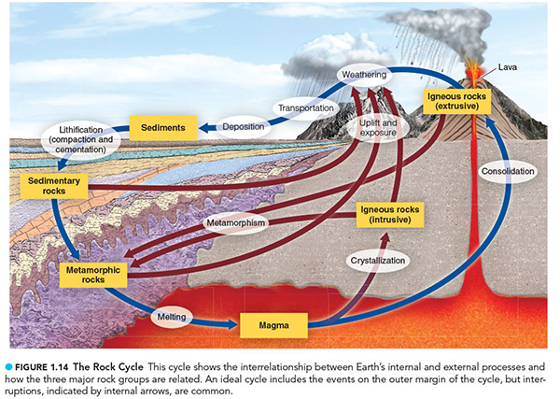

* The central thesis of the theory of organic evolution is that all living organisms evolved (descended with modifications) from organisms that existed in the past.
* Time sets geology apart from the other sciences except astronomy, and an appreciation of the enormity of geologic time is central to understanding Earth’s evolution. The geologic time scale is the calendar geologists use to date past events.
* The principle of uniformitarianism is basic to the interpretation of Earth history. The principle holds that the laws of nature have been constant through time and the same processes operating today have operated in the past, although at different rates.
* Geology is an integral part of everyone’s lives. Everyone’s standard of living depends directly on their consumption of geologic materials that formed millions and billions of years ago.

Lecture Suggestions

1. Almost every day, there are stories in the newspapers and on radio and television that are relevant to geology—about volcanic eruptions, earthquakes, floods, landslides, subsidence or collapse of old mines, water quality, pollution, waste (especially toxic) disposal, and so on. Start a file of these clips and introduce them at the appropriate places in the course. In addition, or alternatively, suggest that students bring articles or summaries of information from newscasts.
2. Ask the students if they can explain how flipping a light switch makes light. We depend on science, yet the average person doesn't really understand how simple, long-existing technologies work. Discuss how many other things are common in everyday life but may be considered “magic.”
3. Point out ways in which people employ the scientific method for coming to conclusions in their daily lives. Extract from these examples the elements and sequences of thought embodied by the scientific method. What are facts? What is an explanation? Contrast conclusions based on the scientific method with those based on the supernatural. Where does faith come in? Is faith important in science? If so, where?
4. Point out that everyone uses the scientific method to develop broad conclusions in their daily life, sort of a “scientific theory of (individual) human experience.” Have the students give examples, such as the knowledge that it’s unsafe to walk through moving traffic.
5. Demonstrate with an everyday example how the scientific method can be used to construct hypotheses about events that have not been directly observed. An example may be a road-kill that was not witnessed, but its result was later observed. Stress that the lack of opportunity to observe historical events in geology is more of an apparent obstacle than a real problem. There are many ways that scientists can use scientific data to infer past events, using radiometric dating to determine the age of a material, for example. Although particular historical events have only happened once, the class of events to which each belongs (e.g., mountain building) is represented by thousands of individual events, each of which can serve as either data or a test of a hypothesis or theory.
6. Clearly contrast the popular use of the term “theory” (meaning speculation, guess, or conjecture) with the legitimate scientific use of the term. Come up with some fun examples of how the word is misused in everyday language. For example, “My theory on why she dumped him is that he doesn’t drive a nice car.” Correctly speaking, that would be a hypothesis!
7. Teach students what a planet is by discussing why Pluto is no longer considered a planet. Encourage a class discussion on whether Pluto should regain its planetary status or remain a lesser “dwarf planet.”
8. As Thomas Kuhn has proposed, plate tectonic theory represents, perhaps, the clearest example of how a reigning theory is questioned and is eventually discarded for another. In particular, emphasize the largely descriptive nature of geology and its hypotheses prior to plate tectonic theory as an analogy to the initial and latter stages of the scientific method. A discussion of plate tectonic theory can aid in illustrating the nature of the scientific method, the development of scientific theories, and the day-to-day business of doing science, as well as the elements and history of the theory itself. However, one should postpone this discussion until Chapter 2: Plate Tectonics: A Unifying Theory.
9. Highlight the contrast in physical properties between the lithosphere and the asthenosphere and how these determine the behavior of plates.
10. The rock cycle is really the rock recycle: Any rock can become any other type of rock. The rock cycle is a description of the processes by which rocks and materials (such as magma or sediments) are endlessly transformed from one state to another.
11. When covering the principle of uniformitarianism, ask a number of students to each give one example of this principle drawn from their daily experience.
12. Illustrate the importance of natural resources to societies with an example of a war that was fought over natural resources or a society that failed due to a shortage of natural resources. Examples may include the Persian Gulf War, African wars fought for diamonds, and the failure of society on Easter Island due to the loss of resources.

Enrichment Topics

**Topic 1. Climate Change.** One of the major issues facing humanity is climate change. While the climate has changed in Earth’s past and has been warmer than ever predicted, it is human systems that depend on climate being more or less constant and predictable. Some of the systems we depend on that can change include:

* Major agricultural areas can become too dry and hot for growing food. Moving agriculture closer to higher latitudes has political and environmental ramifications. For example, what if the American bread basket moves into Canada? What does that mean for the U.S.? Also, good soils must build up over decades and centuries. Just because the climate becomes favorable for agriculture in a more northern location does not mean that the soils will also be good. Also, many of the world’s people rely on subsistence agriculture in which they grow enough food to meet their family’s needs and not much more. Worsening environmental conditions will affect the ability of many of these people to survive.
* Many people live in coastal areas and much of society’s infrastructure is concentrated near coastlines. Sea level rise will cost millions of people their homes. In low-lying Florida, a one-foot rise in sea level, which could happen by the end of the century, will result in the loss of 100 feet of beaches. Communities are already having trouble protecting their homes and businesses, and the situation will just get worse.
* Ecosystems are adapted to the climatic conditions in which they evolved. Humans have restricted many of those ecosystems to certain areas, such as national parks. For example, the remaining redwood trees are found in national and state parks in California. If temperature and precipitation conditions become unfavorable, the redwoods in the park would die off, but there is little undeveloped land for new forests to grow. Also, rising sea level will drown many coastal ecosystems, such as mangrove forests and coral reefs. These are important ecosystems for seafood sources and coastal protection.

**Topic 2. Scale of the Solar System.** Use a football field analogy to convey to students the size of the solar system and the relative proximities of the planets to the Sun.

* Put the Sun on the goal line.
* Mercury is on the 1-foot line.
* Venus is on the 2-foot line.
* Earth is on the 1-yard line.
* Mars is on the 1 ½-yard line.
* Jupiter is on the 5-yard line.
* Saturn is on the 10-yard line.
* Uranus is on the 20-yard line.
* Neptune is on the 30-yard line.
* Pluto is on the 40-yard line.

On the same scale, the nearest star would be 500 miles away.

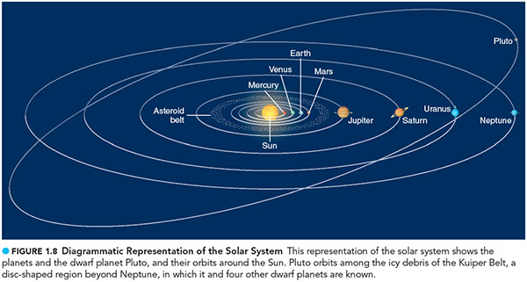

**Topic 3. The Mayan Calendar Predicts the Earth will End in 2012.** People seem to like worrying about the end of Earth, and every few years, there’s another set of “facts” that support the prediction that the end is near. Use the idea of the end of the Earth in 2012, as “predicted” by the Mayan people, as the basis of a discussion on how science is done and how the public can be manipulated into believing in all sorts of pseudoscience. This video with the manager of NASA’s Near-Earth Object Office addresses the claims of the prediction: [2012 -- A Scientific Reality Check](http://www.jpl.nasa.gov/video/index.cfm?id=876)

Common Misconceptions

**Misconception 1**: Geology is less scientific than physics or chemistry.

**Fact:** A science is distinguished by its methodology. Geology uses the scientific method in investigating questions about Earth (and other bodies in the universe, such as the Moon and other planets). Although many geologic studies cannot be conducted under the tightly controlled conditions of a laboratory and must be conducted in the outside world, they are nonetheless approached in a strictly scientific way.

**Misconception 2**: A theory is “just” a theory. It is not highly regarded by all scientists.

**Fact:** A theory is as good as it gets in science. A law is a statement about something that happens all the time, like the law of gravity explains what will happen if one releases a coin held above the ground every time. A theory is an explanation of a complex set of phenomena. It is accepted by virtually all scientists, and there is no major evidence that refutes it. The Theory of Evolution and the Theory of Plate Tectonics are both major frameworks on which most observations (field and experimental) in the biological and earth sciences, respectively, rest. Neither science would make sense in the modern world without those theories.

**Misconception 3**: Science is no different from a belief in the supernatural. A person can choose to “believe” in ghosts or “believe” in global warming.

**Fact:** Science is based on facts and data, and one’s understanding of the supernatural is not. There is no scientific way to validate the supernatural, so it is not the same as a scientific theory or hypothesis. It is necessary to have faith in a few things in science: that the world is as we perceive it and that we are capable of understanding it, for example.

**Misconception 4**: Global warming is just a political issue. Members of certain political parties believe in global warming, and other parties don’t.

**Fact**: Global warming is an ecological, economic, and moral issue. Although interest in reducing greenhouse gas emissions to decrease the projected rise in temperatures appears to wax and wane in the United States and globally, global warming will affect everyone. Many businesses are finding ways to reduce their emissions, develop “green” products, and make profits.

Consider This

1. Why is plate tectonics a theory and not a fact? Which portions of it are theory and what are facts?
2. Why is plate tectonics called the unifying theory of geology? How can the distribution of volcanoes, earthquakes, mountain ranges, and mineral deposits be explained without it?
3. Why can the rock cycle be considered a part of plate tectonics? Does the fact that the rock cycle involves the hydrologic cycle and atmospheric processes separate it from plate tectonics? How are hydrologic and atmospheric processes also a part of plate tectonics?

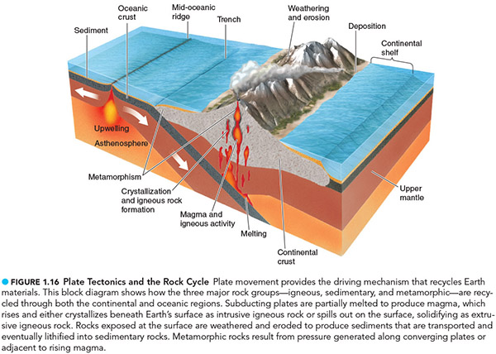

1. Speculate on the implications of plate tectonics with respect to world politics. What does plate tectonics have to do with global politics? How much better or worse might things be if Pangaea had never broken apart?
2. How would understanding earth history be different without the principle of uniformitarianism?
3. Students are very likely to have had little or no exposure to the theory of organic evolution. Explaining the theory carefully and with lots of evidence to back it up is extremely important for the understanding of science by these citizens and future parents, school board members, and book buyers.
4. What properties make Earth habitable, while the other planets in the solar system are not?

Key Terms

|  |  |  |
| --- | --- | --- |
| Asthenosphere | Jovian planets | Principle of uniformitarianism |
| Big Bang | Lithosphere | Rock |
| Core | Magma | Rock cycle |
| Crust | Mantle | Scientific method |
| Fossil | Metamorphic rock | Sedimentary rock |
| Geologic time scale | Mineral | Solar nebula theory |
| Geology | Organic evolution | System |
| Greenhouse effect |  |  |
| Hypothesis | Plate | Terrestrial planets |
| Igneous rock | Plate tectonic theory | Theory |

Internet Sites, Videos, Software, and Demonstration Aids

Internet Sites

1. Geology.com: Geoscience News and Information (<http://geology.com/>).

This website provides information about Geology articles and news, including information about careers in geology, a highly paid profession.

1. The Grand Canyon Suite by Ferde Grofe is a good example of geology-inspired art. You can listen to it here: The Grand Canyon Suite (<http://www.allmusic.com/album/grofé-grand-canyon-suite-gershwin-porgy-bess-symphonic-suite-mw0001819680>).
2. Introduction to the 8 Planets: A Guide to the Solar System (<http://nineplanets.org/>).

This long-standing website presents information on the objects of the solar system, focusing on scientific knowledge, but also on history and mythology.

1. Earth Observatory: Satellite Images of Earth (<http://earthobservatory.nasa.gov/>).

This site is the portal to satellite images of Earth from space and focuses on natural processes and the visible changes due to those processes or human influences.

1. Smithsonian National Museum of Natural History: Introduction to Geology. (<http://naturalhistory.si.edu/>).

This website presents Introductory Geology in a multimedia format.

1. Real Climate: Site on Climatology (<http://www.realclimate.org/>).

This website provides real news about climate science by real climate scientists.

1. Intergovernmental Panel on Climate Change: Assessment of Science Related to Climate Change (<https://www.ipcc.ch/>).

This website presents information about The Intergovernmental Panel on Climate Change (IPCC). Every few years, the IPCC issues a report authored by many scientists who study climate change. This report is highly regarded by scientists, politicians, and journalists.

1. Pew Center on Climate Change: Climate Change News and Information (<http://www.c2es.org/>).

This website provides information about climate change news and politics at the state, federal, and international levels.

Videos

1. *Earth: The Biography.* BBC, DVD (2008, 230 min.)

The video shows some of the Earth’s most remarkable features with the help of satellite images and computer graphics.

1. *Visions of Earth.* Delmar/Cengage Learning, DVD (2010, 152 min.)

An introduction to Earth science from the American Geological Institute.

1. *The Nature of Earth: An Introduction to Geology.* Arlington, VA: Teaching Co., DVD (2006, 18 hours)

This video shows John J. Renton introducing the principles of geology.

1. *Planet Earth*—The Complete BBC Series. Discovery, DVD (2007, 550 min.)

The video presents an 11-part series of different environments and the living creatures that inhabit them, narrated by David Attenborough.

1. *The Geology of the United States.* Lakewood, Colo, DVD (2005, 30 min.)

The video provides information regarding the principle landforms and physiographic provinces of the United States.

1. *The Universe*, Collectors Set. History Channel, DVD (2008, 33 hours, 41 min.)

This video shows the use of computer graphics and animation, NASA images, and scientific information that blend together in the exploration of the universe.

1. *Geography Resources: Introducing Mapping Concepts.* Insight Media, DVD (2004, 26 min.)

This video explores the principles of maps and mapping, including the use of the Global Positioning System.

1. *Geologic Maps: Portraits of the Earth.* Lakewood, Colo, DVD (2007, 20 min.)

This video introduces what geologic maps depict.

1. *Journey to the Edge of the Universe.* National Geographic, DVD (2009, 90 min.)

This video presents a travel through the universe in a single unbroken image by the Hubble Space Telescope.

1. *The Planets.* A & E Home Video, DVD (1999, 400 min.)

This video presents a guided journey through the solar system using NASA footage.

1. *An Inconvenient Truth.* Paramount Home Entertainment (Australasia), DVD (2006, 86 min.)

This video shows Vice President Al Gore’s Academy-Award winning 2006 documentary on global warming and its potential effects on our planet.

1. *Warnings from the Ice.* WGBH Boston Video, DVD (2008, 54 min.)

This video provides information about Antarctic ice sheets that yield evidence of how the planet is warming.

1. *Global Warming: The Rising Storm.* Ambrose Video Pub., DVD (2007, 114 min.)

The video shows the effects of global warming on the planet that can already be seen.

1. *Wonders of the Solar System*, BBC, DVD (2010, 50 minutes)

The video covers some of the most amazing features of our solar system using the latest scientific knowledge and images.

1. *Global Warming: Science and Solutions.* Ambrose Video Pub., DVD (2006, 116 min.)

This video examines the possible solutions to the planet’s rising temperatures.

1. *Miracle Planet.* National Film Board of Canada, DVD (2005, 250 min.)

This video shows Earth’s amazing evolution over more than 4 billion years.