Online Test Bank
to accompany

Total Learning:
Developmental Curriculum for the Young Child
Eighth Edition

Joanne Hendrick
University of Oklahoma, Emerita

Patricia Weissman

Prepared by
Patricia Weissman


Boston Columbus Indianapolis New York San Francisco Upper Saddle River
Amsterdam Cape Town Dubai London Madrid Milan Munich Paris Montreal Toronto
Delhi Mexico City Sao Paulo Sydney Hong Kong Seoul Singapore Taipei Tokyo

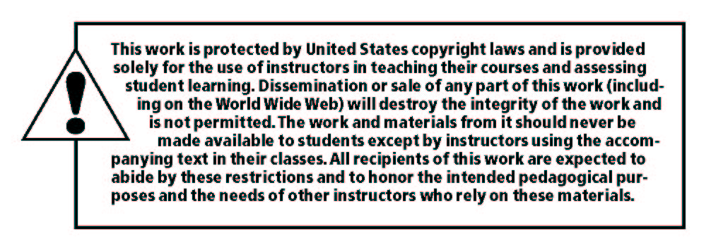

______________________________________________________________________________

Copyright © 2011, 2007 by Pearson Education, Inc., Upper Saddle River, New Jersey 07458.
All rights reserved. Printed in the United States of America. This publication is protected by Copyright and permission should be obtained from the publisher prior to any prohibited reproduction, storage in a retrieval system, or transmission in any form or by any means, electronic, mechanical, photocopying, recording, or likewise. For information regarding permission(s), write to: Rights and Permissions Department.

Pearson® is a registered trademark of Pearson plc

Instructors of classes using Hendrick/Weissman’s Total Learning: Developmental Curriculum for the Young Child, Eighth Edition, may reproduce material from the test bank for classroom use.

10 9 8 7 6 5 4 3 2 1 ISBN-10: 0137034121
ISBN-13: 9780137034123
www.pearsonhighered.com

Table of Contents

Chapter 1: The Purpose of Curriculum

Chapter 2: Including Families in the Life of the School

Chapter 3: Play: The Integrative Force in Learning

Chapter 4: Designing the Supportive Environment

Chapter 5: Creating Supportive Curriculum Plans and Schedules
Chapter 6: Getting to Know the Children by Keeping Track of What They’re
Learning

Chapter 7: Planning with Individual Children in Mind: Using Behavioral
Objectives in the School

Chapter 8: Keeping Children Safe and Well Fed

Chapter 9: Developing Physical Competence

Chapter 10: Achieving Emotional Competence

Chapter 11: Getting Along Together: Achieving Competence in
Interpersonal Relations

Chapter 12: Who Am I? Who Are You?: Coming to Terms with Multicultural,
Gender, and Disability Issues

Chapter 13: Freeing Children to Be Creative
Chapter 14: Developing Verbal Competence

Chapter 15: Taking the First Steps on the Road to Literacy
Chapter 16: Helping Children Learn to Think for Themselves: Using the Emergent Approach
Chapter 17: Helping Children Develop Mental Abilities and Academic
Competence: Using the Conventional Approach

Answer Key for Test Questions
CHAPTER 1
THE PURPOSE OF CURRICULUM

TEST QUESTIONS

Essay

1. List the five selves identified in the text and beside each one give an example of an important area of learning that applies to that self and suggest a way to incorporate that area into a curriculum plan for 5-year-olds. Then prepare a contrasting curriculum plan for 2-year-olds. For example, an important learning area related to the physical self might be good nutrition. How might learning about what constitutes good nutrition be incorporated at each age level?

2. Describe two episodes in which you observed young children striving to achieve competence in a new skill. Be sure to explain which self that particular competency belonged to most closely and describe how the child went about increasing his or her skill in that area.

3. Discuss both the advantages and disadvantages of relying on the behaviorist learning model as it might be applied to educating young children. Give examples in which the application of such a model might be inappropriate to the subject matter of the curriculum.

4. Taking into account the factors discussed in Chapter 1, discuss your own personal requirements you feel an early childhood program should meet before you could accept a position on its staff.

5. List three findings from recent brain research and how you would use this information in planning your early childhood curriculum.

Situational questions

In the blank beside each item, write the letter that indicates the one best answer.

1. Two preschool teachers are talking together about how they plan curriculum. Teacher A says she always plans curriculum around social studies, science and art. Teacher B says he always plans his curriculum around processes, such as play, group time and various expressive activities. According to the text, Teacher A probably plans to structure her curriculum according to subject matter because:
a. that is the way curriculum was presented to her when she went to school.
b. planning this way takes the social and emotional development of the child into consideration.
c. planning this way helps children get ready for later experiences in elementary school.
d. organizing curriculum by subjects makes certain all five selves of the child will be educated.

2. You have been asked to visit a school and observe a particular teacher. While there you observe her lesson plans for the day and see that the activities are grouped under the headings social, emotional, physical, creative and cognitive. When talking with her during lunch, she says that she believes children should be encouraged to figure things out for themselves as they interact with the environment. Based on this information, you decide that the teacher follows:
a. a nature/nurture philosophy.
b. a behaviorist philosophy.
c. an environmentalist philosophy.
d. a constructivist, developmental philosophy.

Multiple choice

In the blank beside each item, write the letter that indicates the one best answer.

1. The teacher who wishes to have the children learn by means of actual experience will:
a. read them a book about firefighters.
b. during story hour have a child tell the others about his visit to the fire station.
c. take the children to the firehouse, and let them sit on the fire truck.
d. show them a series of photographs of firefighters putting out a fire.

2. According to the author, the fundamental purpose of early childhood education should be to:
a. prepare children for continuing later success in elementary school.
b. foster growth of developmental sequences.
c. teach young children fundamental academic skills, such as the names of colors, shapes and their ABC's.
d. foster competence in dealing with life.

3. Which of the following is true regarding the incorporation of standards-based education into developmentally-appropriate practice?
a. It is impossible considering they stem from opposing philosophies.
b. It is possible and desirable.
c. It is very difficult because there is no professional guidance for incorporating standards into DAP.
d. It is possible, but early childhood teachers should avoid attempting to incorporate standards into DAP.

4. According to brain researchers, it is important to provide children with experiences that involve all the senses because:
a. the brain is more likely to receive and process the information.
b. the children will be more interested.
c. the young child’s brain cannot process information from senses separately.
d. the brain must develop each sense.

5. Piagetian learning theory maintains that:
a. interaction between the child and the environment is an important aspect of learning.
b. direct exploration is a vital element in early education.
c. children pass through a series of cognitive stages as they mature.
d. children actually think differently than adults do.
e. all the above statements are true.
f. only a and c are true.

6. Emergent curriculum primarily emphasizes:
a. teachers and children collaborating together to pursue.a common interest.
b. all five selves in every learning activity.
c. helping children learn important facts that will emerge in elementary school.
d. the use of self-expressive materials as sensory modifiers during the process of using them.

7. The behaviorist learning approach is characterized by:
a. using rewards to encourage desirable behavior.
b. offering an open classroom where children are responsible for choosing what to work on.
c. strongly emphasizing stage-related behaviors.
d. building on what the child already knows.

8. One of the limitations of using the behaviorist learning approach is that:
a. it is only used by people who have had very thorough training in its principles.
b. there is no research to support that theory.
c. it has been generally found to be an ineffective way of handling children.
d. we do not know how long reinforced behavior is likely to continue once the reward is removed.

9. According to the philosophy expressed in Total Learning, to foster competence in the classroom there must first be:
a. learning standards.
b. a climate of caring.
c. classroom rules.
d. a parent volunteer each day.

10. The reason teachers need to know what constitutes typical ages and growth sequences is because:
- typical children should reach identical stages of development at identical times.
- knowing what is typical for a developmental level helps teachers identify behavior that is definitely atypical.
- teachers should not try to teach children their ABC's because kindergarten teachers are supposed to do that.
- research reveals that children from a variety of cultures all develop at the same rate in just about every area.
- b and c are both correct.

11. DAP is the abbreviation for:
a. Developmentally Appropriate Practice.
b. Developmentally Approved Practice.
- Developmentally and Culturally Approved Practice.
- Developmentally Applied Practice.

12. Research on brain development offers many findings that:
- emphasize the importance of early learning and education.
- show that the brains of preschool children are much more active than the brains of adults are.
- experience is important because it builds and strengthens connections between neurons.
- different areas of the brain develop at different times and different rates.
- all of the above statements are true.

True/False

Indicate the correct answer by writing T (true) or F (false) at the left of the following statement.

1. Teachers who use the emergent approach take their cues from the interests of the children and therefore do not plan the curriculum in advance, because this would produce a teacher-dominated environment rather than a child-centered environment.

2. All teachers use the principles of positive reinforcement when they reprimand children.

3. Although federally-mandated testing does not begin until third grade, standards-based education is gaining momentum in early childhood programs.

4. It is particularly important for teachers to know what constitutes developmentally appropriate curriculum because the profession is experiencing increased pressure at the present time to push formal academic learning on young children before they are ready for it.

5. Although it is true that when children are very young parents exert the most influence on their development, once children begin attending school consistently the influence of the teacher becomes the most important influence.

6. The research project called The Perry Preschool Project found there were numerous long-lasting benefits for children who had attended that preschool.

7. There are very few research studies available that demonstrate that preschool education offers lasting benefits for children who attend quality programs.

8. Neurons link together in chains because each neuron can only connect to one other neuron.

9. Critical periods refer to the times of day when teachers should sit down and assess what the interests of the children are so they can adjust the curriculum plan accordingly.

10. It’s best not to talk to the children while they are involved in a real experience because adding language at that time distracts and confuses them.

11. Emotional responses in the body affect how well the brain remembers information.

ANSWER KEY FOR TEST QUESTIONS

CHAPTER 1
THE PURPOSE OF CURRICULUM

Situational questions
(1) a, (2) d

Multiple choice
(1) c, (2) d, (3) b, (4) a, (5) e, (6) a, (7) a, (8) d, (9) b, (10) b, (11) a, (12) e

True/False
(1) F, (2) F, (3) T, (4) T, (5) F, (6) T, (7) F, (8) F, (9) F, (10) F, (11) T

