Basic Technical Mathematics with Calculus, 11 Cdn. Ed. (Washington)
Chapter 1 Basic Algebraic Operations

1.1 Numbers

1.1.1 Identify Integer/Rational/Irrational/Real/Imaginary Numbers

Identify the specified numbers.

1) The integers in the following list:
25, 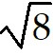, -22, 0, 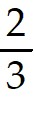, - 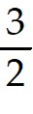, 1.7, 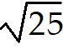
A) 25, -22, 0,
B) 25, 0
C) 25, -22, 0
D) 25, 0,
Answer: A
Diff: 1 Type: BI Var: 50+ Page Ref: 2
Topic: 1.1 Numbers
Skill: Recall
Objective: (1.1) Identify Integer/Rational/Irrational/Real/Imaginary Numbers

2) The rational numbers in the following list:
11, 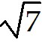, -24, 0, 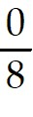, 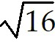, 0.68
A) 11, -24, 0, , , 0.68
B) 11, -24, 0, ,
C) 11, -24, 0,
D)
Answer: A
Diff: 1 Type: BI Var: 50+ Page Ref: 2
Topic: 1.1 Numbers
Skill: Recall
Objective: (1.1) Identify Integer/Rational/Irrational/Real/Imaginary Numbers

3) The irrational numbers in the following list:
9, 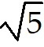, -7, 0, , , 0.35
A)
B) , 0.35
C) ,
D) , , 0.35
Answer: A
Diff: 1 Type: BI Var: 50+ Page Ref: 2
Topic: 1.1 Numbers
Skill: Recall
Objective: (1.1) Identify Integer/Rational/Irrational/Real/Imaginary Numbers

4) The real numbers in the following list:
5, , -16, 0, 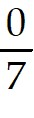,
A) 5, , -16, 0, ,
B) 5, -16, 0,
C) 5, -16, 0, ,
D) 5, -16, 0,
Answer: A
Diff: 1 Type: BI Var: 50+ Page Ref: 2
Topic: 1.1 Numbers
Skill: Recall
Objective: (1.1) Identify Integer/Rational/Irrational/Real/Imaginary Numbers

5) The real numbers in the following list:
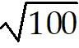, 9, 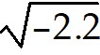, 2.2, 1.11, 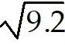, 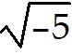, 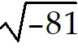
A) , 9, 2.2, 1.11,
B) , 9, , 2.2, 1.11, , ,
C) , 9, 2.2, 1.11
D) 9, 2.2, 1.11
Answer: A
Diff: 1 Type: BI Var: 50+ Page Ref: 2
Topic: 1.1 Numbers
Skill: Recall
Objective: (1.1) Identify Integer/Rational/Irrational/Real/Imaginary Numbers

6) The imaginary numbers in the following list:
, -6, 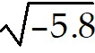, -5.8, -0.83, 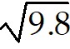, 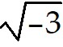, 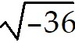
A) , ,
B) , -6, , -5.8, -0.83, , ,
C) , , , ,
D) , ,
Answer: A
Diff: 1 Type: BI Var: 50+ Page Ref: 2
Topic: 1.1 Numbers
Skill: Recall
Objective: (1.1) Identify Integer/Rational/Irrational/Real/Imaginary Numbers

1.1.2 Find Absolute Value

Find the absolute value.

1) 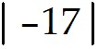
A) 17
B) -17
C) ± 17
D) 0
Answer: A
Diff: 1 Type: BI Var: 24 Page Ref: 3-4
Topic: 1.1 Numbers
Skill: Recall
Objective: (1.1) Find Absolute Value

2) 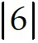
A) 6
B) -6
C) ± 6
D) 0
Answer: A
Diff: 1 Type: BI Var: 1 Page Ref: 3-4
Topic: 1.1 Numbers
Skill: Recall
Objective: (1.1) Find Absolute Value

3) 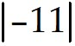
A) 11
B) -11
C) ± 11
D) 0
Answer: A
Diff: 1 Type: BI Var: 1 Page Ref: 3-4
Topic: 1.1 Numbers
Skill: Recall
Objective: (1.1) Find Absolute Value

4) 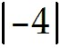
A) 4
B) -4
C) ± 4
D) 0
Answer: A
Diff: 1 Type: BI Var: 1 Page Ref: 3-4
Topic: 1.1 Numbers
Skill: Recall
Objective: (1.1) Find Absolute Value

5) 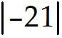
A) 21
B) -21
C) ± 21
D) 0
Answer: A
Diff: 1 Type: BI Var: 1 Page Ref: 3-4
Topic: 1.1 Numbers
Skill: Recall
Objective: (1.1) Find Absolute Value

6) 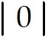
A) 0
B) 1
C) -1
D) Not defined
Answer: A
Diff: 1 Type: BI Var: 1 Page Ref: 3-4
Topic: 1.1 Numbers
Skill: Recall
Objective: (1.1) Find Absolute Value

7) 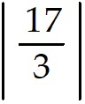
A) 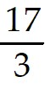
B) 0
C) -
D) ±
Answer: A
Diff: 1 Type: BI Var: 28 Page Ref: 3-4
Topic: 1.1 Numbers
Skill: Recall
Objective: (1.1) Find Absolute Value

8) 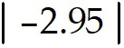
A) 2.95
B) -2.95
C) ± 2.95
D) 0
Answer: A
Diff: 1 Type: BI Var: 10 Page Ref: 3-4
Topic: 1.1 Numbers
Skill: Recall
Objective: (1.1) Find Absolute Value

9) 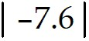
A) 7.6
B) -7.6
C) ± 7.6
D) 0
Answer: A
Diff: 1 Type: BI Var: 50+ Page Ref: 3-4
Topic: 1.1 Numbers
Skill: Recall
Objective: (1.1) Find Absolute Value

10) 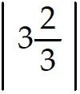
A) 3
B) - 3
C) ± 3
D) 0
Answer: A
Diff: 1 Type: BI Var: 36 Page Ref: 3-4
Topic: 1.1 Numbers
Skill: Recall
Objective: (1.1) Find Absolute Value

1.1.3 Insert Inequality Sign Between Numbers

Insert the correct sign of inequality (> or <) between the given numbers.

1) 1 5
A) 1 < 5
B) 1 > 5
Answer: A
Diff: 1 Type: BI Var: 50+ Page Ref: 4
Topic: 1.1 Numbers
Skill: Recall
Objective: (1.1) Insert Inequality Sign Between Numbers

2) -1.2 -8.4
A) -1.2 > -8.4
B) -1.2 < -8.4
Answer: A
Diff: 1 Type: BI Var: 50+ Page Ref: 4
Topic: 1.1 Numbers
Skill: Recall
Objective: (1.1) Insert Inequality Sign Between Numbers

3) 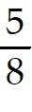 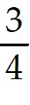
A) <
B) >
Answer: A
Diff: 1 Type: BI Var: 50+ Page Ref: 4
Topic: 1.1 Numbers
Skill: Recall
Objective: (1.1) Insert Inequality Sign Between Numbers

4) -55 66
A) -55 < 66
B) -55 > 66
Answer: A
Diff: 1 Type: BI Var: 50+ Page Ref: 4
Topic: 1.1 Numbers
Skill: Recall
Objective: (1.1) Insert Inequality Sign Between Numbers

5) -12 -82
A) -12 > -82
B) -12 < -82
Answer: A
Diff: 1 Type: BI Var: 50+ Page Ref: 4
Topic: 1.1 Numbers
Skill: Recall
Objective: (1.1) Insert Inequality Sign Between Numbers

6) π -1
A) π > -1
B) π < -1
Answer: A
Diff: 1 Type: BI Var: 8 Page Ref: 4
Topic: 1.1 Numbers
Skill: Recall
Objective: (1.1) Insert Inequality Sign Between Numbers

7) 2.84
A) < 2.84
B) > 2.84
Answer: A
Diff: 1 Type: BI Var: 7 Page Ref: 4
Topic: 1.1 Numbers
Skill: Recall
Objective: (1.1) Insert Inequality Sign Between Numbers

8) -34 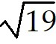
A) -34 <
B) -34 >
Answer: A
Diff: 1 Type: BI Var: 50+ Page Ref: 4
Topic: 1.1 Numbers
Skill: Recall
Objective: (1.1) Insert Inequality Sign Between Numbers

9) -1 - 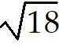
A) -1 > -
B) -1 < -
Answer: A
Diff: 1 Type: BI Var: 50+ Page Ref: 4-5
Topic: 1.1 Numbers
Skill: Recall
Objective: (1.1) Insert Inequality Sign Between Numbers

1.1.4 Find Reciprocal of Rational Number

Find the reciprocal of the number.

1) 7
A) 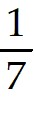
B) -7
C) 1
D) -
Answer: A
Diff: 1 Type: BI Var: 40 Page Ref: 4-5
Topic: 1.1 Numbers
Skill: Recall
Objective: (1.1) Find Reciprocal of Rational Number

2) -6
A) - 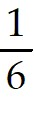
B) 6
C) 0
D)
Answer: A
Diff: 1 Type: BI Var: 8 Page Ref: 4-5
Topic: 1.1 Numbers
Skill: Recall
Objective: (1.1) Find Reciprocal of Rational Number

3)
A)
B) -
C) 1
D) -
Answer: A
Diff: 1 Type: BI Var: 38 Page Ref: 4-5
Topic: 1.1 Numbers
Skill: Recall
Objective: (1.1) Find Reciprocal of Rational Number

4) - 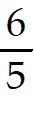
A) - 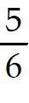
B)
C) 1
D)
Answer: A
Diff: 1 Type: BI Var: 38 Page Ref: 4-5
Topic: 1.1 Numbers
Skill: Recall
Objective: (1.1) Find Reciprocal of Rational Number

5) 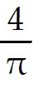
A) 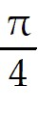
B) π
C) -
D) 4π
Answer: A
Diff: 1 Type: BI Var: 8 Page Ref: 4-5
Topic: 1.1 Numbers
Skill: Recall
Objective: (1.1) Find Reciprocal of Rational Number

6)
A)
B) -
C) -
D) et
Answer: A
Diff: 1 Type: BI Var: 50+ Page Ref: 4-5
Topic: 1.1 Numbers
Skill: Recall
Objective: (1.1) Find Reciprocal of Rational Number

1.1.5 Locate Number on Number Line

Locate each number on a number line.

1) 1, 3, 5, 7
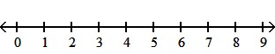
A)
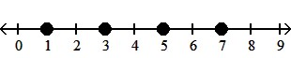
B)
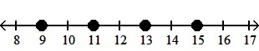
C)
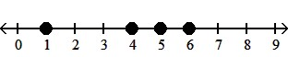
D)
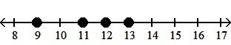
Answer: A
Diff: 1 Type: BI Var: 7 Page Ref: 3-4
Topic: 1.1 Numbers
Skill: Recall
Objective: (1.1) Locate Number on Number Line

2) -1, 1, 3, 5
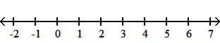
A)
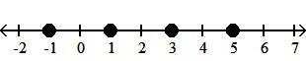
B)
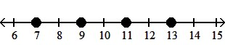
C)
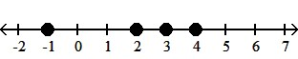
D)
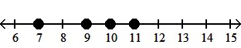
Answer: A
Diff: 1 Type: BI Var: 7 Page Ref: 3-4
Topic: 1.1 Numbers
Skill: Recall
Objective: (1.1) Locate Number on Number Line

3) -1.75, 0.25, 3.75, -2.5
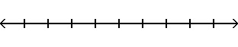
A)
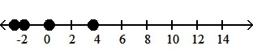
B)
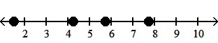
C)
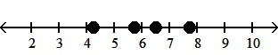
D)
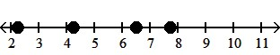
Answer: A
Diff: 1 Type: BI Var: 50+ Page Ref: 3-4
Topic: 1.1 Numbers
Skill: Recall
Objective: (1.1) Locate Number on Number Line

4) , 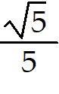, 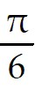, 2.4
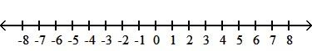
A)
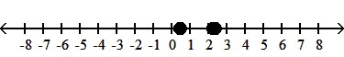
B)
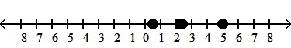
C)
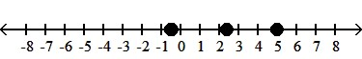
D)
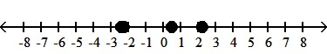
Answer: A
Diff: 1 Type: BI Var: 50+ Page Ref: 3-4
Topic: 1.11 Formulas and Literal Equations
Skill: Recall
Objective: (1.1) Locate Number on Number Line

5) -5, 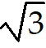, -1, -6
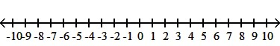
A)
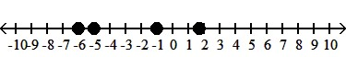
B)
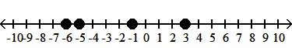
C)
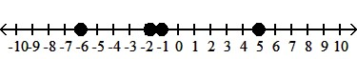
D)
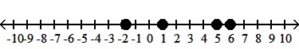
Answer: A
Diff: 1 Type: BI Var: 50+ Page Ref: 3-4
Topic: 1.1 Numbers
Skill: Recall
Objective: (1.1) Locate Number on Number Line

6) - 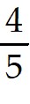, -4, 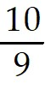, 7
A)
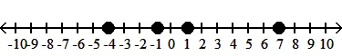
B)
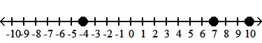
C)
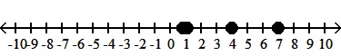
D)
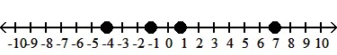
Answer: A
Diff: 1 Type: BI Var: 50+ Page Ref: 3-4
Topic: 1.1 Numbers
Skill: Recall
Objective: (1.1) Locate Number on Number Line

1.1.6 List Numbers in Numerical Order

Write the numbers in numerical order, smallest to largest.

1) 7, -13, 25, -17, 2
A) -17, -13, 2, 7, 25
B) 2, 7, 13, 17, 25
C) -13, -17, 2, 7, 25
D) 25, 7, 2, -13, -17
Answer: A
Diff: 1 Type: BI Var: 50+ Page Ref: 3
Topic: 1.1 Numbers
Skill: Recall
Objective: (1.1) List Numbers in Numerical Order

2) | -8|, -| 11|, -| 3|
A) -| 11|, -| 3|, | -8|
B) -| -3|, -| 11|, | -8|
C) -| 3|, | -8|, -| 11|
D) | -8|, -| 3|, -| 11|
Answer: A
Diff: 1 Type: BI Var: 50+ Page Ref: 3
Topic: 1.1 Numbers
Skill: Recall
Objective: (1.1) List Numbers in Numerical Order

3) , -9, 5, - 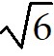, 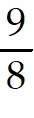
A) -9, - , , , 5
B) - , -9, , , 5
C) , , -9, - , 5
D) 5, , , - , 9
Answer: A
Diff: 1 Type: BI Var: 50+ Page Ref: 3
Topic: 1.1 Numbers
Skill: Recall
Objective: (1.1) List Numbers in Numerical Order

4) , - , - 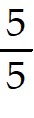, 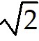, -2
A) -2, - , - , ,
B) - , - , -2, ,
C) , -2, , - , -
D) - , - , -2, ,
Answer: A
Diff: 1 Type: BI Var: 36 Page Ref: 3
Topic: 1.1 Numbers
Skill: Recall
Objective: (1.1) List Numbers in Numerical Order

1.1.7 *Know Concepts: Numbers

Answer the question.

1) True or False.
Every whole number is a real number.
Answer: TRUE
Diff: 1 Type: TF Var: 1 Page Ref: 2
Topic: 1.1 Numbers
Skill: Recall
Objective: (1.1) *Know Concepts: Numbers

2) True or False.
Some rational numbers are irrational.
Answer: FALSE
Diff: 1 Type: TF Var: 1 Page Ref: 2
Topic: 1.1 Numbers
Skill: Recall
Objective: (1.1) *Know Concepts: Numbers

3) True or False.
Some rational numbers are integers.
Answer: TRUE
Diff: 2 Type: TF Var: 1 Page Ref: 2
Topic: 1.1 Numbers
Skill: Recall
Objective: (1.1) *Know Concepts: Numbers

4) True or False.
Every integer is an irrational number.
Answer: FALSE
Diff: 1 Type: TF Var: 1 Page Ref: 2
Topic: 1.1 Numbers
Skill: Recall
Objective: (1.1) *Know Concepts: Numbers

5) True or False.
Some real numbers are integers.
Answer: TRUE
Diff: 1 Type: TF Var: 1 Page Ref: 2
Topic: 1.1 Numbers
Skill: Recall
Objective: (1.1) *Know Concepts: Numbers

6) True or False.
The absolute value of any number is positive.
Answer: FALSE
Diff: 2 Type: TF Var: 1 Page Ref: 2
Topic: 1.1 Numbers
Skill: Recall
Objective: (1.1) *Know Concepts: Numbers

7) True or False.
The absolute value of any nonzero number is an irrational number.
Answer: FALSE
Diff: 1 Type: TF Var: 1 Page Ref: 2
Topic: 1.1 Numbers
Skill: Recall
Objective: (1.1) *Know Concepts: Numbers

8) True or False.
- 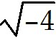 is an imaginary number.
Answer: TRUE
Diff: 1 Type: TF Var: 9 Page Ref: 2
Topic: 1.1 Numbers
Skill: Recall
Objective: (1.1) *Know Concepts: Numbers

9) True or False.
If number a is to the left of number b on a number line, then a > b.
Answer: FALSE
Diff: 1 Type: TF Var: 1 Page Ref: 2
Topic: 1.1 Numbers
Skill: Recall
Objective: (1.1) *Know Concepts: Numbers

10) True or False.
A fraction cannot contain an imaginary number in the denominator.
Answer: FALSE
Diff: 1 Type: TF Var: 1 Page Ref: 2
Topic: 1.1 Numbers
Skill: Recall
Objective: (1.1) *Know Concepts: Numbers

1.2 Fundamental Operations of Algebra

1.2.1 Evaluate Addition, Subtraction Expression

Perform the indicated operation.

1) 9 + ( -6)
A) 3
B) 15
C) -3
D) -15
Answer: A
Diff: 1 Type: BI Var: 50+ Page Ref: 8
Topic: 1.2 Fundamental Operations of Algebra
Skill: Recall
Objective: (1.2) Evaluate Addition, Subtraction Expression

2) -4 + 18
A) 14
B) 22
C) -14
D) -22
Answer: A
Diff: 1 Type: BI Var: 50+ Page Ref: 8
Topic: 1.2 Fundamental Operations of Algebra
Skill: Recall
Objective: (1.2) Evaluate Addition, Subtraction Expression

3) -23 + ( -4)
A) -27
B) -19
C) 19
D) 27
Answer: A
Diff: 1 Type: BI Var: 50+ Page Ref: 8
Topic: 1.2 Fundamental Operations of Algebra
Skill: Recall
Objective: (1.2) Evaluate Addition, Subtraction Expression

4) 2 - 6
A) -4
B) 8
C) 4
D) -8
Answer: A
Diff: 1 Type: BI Var: 50+ Page Ref: 8
Topic: 1.2 Fundamental Operations of Algebra
Skill: Recall
Objective: (1.2) Evaluate Addition, Subtraction Expression

5) -8 - 15
A) -23
B) 23
C) 7
D) -7
Answer: A
Diff: 1 Type: BI Var: 50+ Page Ref: 8
Topic: 1.2 Fundamental Operations of Algebra
Skill: Recall
Objective: (1.2) Evaluate Addition, Subtraction Expression

6) -14 - ( -5)
A) -9
B) 19
C) 9
D) -19
Answer: A
Diff: 1 Type: BI Var: 50+ Page Ref: 8
Topic: 1.2 Fundamental Operations of Algebra
Skill: Recall
Objective: (1.2) Evaluate Addition, Subtraction Expression

7) 10 - ( -3)
A) 13
B) -7
C) 7
D) -13
Answer: A
Diff: 1 Type: BI Var: 50+ Page Ref: 8
Topic: 1.2 Fundamental Operations of Algebra
Skill: Recall
Objective: (1.2) Evaluate Addition, Subtraction Expression

1.2.2 Evaluate Multiplication Expression

Find the product.

1) ( 14)( 33)
A) 462
B) 4620
C) 448
D) 362
Answer: A
Diff: 1 Type: BI Var: 50+ Page Ref: 9
Topic: 1.2 Fundamental Operations of Algebra
Skill: Recall
Objective: (1.2) Evaluate Multiplication Expression

2) ( 39)( -15)
A) -585
B) 585
C) -624
D) -685
Answer: A
Diff: 1 Type: BI Var: 50+ Page Ref: 9
Topic: 1.2 Fundamental Operations of Algebra
Skill: Recall
Objective: (1.2) Evaluate Multiplication Expression

3) ( -31)( 42)
A) -1302
B) -13,020
C) -1344
D) -1402
Answer: A
Diff: 1 Type: BI Var: 50+ Page Ref: 9
Topic: 1.2 Fundamental Operations of Algebra
Skill: Recall
Objective: (1.2) Evaluate Multiplication Expression

4) ( -10)( -13)
A) 130
B) 1300
C) 140
D) 30
Answer: A
Diff: 1 Type: BI Var: 50+ Page Ref: 9
Topic: 1.2 Fundamental Operations of Algebra
Skill: Recall
Objective: (1.2) Evaluate Multiplication Expression

5) ( 2)( -1)( -1)
A) 2
B) -2
C) -4
D) 12
Answer: A
Diff: 1 Type: BI Var: 50+ Page Ref: 9
Topic: 1.2 Fundamental Operations of Algebra
Skill: Recall
Objective: (1.2) Evaluate Multiplication Expression

6) ( -4)( -4)( 5)
A) 80
B) 180
C) 70
D) -80
Answer: A
Diff: 1 Type: BI Var: 50+ Page Ref: 9
Topic: 1.2 Fundamental Operations of Algebra
Skill: Recall
Objective: (1.2) Evaluate Multiplication Expression

7) ( -7)( -3)( -9)
A) -189
B) -89
C) -199
D) 189
Answer: A
Diff: 1 Type: BI Var: 50+ Page Ref: 9
Topic: 1.2 Fundamental Operations of Algebra
Skill: Recall
Objective: (1.2) Evaluate Multiplication Expression

8) ( -9)( -9)
A) 81
B) -81
C) 91
D) -91
Answer: A
Diff: 1 Type: BI Var: 13 Page Ref: 9
Topic: 1.2 Fundamental Operations of Algebra
Skill: Recall
Objective: (1.2) Evaluate Multiplication Expression

9) ( -7)( -7)( -7)
A) -343
B) 343
C) -353
D) -333
Answer: A
Diff: 1 Type: BI Var: 8 Page Ref: 9
Topic: 1.2 Fundamental Operations of Algebra
Skill: Recall
Objective: (1.2) Evaluate Multiplication Expression

10) ( -11)( 0)
A) 0
B) -11
C) 11
D) 1
Answer: A
Diff: 1 Type: BI Var: 40 Page Ref: 11
Topic: 1.2 Fundamental Operations of Algebra
Skill: Recall
Objective: (1.2) Evaluate Multiplication Expression

1.2.3 Evaluate Multiplication/Division Expression

Perform the indicated operation.

1) 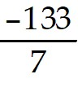
A) -19
B) - 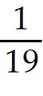
C) 19
D) -29
Answer: A
Diff: 1 Type: BI Var: 50+ Page Ref: 9
Topic: 1.2 Fundamental Operations of Algebra
Skill: Recall
Objective: (1.2) Evaluate Multiplication/Division Expression

2) 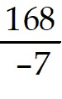
A) -24
B) - 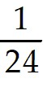
C) 24
D) -34
Answer: A
Diff: 1 Type: BI Var: 50+ Page Ref: 9
Topic: 1.2 Fundamental Operations of Algebra
Skill: Recall
Objective: (1.2) Evaluate Multiplication/Division Expression

3) 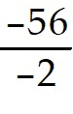
A) 28
B) 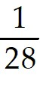
C) -28
D) 18
Answer: A
Diff: 1 Type: BI Var: 50+ Page Ref: 9
Topic: 1.2 Fundamental Operations of Algebra
Skill: Recall
Objective: (1.2) Evaluate Multiplication/Division Expression

4) 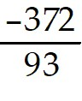
A) -4
B) - 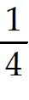
C) 4
D) -14
Answer: A
Diff: 1 Type: BI Var: 50+ Page Ref: 9
Topic: 1.2 Fundamental Operations of Algebra
Skill: Recall
Objective: (1.2) Evaluate Multiplication/Division Expression

5) 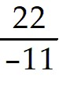
A) -2
B) - 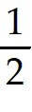
C) 2
D) -12
Answer: A
Diff: 1 Type: BI Var: 50+ Page Ref: 9
Topic: 1.2 Fundamental Operations of Algebra
Skill: Recall
Objective: (1.2) Evaluate Multiplication/Division Expression

6) 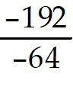
A) 3
B) 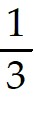
C) -3
D) -7
Answer: A
Diff: 1 Type: BI Var: 50+ Page Ref: 9
Topic: 1.2 Fundamental Operations of Algebra
Skill: Recall
Objective: (1.2) Evaluate Multiplication/Division Expression

7) 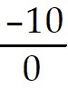
A) Undefined
B) 0
C) 1
D) 10
Answer: A
Diff: 3 Type: BI Var: 50+ Page Ref: 11
Topic: 1.2 Fundamental Operations of Algebra
Skill: Recall
Objective: (1.2) Evaluate Multiplication/Division Expression

8) 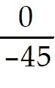
A) 0
B) Undefined
C) 1
D) 45
Answer: A
Diff: 1 Type: BI Var: 50+ Page Ref: 11
Topic: 1.2 Fundamental Operations of Algebra
Skill: Recall
Objective: (1.2) Evaluate Multiplication/Division Expression

9) 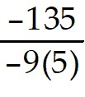
A) 3
B) 15
C) -3
D) -15
Answer: A
Diff: 1 Type: BI Var: 50+ Page Ref: 9
Topic: 1.2 Fundamental Operations of Algebra
Skill: Recall
Objective: (1.2) Evaluate Multiplication/Division Expression

10) 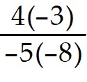
A) - 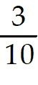
B)
C) - 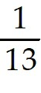
D)
Answer: A
Diff: 1 Type: BI Var: 50+ Page Ref: 10
Topic: 1.2 Fundamental Operations of Algebra
Skill: Recall
Objective: (1.2) Evaluate Multiplication/Division Expression

1.2.4 Evaluate Expression with Addition/Subtraction/Multiplication/Division

Find the value of the expression.

1) 7 + 13 × 5 - ( -7)
A) 79
B) 107
C) 93
D) 32
Answer: A
Diff: 1 Type: BI Var: 50+ Page Ref: 9-10
Topic: 1.2 Fundamental Operations of Algebra
Skill: Recall
Objective: (1.2) Evaluate Expression with Addition/Subtraction/Multiplication/Division

2) 10 + ( -26)( -13) + ( -17)
A) 331
B) 451
C) -144
D) 32
Answer: A
Diff: 1 Type: BI Var: 50+ Page Ref: 9-10
Topic: 1.2 Fundamental Operations of Algebra
Skill: Recall
Objective: (1.2) Evaluate Expression with Addition/Subtraction/Multiplication/Division

3) 9( -5) + 26( -7)
A) -227
B) 227
C) 1953
D) 47
Answer: A
Diff: 1 Type: BI Var: 50+ Page Ref: 9-10
Topic: 1.2 Fundamental Operations of Algebra
Skill: Recall
Objective: (1.2) Evaluate Expression with Addition/Subtraction/Multiplication/Division

4) ( -30 - 11)( -12 - 26)
A) 1558
B) -266
C) -1558
D) 266
Answer: A
Diff: 1 Type: BI Var: 50+ Page Ref: 9-10
Topic: 1.2 Fundamental Operations of Algebra
Skill: Recall
Objective: (1.2) Evaluate Expression with Addition/Subtraction/Multiplication/Division

5) ( -7 - 6)[ 8 + ( 4 + 2)]
A) -182
B) 27
C) -110
D) 23
Answer: A
Diff: 1 Type: BI Var: 50+ Page Ref: 9-10
Topic: 1.2 Fundamental Operations of Algebra
Skill: Recall
Objective: (1.2) Evaluate Expression with Addition/Subtraction/Multiplication/Division

6) 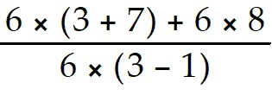
A) 9
B) 14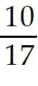
C) 2
D) 6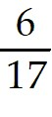
Answer: A
Diff: 1 Type: BI Var: 50+ Page Ref: 9-10
Topic: 1.2 Fundamental Operations of Algebra
Skill: Recall
Objective: (1.2) Evaluate Expression with Addition/Subtraction/Multiplication/Division

7) 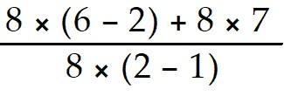
A) 11
B) 6
C) 2
D) 5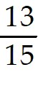
Answer: A
Diff: 1 Type: BI Var: 50+ Page Ref: 9-10
Topic: 1.2 Fundamental Operations of Algebra
Skill: Recall
Objective: (1.2) Evaluate Expression with Addition/Subtraction/Multiplication/Division

8) 5[ -6 + 8( -6 + 5)]
A) -70
B) -10
C) -38
D) -14
Answer: A
Diff: 1 Type: BI Var: 50+ Page Ref: 9-10
Topic: 1.2 Fundamental Operations of Algebra
Skill: Recall
Objective: (1.2) Evaluate Expression with Addition/Subtraction/Multiplication/Division

9) - 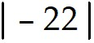 - 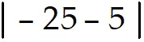
A) -52
B) -8
C) 52
D) 8
Answer: A
Diff: 1 Type: BI Var: 50+ Page Ref: 9-10
Topic: 1.2 Fundamental Operations of Algebra
Skill: Recall
Objective: (1.2) Evaluate Expression with Addition/Subtraction/Multiplication/Division

1.2.5 Determine Fundamental Algebraic Law

Determine which of the fundamental laws of algebra is demonstrated.

1) ( 7 + 4) + 9 = ( 4 + 7) + 9
A) Commutative
B) Associative
C) Distributive
D) Identity
Answer: A
Diff: 1 Type: BI Var: 50+ Page Ref: 7
Topic: 1.2 Fundamental Operations of Algebra
Skill: Recall
Objective: (1.2) Determine Fundamental Algebraic Law

2) 5(x + 8) = 5x + 5 × 8
A) Distributive
B) Associative
C) Commutative
Answer: A
Diff: 1 Type: BI Var: 50+ Page Ref: 7
Topic: 1.2 Fundamental Operations of Algebra
Skill: Recall
Objective: (1.2) Determine Fundamental Algebraic Law

3) 3 + 8 = 8 + 3
A) Commutative
B) Associative
C) Distributive
Answer: A
Diff: 1 Type: BI Var: 50+ Page Ref: 7
Topic: 1.2 Fundamental Operations of Algebra
Skill: Recall
Objective: (1.2) Determine Fundamental Algebraic Law

4) ( 2 × 1) × 5 = 2 × ( 1 × 5)
A) Associative
B) Commutative
C) Distributive
Answer: A
Diff: 1 Type: BI Var: 50+ Page Ref: 7
Topic: 1.2 Fundamental Operations of Algebra
Skill: Recall
Objective: (1.2) Determine Fundamental Algebraic Law

5) 6 × 5 = 5 × 6
A) Commutative
B) Associative
C) Distributive
Answer: A
Diff: 1 Type: BI Var: 50+ Page Ref: 7
Topic: 1.2 Fundamental Operations of Algebra
Skill: Recall
Objective: (1.2) Determine Fundamental Algebraic Law

6) ( -3 + 1) - 1 = -3 + ( 1 - 1)
A) Associative
B) Commutative
C) Distributive
Answer: A
Diff: 1 Type: BI Var: 50+ Page Ref: 7
Topic: 1.2 Fundamental Operations of Algebra
Skill: Recall
Objective: (1.2) Determine Fundamental Algebraic Law

1.2.6 Determine Equality of Expressions

Determine whether the first literal expression is equal to the second literal expression.

1) a + b, b - (-a)
A) Yes
B) No
Answer: A
Diff: 2 Type: BI Var: 1 Page Ref: 7-8
Topic: 1.2 Fundamental Operations of Algebra
Skill: Recall
Objective: (1.2) Determine Equality of Expressions

2) a - b, b - a
A) No
B) Yes
Answer: A
Diff: 2 Type: BI Var: 1 Page Ref: 7-8
Topic: 1.2 Fundamental Operations of Algebra
Skill: Recall
Objective: (1.2) Determine Equality of Expressions

3) -a - b, -b + (-a)
A) Yes
B) No
Answer: A
Diff: 2 Type: BI Var: 1 Page Ref: 7-8
Topic: 1.2 Fundamental Operations of Algebra
Skill: Recall
Objective: (1.2) Determine Equality of Expressions

4) b - a, a - (-b)
A) No
B) Yes
Answer: A
Diff: 2 Type: BI Var: 1 Page Ref: 7-8
Topic: 1.2 Fundamental Operations of Algebra
Skill: Recall
Objective: (1.2) Determine Equality of Expressions

1.2.7 *Know Concepts: Fundamental Operations of Algebra

Provide an appropriate response.

1) If an even number of negative numbers are multiplied, what will be the sign of the product?
A) Positive
B) Negative
C) Cannot be determined
D) It depends upon the numbers
Answer: A
Diff: 2 Type: BI Var: 2 Page Ref: 9
Topic: 1.2 Fundamental Operations of Algebra
Skill: Recall
Objective: (1.2) *Know Concepts: Fundamental Operations of Algebra

2) What conditions must be placed on the values of x and y so the expression 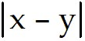 will be equal to the expression 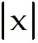 + 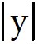 ?
A) x and y must have opposite signs or at least one be zero.
B) x and y must have the same signs or at least one be zero.
C) y must always be negative.
D) y must always be positive.
Answer: A
Diff: 2 Type: BI Var: 1 Page Ref: 9
Topic: 1.2 Fundamental Operations of Algebra
Skill: Recall
Objective: (1.2) *Know Concepts: Fundamental Operations of Algebra

3) The gross profit percentage of a company is defined as 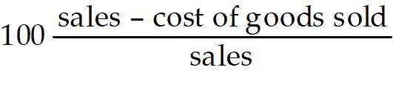 . Is it correct to say that a company has 0% gross profit before it makes its first sale?
A) No
B) Yes
Answer: A
Diff: 2 Type: BI Var: 1 Page Ref: 9-11
Topic: 1.2 Fundamental Operations of Algebra
Skill: Recall
Objective: (1.2) *Know Concepts: Fundamental Operations of Algebra

4) Two identical orders for goods are to be shipped. The first stock picker puts part 1 of the order on pallet A. He puts parts 2 and 3 of the order on pallet B and loads his truck. The second stock picker puts parts 1 and 2 on pallet A, and part 3 on pallet B before loading his truck. Which fundamental law of algebra shows that the trucks have identical orders?
A) Associative law of addition
B) Distributive law
C) Commutative law of addition
D) Commutative law of multiplication
Answer: A
Diff: 2 Type: BI Var: 1 Page Ref: 9-11
Topic: 1.2 Fundamental Operations of Algebra
Skill: Recall
Objective: (1.2) *Know Concepts: Fundamental Operations of Algebra

5) 7 car dealers each sell 18 trucks and 26 cars. An expression to determine the total number of vehicles sold is 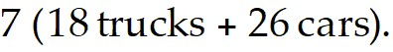 Which fundamental law of algebra does this expression illustrate?
A) Distributive law
B) Associative law of multiplication
C) Commutative law of addition
D) Commutative law of multiplication
Answer: A
Diff: 2 Type: BI Var: 50+ Page Ref: 9-11
Topic: 1.2 Fundamental Operations of Algebra
Skill: Recall
Objective: (1.2) *Know Concepts: Fundamental Operations of Algebra

1.3 Calculators and Approximate Numbers

1.3.1 Determine Whether Given Number is Exact or Approximate

Determine whether the given number is approximate or exact.

1) The history class has 141 students.
A) Exact
B) Approximate
Answer: A
Diff: 1 Type: BI Var: 50+ Page Ref: 13
Topic: 1.3 Measurement, Calculation, and Approximate Numbers
Skill: Recall
Objective: (1.3) Determine Whether Given Number is Exact or Approximate

2) The blackboard in the mathematics classroom is 49 inches long.
A) Approximate
B) Exact
Answer: A
Diff: 1 Type: BI Var: 50+ Page Ref: 13
Topic: 1.3 Measurement, Calculation, and Approximate Numbers
Skill: Recall
Objective: (1.3) Determine Whether Given Number is Exact or Approximate

3) The cost of gasoline is $0.889 per gallon.
A) Exact
B) Approximate
Answer: A
Diff: 1 Type: BI Var: 50+ Page Ref: 13
Topic: 1.3 Measurement, Calculation, and Approximate Numbers
Skill: Recall
Objective: (1.3) Determine Whether Given Number is Exact or Approximate

4) Susan's new car gets 20.4 miles per gallon of gasoline.
A) Approximate
B) Exact
Answer: A
Diff: 1 Type: BI Var: 50+ Page Ref: 13
Topic: 1.3 Measurement, Calculation, and Approximate Numbers
Skill: Recall
Objective: (1.3) Determine Whether Given Number is Exact or Approximate

5) Jennifer has 32 teeth.
A) Exact
B) Approximate
Answer: A
Diff: 1 Type: BI Var: 1 Page Ref: 13
Topic: 1.3 Measurement, Calculation, and Approximate Numbers
Skill: Recall
Objective: (1.3) Determine Whether Given Number is Exact or Approximate

6) The ammeter showed a reading of 0.44A.
A) Approximate
B) Exact
Answer: A
Diff: 1 Type: BI Var: 50+ Page Ref: 13
Topic: 1.3 Measurement, Calculation, and Approximate Numbers
Skill: Recall
Objective: (1.3) Determine Whether Given Number is Exact or Approximate

7) The thermometer showed that the temperature in the classroom was 74°F.
A) Approximate
B) Exact
Answer: A
Diff: 1 Type: BI Var: 11 Page Ref: 13
Topic: 1.3 Measurement, Calculation, and Approximate Numbers
Skill: Recall
Objective: (1.3) Determine Whether Given Number is Exact or Approximate

8) One mole of an element contains 6.022 × 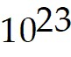 atoms.
A) Approximate
B) Exact
Answer: A
Diff: 1 Type: BI Var: 1 Page Ref: 13
Topic: 1.3 Measurement, Calculation, and Approximate Numbers
Skill: Recall
Objective: (1.3) Determine Whether Given Number is Exact or Approximate

9) The radius of the planet is 2428 km.
A) Approximate
B) Exact
Answer: A
Diff: 1 Type: BI Var: 50+ Page Ref: 13
Topic: 1.3 Measurement, Calculation, and Approximate Numbers
Skill: Recall
Objective: (1.3) Determine Whether Given Number is Exact or Approximate

10) There are 5280 feet in a mile.
A) Exact
B) Approximate
Answer: A
Diff: 1 Type: BI Var: 1 Page Ref: 13
Topic: 1.3 Measurement, Calculation, and Approximate Numbers
Skill: Recall
Objective: (1.3) Determine Whether Given Number is Exact or Approximate

1.3.2 Determine Number of Significant Digits in Given Approximate Number

Determine the number of significant digits in the given approximate number.

1) 65,400
A) 3
B) 4
C) 1
D) 5
Answer: A
Diff: 1 Type: BI Var: 50+ Page Ref: 17
Topic: 1.3 Measurement, Calculation, and Approximate Numbers
Skill: Recall
Objective: (1.3) Determine Number of Significant Digits in Given Approximate Number

2) 0.00949
A) 3
B) 8
C) 2
D) 4
Answer: A
Diff: 1 Type: BI Var: 50+ Page Ref: 17
Topic: 1.3 Measurement, Calculation, and Approximate Numbers
Skill: Recall
Objective: (1.3) Determine Number of Significant Digits in Given Approximate Number

3) 9030
A) 3
B) 2
C) 4
D) 1
Answer: A
Diff: 1 Type: BI Var: 50+ Page Ref: 17
Topic: 1.3 Measurement, Calculation, and Approximate Numbers
Skill: Recall
Objective: (1.3) Determine Number of Significant Digits in Given Approximate Number

4) 0.0709
A) 3
B) 4
C) 2
D) 1
Answer: A
Diff: 1 Type: BI Var: 50+ Page Ref: 17
Topic: 1.3 Measurement, Calculation, and Approximate Numbers
Skill: Recall
Objective: (1.3) Determine Number of Significant Digits in Given Approximate Number

5) 70,050
A) 4
B) 2
C) 5
D) 3
Answer: A
Diff: 1 Type: BI Var: 50+ Page Ref: 17
Topic: 1.3 Measurement, Calculation, and Approximate Numbers
Skill: Recall
Objective: (1.3) Determine Number of Significant Digits in Given Approximate Number

6) 0.09007
A) 4
B) 6
C) 5
D) 2
Answer: A
Diff: 1 Type: BI Var: 50+ Page Ref: 17
Topic: 1.3 Measurement, Calculation, and Approximate Numbers
Skill: Recall
Objective: (1.3) Determine Number of Significant Digits in Given Approximate Number

7) 7000.4
A) 5
B) 2
C) 3
D) 4
Answer: A
Diff: 1 Type: BI Var: 50+ Page Ref: 17
Topic: 1.3 Measurement, Calculation, and Approximate Numbers
Skill: Recall
Objective: (1.3) Determine Number of Significant Digits in Given Approximate Number

8) 0.020020
A) 5
B) 6
C) 2
D) 3
Answer: A
Diff: 1 Type: BI Var: 50+ Page Ref: 17
Topic: 1.3 Measurement, Calculation, and Approximate Numbers
Skill: Recall
Objective: (1.3) Determine Number of Significant Digits in Given Approximate Number

9) 300
A) 1
B) 5
C) 2
D) 4
Answer: A
Diff: 1 Type: BI Var: 9 Page Ref: 17
Topic: 1.3 Measurement, Calculation, and Approximate Numbers
Skill: Recall
Objective: (1.3) Determine Number of Significant Digits in Given Approximate Number

10) 403.080
A) 6
B) 3
C) 2
D) 4
Answer: A
Diff: 1 Type: BI Var: 50+ Page Ref: 17
Topic: 1.3 Measurement, Calculation, and Approximate Numbers
Skill: Recall
Objective: (1.3) Determine Number of Significant Digits in Given Approximate Number

1.3.3 Determine Accuracy and Precision

First determine which number (x or y) is more accurate, then which is more precise.

1) x = 12.9, y = 0.35
A) x, y
B) x, x
C) y, x
D) y, y
Answer: A
Diff: 2 Type: BI Var: 50+ Page Ref: 17-18
Topic: 1.3 Measurement, Calculation, and Approximate Numbers
Skill: Recall
Objective: (1.3) Determine Accuracy and Precision

2) x = 0.058, y = 1540
A) y, x
B) x, x
C) x, y
D) y, y
Answer: A
Diff: 2 Type: BI Var: 50+ Page Ref: 17-18
Topic: 1.3 Measurement, Calculation, and Approximate Numbers
Skill: Recall
Objective: (1.3) Determine Accuracy and Precision

3) x = 0.6, y = 18
A) y, y
B) x, x
C) x, y
D) y, x
Answer: A
Diff: 2 Type: BI Var: 50+ Page Ref: 17-18
Topic: 1.3 Measurement, Calculation, and Approximate Numbers
Skill: Recall
Objective: (1.3) Determine Accuracy and Precision

4) x = 9690, y = 0.007
A) x, y
B) x, x
C) y, x
D) y, y
Answer: A
Diff: 2 Type: BI Var: 50+ Page Ref: 17-18
Topic: 1.3 Measurement, Calculation, and Approximate Numbers
Skill: Recall
Objective: (1.3) Determine Accuracy and Precision

5) x = 7,000, y = 0.00 40
A) y, y
B) x, x
C) y, x
D) x, y
Answer: A
Diff: 2 Type: BI Var: 50+ Page Ref: 17-18
Topic: 1.3 Measurement, Calculation, and Approximate Numbers
Skill: Recall
Objective: (1.3) Determine Accuracy and Precision

1.3.4 Round Approximate Number to Stated Significant Digits

Round off the approximate number as indicated.
1) 3153 3 significant digits
A) 3150
B) 3153
C) 3200
D) 3160
Answer: A
Diff: 2 Type: BI Var: 50+ Page Ref: 18
Topic: 1.3 Measurement, Calculation, and Approximate Numbers
Skill: Recall
Objective: (1.3) Round Approximate Number to Stated Significant Digits

2) 8479 2 significant digits
A) 8500
B) 8600
C) 8480
D) 8400
Answer: A
Diff: 2 Type: BI Var: 50+ Page Ref: 18
Topic: 1.3 Measurement, Calculation, and Approximate Numbers
Skill: Recall
Objective: (1.3) Round Approximate Number to Stated Significant Digits

3) 89.23 3 significant digits
A) 89.2
B) 89.3
C) 89.1
D) 89
Answer: A
Diff: 2 Type: BI Var: 50+ Page Ref: 18
Topic: 1.3 Measurement, Calculation, and Approximate Numbers
Skill: Recall
Objective: (1.3) Round Approximate Number to Stated Significant Digits

4) 13.76 2 significant digits
A) 14
B) 14.1
C) 13.9
D) 13.8
Answer: A
Diff: 2 Type: BI Var: 50+ Page Ref: 18
Topic: 1.3 Measurement, Calculation, and Approximate Numbers
Skill: Recall
Objective: (1.3) Round Approximate Number to Stated Significant Digits

5) 0.009999 3 significant digits
A) 0.0100
B) 0.010
C) 0.01
D) 0.00999
Answer: A
Diff: 2 Type: BI Var: 3 Page Ref: 18
Topic: 1.3 Measurement, Calculation, and Approximate Numbers
Skill: Recall
Objective: (1.3) Round Approximate Number to Stated Significant Digits

6) 0.09999 2 significant digits
A) 0.10
B) 0.100
C) 0.1
D) 0.099
Answer: A
Diff: 2 Type: BI Var: 3 Page Ref: 18
Topic: 1.3 Measurement, Calculation, and Approximate Numbers
Skill: Recall
Objective: (1.3) Round Approximate Number to Stated Significant Digits

7) 0.09499 3 significant digits
A) 0.0950
B) 0.095
C) 0.09
D) 0.0949
Answer: A
Diff: 2 Type: BI Var: 3 Page Ref: 18
Topic: 1.3 Measurement, Calculation, and Approximate Numbers
Skill: Recall
Objective: (1.3) Round Approximate Number to Stated Significant Digits

8) 0.09499 2 significant digits
A) 0.095
B) 0.0950
C) 0.09
D) 0.094
Answer: A
Diff: 2 Type: BI Var: 3 Page Ref: 18
Topic: 1.3 Measurement, Calculation, and Approximate Numbers
Skill: Recall
Objective: (1.3) Round Approximate Number to Stated Significant Digits

9) 9105 3 significant digits
A) 9110
B) 9105
C) 9210
D) 9010
Answer: A
Diff: 2 Type: BI Var: 50+ Page Ref: 18
Topic: 1.3 Measurement, Calculation, and Approximate Numbers
Skill: Recall
Objective: (1.3) Round Approximate Number to Stated Significant Digits

10) 2050 2 significant digits
A) 2100
B) 2200
C) 2000
D) 250
Answer: A
Diff: 2 Type: BI Var: 50+ Page Ref: 18
Topic: 1.3 Measurement, Calculation, and Approximate Numbers
Skill: Recall
Objective: (1.3) Round Approximate Number to Stated Significant Digits

1.3.5 Use Calculator to Express with Proper Acc/Prec (Approx Number)

Perform the indicated operations on a calculator. Express the result with the proper accuracy and precision. Assume that all numbers are approximate.

1) 1.9 + 0.494 - 16.31
A) -13.9
B) -13.916
C) -14
D) -13.92
Answer: A
Diff: 2 Type: BI Var: 50+ Page Ref: 19
Topic: 1.3 Measurement, Calculation, and Approximate Numbers
Skill: Recall
Objective: (1.3) Use Calculator to Express with Proper Acc/Prec (Approx Number)

2) 3.77( 60.38)
A) 228
B) 227.6326
C) 200
D) 227.6
Answer: A
Diff: 2 Type: BI Var: 50+ Page Ref: 19
Topic: 1.3 Measurement, Calculation, and Approximate Numbers
Skill: Recall
Objective: (1.3) Use Calculator to Express with Proper Acc/Prec (Approx Number)

3) 0.98 ÷ 372
A) 0.0026
B) 0.00263
C) 0.002634
D) 380
Answer: A
Diff: 2 Type: BI Var: 50+ Page Ref: 19
Topic: 1.3 Measurement, Calculation, and Approximate Numbers
Skill: Recall
Objective: (1.3) Use Calculator to Express with Proper Acc/Prec (Approx Number)

4) 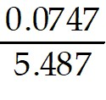 + 0.0637
A) 0.0773
B) 0.077
C) -0.0501
D) -0.050
Answer: A
Diff: 2 Type: BI Var: 50+ Page Ref: 19
Topic: 1.3 Measurement, Calculation, and Approximate Numbers
Skill: Recall
Objective: (1.3) Use Calculator to Express with Proper Acc/Prec (Approx Number)

5) 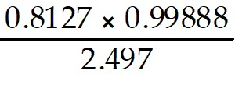
A) 0.3251
B) 0.325
C) 3.069
D) 3.07
Answer: A
Diff: 2 Type: BI Var: 50+ Page Ref: 19
Topic: 1.3 Measurement, Calculation, and Approximate Numbers
Skill: Recall
Objective: (1.3) Use Calculator to Express with Proper Acc/Prec (Approx Number)

6) 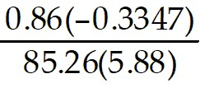
A) -0.00057
B) -0.0005700
C) -0.000570
D) -0.0006
Answer: A
Diff: 2 Type: BI Var: 50+ Page Ref: 19
Topic: 1.3 Measurement, Calculation, and Approximate Numbers
Skill: Recall
Objective: (1.3) Use Calculator to Express with Proper Acc/Prec (Approx Number)

7) 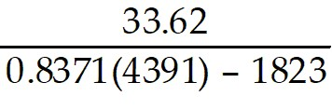
A) 0.01815
B) 0.0181
C) 0.0156
D) 0.01560
Answer: A
Diff: 2 Type: BI Var: 50+ Page Ref: 19
Topic: 1.3 Measurement, Calculation, and Approximate Numbers
Skill: Recall
Objective: (1.3) Use Calculator to Express with Proper Acc/Prec (Approx Number)

8) 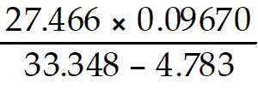
A) 0.09298
B) 0.092980
C) 0.0930
D) 0.01665
Answer: A
Diff: 2 Type: BI Var: 50+ Page Ref: 19
Topic: 1.3 Measurement, Calculation, and Approximate Numbers
Skill: Recall
Objective: (1.3) Use Calculator to Express with Proper Acc/Prec (Approx Number)

9) 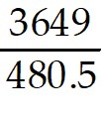 - 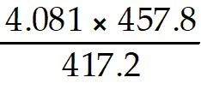
A) 3.116
B) 3.12
C) 34.01
D) 34.0
Answer: A
Diff: 2 Type: BI Var: 50+ Page Ref: 19
Topic: 1.3 Measurement, Calculation, and Approximate Numbers
Skill: Recall
Objective: (1.3) Use Calculator to Express with Proper Acc/Prec (Approx Number)

10) 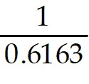 + 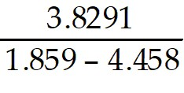
A) 0
B) 0.000
C) 0.0000
D) 0.00
Answer: A
Diff: 2 Type: BI Var: 50+ Page Ref: 19
Topic: 1.3 Measurement, Calculation, and Approximate Numbers
Skill: Recall
Objective: (1.3) Use Calculator to Express with Proper Acc/Prec (Approx Number)

1.3.6 Use Calculator to Express with Proper Acc/Prec (Exact, Approx Number)

Perform the indicated operation and express with the proper accuracy and precision. The first number given is approximate and the second number is exact. (Use calculator if needed).

1) 0.5561 + 15.9
A) 16.46
B) 16.4561
C) 16.5
D) 16
Answer: A
Diff: 2 Type: BI Var: 50+ Page Ref: 19-20
Topic: 1.3 Measurement, Calculation, and Approximate Numbers
Skill: Recall
Objective: (1.3) Use Calculator to Express with Proper Acc/Prec (Exact, Approx Number)

2) 17.319 - 36.9
A) -19.581
B) -19.6
C) 19.581
D) -20
Answer: A
Diff: 2 Type: BI Var: 50+ Page Ref: 19-20
Topic: 1.3 Measurement, Calculation, and Approximate Numbers
Skill: Recall
Objective: (1.3) Use Calculator to Express with Proper Acc/Prec (Exact, Approx Number)

3) 8.976( 22)
A) 197.5
B) 197.472
C) 197.47
D) 197
Answer: A
Diff: 2 Type: BI Var: 50+ Page Ref: 19-20
Topic: 1.3 Measurement, Calculation, and Approximate Numbers
Skill: Recall
Objective: (1.3) Use Calculator to Express with Proper Acc/Prec (Exact, Approx Number)

4) 3.68 ÷ 3638
A) 0.00101
B) 0.00101154
C) 0.0
D) 0
Answer: A
Diff: 2 Type: BI Var: 50+ Page Ref: 19-20
Topic: 1.3 Measurement, Calculation, and Approximate Numbers
Skill: Recall
Objective: (1.3) Use Calculator to Express with Proper Acc/Prec (Exact, Approx Number)

5) 8 ÷ 307
A) 0.03
B) 0.02605863
C) 0.026
D) 26.0586319
Answer: A
Diff: 2 Type: BI Var: 50+ Page Ref: 19-20
Topic: 1.3 Measurement, Calculation, and Approximate Numbers
Skill: Recall
Objective: (1.3) Use Calculator to Express with Proper Acc/Prec (Exact, Approx Number)

1.3.7 Solve Apps: Approximate Numbers

Solve the problem. Assume all numbers are approximate unless otherwise stated or the number has been determined by a definition or counting process.

1) The current (in amperes, A) running through a resistor in an electric circuit can be calculated by dividing the voltage measured across the resistor (in volts) by the resistance of the resistor (in ohms). If the voltage measured across a resistor is 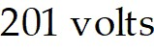 and the resistance is 210 ohms, how much current runs through the resistor?
A) 0.96 A
B) 1 A
C) 9 A
D) 81,000 A
Answer: A
Diff: 3 Type: BI Var: 50+ Page Ref: 20-21
Topic: 1.3 Measurement, Calculation, and Approximate Numbers
Skill: Applied
Objective: (1.3) Solve Apps: Approximate Numbers

2) If you are told that the height of a trapezoid is 638 mm, that the length of one of its parallel sides is 3419 mm, and that the area of the trapezoid is 3,917,000 mm2, then you could estimate the length of the other parallel side (in mm) by performing the calculation 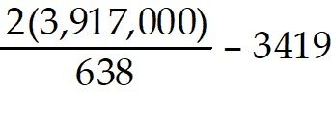. Perform this calculation and report the length found.
A) 12,000 mm
B) 12,300 mm
C) 12,280 mm
D) 12,400 mm
Answer: A
Diff: 3 Type: BI Var: 50+ Page Ref: 20-21
Topic: 1.3 Measurement, Calculation, and Approximate Numbers
Skill: Applied
Objective: (1.3) Solve Apps: Approximate Numbers

3) The expression 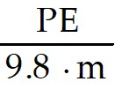 will tell you how high, in meters, you must raise the hammer of a pile driver when you know the mass (m) of the hammer in kg, and what potential energy (PE) in Joules is required. Find the height to which a 64-kg hammer must be raised to have 1270 J of potential energy.
A) 2.0 m
B) 2.02 m
C) 2 m
D) 2.025 m
Answer: A
Diff: 3 Type: BI Var: 50+ Page Ref: 20-21
Topic: 1.3 Measurement, Calculation, and Approximate Numbers
Skill: Applied
Objective: (1.3) Solve Apps: Approximate Numbers

4) The capacitance of a certain element in an electric circuit (in μF) was determined by calculating the value of 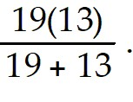 Calculate this capacitance.
A) 7.7 μF
B) 6.5 μF
C) 9.5 μF
D) 11.3 μF
Answer: A
Diff: 3 Type: BI Var: 50+ Page Ref: 20-21
Topic: 1.3 Measurement, Calculation, and Approximate Numbers
Skill: Applied
Objective: (1.3) Solve Apps: Approximate Numbers

5) An electronics manufacturer lists the frequency of one of its crystals as 3.55 MHz. What are the lowest and highest possible frequencies at which the crystal may oscillate?
A) 3.545 MHz and 3.554 MHz
B) 3.54 MHz and 3.56 MHz
C) 3.5 MHz and 3.6 MHz
D) Only at 3.55 MHz
Answer: A
Diff: 3 Type: BI Var: 21 Page Ref: 20-21
Topic: 1.3 Measurement, Calculation, and Approximate Numbers
Skill: Applied
Objective: (1.3) Solve Apps: Approximate Numbers

6) At some point in the decimal equivalent of a rational number, some sequence of digits will start repeating endlessly. An irrational number never has an endlessly repeating sequence of digits. If the fraction 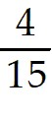 is a rational number, which decimal equivalent digits indicate this?
A) 6
B) 26
C) 15
D) The fraction is irrational.
Answer: A
Diff: 3 Type: BI Var: 4 Page Ref: 20-21
Topic: 1.3 Measurement, Calculation, and Approximate Numbers
Skill: Applied
Objective: (1.3) Solve Apps: Approximate Numbers

7) A technician reports that on three successive test runs, a vehicle used 33.3 ml, 35.37 ml and 32.165 ml of fuel to travel a measured mile. What would be the total fuel used to travel 3 miles?
A) 100.8 ml
B) 100.835 ml
C) 101 ml
D) 100.84 ml
Answer: A
Diff: 3 Type: BI Var: 50+ Page Ref: 20-21
Topic: 1.3 Measurement, Calculation, and Approximate Numbers
Skill: Applied
Objective: (1.3) Solve Apps: Approximate Numbers

8) A computer hard drive stores exactly 512 bytes of data in each disk sector, and there are exactly 16 sectors in a cluster. If a hard drive contains 2048 clusters, how many bytes of data can be stored?
A) 16,777,216 bytes
B) 16,780,000 bytes
C) 16,800,000 bytes
D) 1,048,576 bytes
Answer: A
Diff: 3 Type: BI Var: 6 Page Ref: 20-21
Topic: 1.3 Measurement, Calculation, and Approximate Numbers
Skill: Applied
Objective: (1.3) Solve Apps: Approximate Numbers

9) The formula for finding the volume of a square pyramid is V = s2h, where the s is the side of the base and h is the height. Determine the volume of a 44 cm high pyramid with sides of length 33.39 cm.
A) 16,000 cubic cm
B) 20,000 cubic cm
C) 16,350 cubic cm
D) 22,000 cubic cm
Answer: A
Diff: 3 Type: BI Var: 50+ Page Ref: 20-21
Topic: 1.3 Measurement, Calculation, and Approximate Numbers
Skill: Applied
Objective: (1.3) Solve Apps: Approximate Numbers

1.3.8 Convert Units

Make the indicated unit conversion.

1) Express 3 km in cm
A) 300000 cm
B) 3000 cm
C) 3000000 c.
D) 300 cm
Answer: A
Diff: 2 Type: BI Var: 8 Page Ref: 14-16
Topic: 1.3 Measurement, Calculation, and Approximate Numbers
Skill: Applied
Objective: (1.3) Convert Units

2) Express 45.5 m/s in km/h
A) 163.8 km/h
B) 136.8 km/h
C) 12.64 km/h
D) 126.4 km/h
Answer: A
Diff: 3 Type: BI Var: 50+ Page Ref: 14-16
Topic: 1.3 Measurement, Calculation, and Approximate Numbers
Skill: Applied
Objective: (1.3) Convert Units

3) The earth orbits, on average 940 000 000 km in a year around the sun. What is the average speed of earth orbiting around the sun in km/s.
A) 30 km/s
B) 35 km/s
C) 40 km/s
D) 42 km/s
Answer: A
Diff: 3 Type: BI Var: 1 Page Ref: 14-16
Topic: 1.3 Measurement, Calculation, and Approximate Numbers
Skill: Applied
Objective: (1.3) Convert Units

1.4 Exponents

1.4.1 Simplify Exponent Expression (Mult/Div)

Simplify the expression. Use positive exponents. Assume variables represent nonnegative numbers.

1) ( 9a)( 5a2)
A) 45a3
B) 45a4
C) 9a + 5a2
D) 14a3
Answer: A
Diff: 2 Type: BI Var: 50+ Page Ref: 23-24
Topic: 1.4 Exponents
Skill: Recall
Objective: (1.4) Simplify Exponent Expression (Mult/Div)

2) (-3y)(-7y4)
A) 21y5
B) -21y5
C) -10y4
D) 3y - 7y4
Answer: A
Diff: 2 Type: BI Var: 50+ Page Ref: 23-24
Topic: 1.4 Exponents
Skill: Recall
Objective: (1.4) Simplify Exponent Expression (Mult/Div)

3) ( 4x5)( 3x5)
A) 12x10
B) 12x25
C) 7x10
D) 7x25
Answer: A
Diff: 2 Type: BI Var: 50+ Page Ref: 23-24
Topic: 1.4 Exponents
Skill: Recall
Objective: (1.4) Simplify Exponent Expression (Mult/Div)

4) (-9x3)( 6x4)
A) -54x7
B) -54x12
C) 15x7
D) 15x12
Answer: A
Diff: 2 Type: BI Var: 50+ Page Ref: 23-24
Topic: 1.4 Exponents
Skill: Recall
Objective: (1.4) Simplify Exponent Expression (Mult/Div)

5) (-5x2)(-7x3)
A) 35x5
B) -35x6
C) -12x5
D) -12x6
Answer: A
Diff: 2 Type: BI Var: 50+ Page Ref: 23-24
Topic: 1.4 Exponents
Skill: Recall
Objective: (1.4) Simplify Exponent Expression (Mult/Div)

6) ( 3m4z4)( 4m3z2)
A) 12m7z6
B) 12m7z
C) 12mz6
D) 12mz7
Answer: A
Diff: 2 Type: BI Var: 50+ Page Ref: 23-24
Topic: 1.4 Exponents
Skill: Recall
Objective: (1.4) Simplify Exponent Expression (Mult/Div)

7) 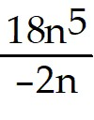
A) -9n4
B) -9n
C) -9n5
D) -9
Answer: A
Diff: 2 Type: BI Var: 50+ Page Ref: 23-24
Topic: 1.4 Exponents
Skill: Recall
Objective: (1.4) Simplify Exponent Expression (Mult/Div)

8) 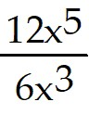
A) 2x2
B) 2x
C) 2x5
D) 2
Answer: A
Diff: 2 Type: BI Var: 50+ Page Ref: 23-24
Topic: 1.4 Exponents
Skill: Recall
Objective: (1.4) Simplify Exponent Expression (Mult/Div)

9) 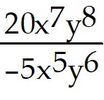
A) -4x2y2
B) -4xy
C) -4x7y8
D) -4x6y7
Answer: A
Diff: 2 Type: BI Var: 50+ Page Ref: 23-24
Topic: 1.4 Exponents
Skill: Recall
Objective: (1.4) Simplify Exponent Expression (Mult/Div)

10) 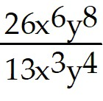
A) 2x3y4
B) 2xy
C) 2x6y8
D) 2x4y6
Answer: A
Diff: 2 Type: BI Var: 50+ Page Ref: 23-24
Topic: 1.4 Exponents
Skill: Recall
Objective: (1.4) Simplify Exponent Expression (Mult/Div)

1.4.2 Simplify Exponent Expression (Powers)

Simplify the expression. Use positive exponents. Assume variables represent nonnegative numbers.

1) ( 24a)6
A) 224a6
B) 210a6
C) 210a
D) 24a6
Answer: A
Diff: 2 Type: BI Var: 50+ Page Ref: 23-24
Topic: 1.4 Exponents
Skill: Recall
Objective: (1.4) Simplify Exponent Expression (Powers)

2) ( -2a6)2
A) 4a12
B) -4a6
C) 4096a6
D) 4096a12
Answer: A
Diff: 2 Type: BI Var: 50+ Page Ref: 23-24
Topic: 1.4 Exponents
Skill: Recall
Objective: (1.4) Simplify Exponent Expression (Powers)

3) ( -3x3y)3
A) -27x9y3
B) -9x3y
C) -9x3y3
D) -27x6y3
Answer: A
Diff: 2 Type: BI Var: 50+ Page Ref: 23-24
Topic: 1.4 Exponents
Skill: Recall
Objective: (1.4) Simplify Exponent Expression (Powers)

4) ( -4p4q4r4)4
A) 256p16q16r16
B) ( -4)16p16q16r16
C) -16p8q8r8
D) 256p8q8r8
Answer: A
Diff: 2 Type: BI Var: 50+ Page Ref: 23-24
Topic: 1.4 Exponents
Skill: Recall
Objective: (1.4) Simplify Exponent Expression (Powers)

5) 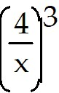
A) 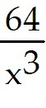
B) 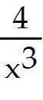
C) 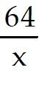
D) 64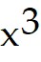
Answer: A
Diff: 2 Type: BI Var: 9 Page Ref: 23-24
Topic: 1.4 Exponents
Skill: Recall
Objective: (1.4) Simplify Exponent Expression (Powers)

6) 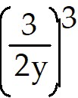
A) 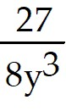
B) 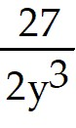
C) 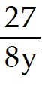
D) 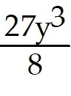
Answer: A
Diff: 2 Type: BI Var: 14 Page Ref: 23-24
Topic: 1.4 Exponents
Skill: Recall
Objective: (1.4) Simplify Exponent Expression (Powers)

7) 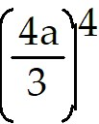
A) 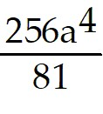
B) 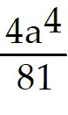
C) 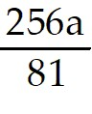
D) 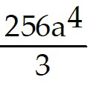
Answer: A
Diff: 2 Type: BI Var: 9 Page Ref: 23-24
Topic: 1.4 Exponents
Skill: Recall
Objective: (1.4) Simplify Exponent Expression (Powers)

8) 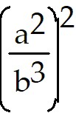
A) 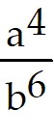
B) 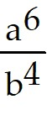
C) 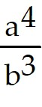
D) 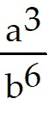
Answer: A
Diff: 2 Type: BI Var: 9 Page Ref: 23-24
Topic: 1.4 Exponents
Skill: Recall
Objective: (1.4) Simplify Exponent Expression (Powers)

9) 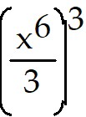
A) 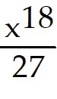
B) 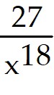
C) 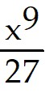
D) 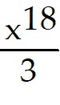
Answer: A
Diff: 2 Type: BI Var: 16 Page Ref: 23-24
Topic: 1.4 Exponents
Skill: Recall
Objective: (1.4) Simplify Exponent Expression (Powers)

1.4.3 Simplify Exponent Expression (Neg/Zero Exponent)

Simplify.

1) 40
A) 1
B) 0
C) 4
D) -1
Answer: A
Diff: 1 Type: BI Var: 15 Page Ref: 24
Topic: 1.4 Exponents
Skill: Recall
Objective: (1.4) Simplify Exponent Expression (Neg/Zero Exponent)

2) -100
A) -1
B) 0
C) -10
D) 1
Answer: A
Diff: 1 Type: BI Var: 15 Page Ref: 24
Topic: 1.4 Exponents
Skill: Recall
Objective: (1.4) Simplify Exponent Expression (Neg/Zero Exponent)

3) 100 + 60
A) 2
B) 16
C) 0
D) 1
Answer: A
Diff: 1 Type: BI Var: 50+ Page Ref: 24
Topic: 1.4 Exponents
Skill: Recall
Objective: (1.4) Simplify Exponent Expression (Neg/Zero Exponent)

4) ( 2x)0
A) 1
B) 2
C) 0
D) 2x
Answer: A
Diff: 1 Type: BI Var: 7 Page Ref: 24
Topic: 1.4 Exponents
Skill: Recall
Objective: (1.4) Simplify Exponent Expression (Neg/Zero Exponent)

5) (x6)-3
A) 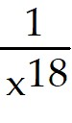
B) x18
C) 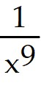
D) x9
Answer: A
Diff: 1 Type: BI Var: 5 Page Ref: 23-24
Topic: 1.4 Exponents
Skill: Recall
Objective: (1.4) Simplify Exponent Expression (Neg/Zero Exponent)

6) ( 7-1 × 6-4)-2
A) 72 × 68
B) 75 × 65
C) 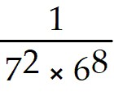
D) 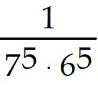
Answer: A
Diff: 1 Type: BI Var: 50+ Page Ref: 23-24
Topic: 1.4 Exponents
Skill: Recall
Objective: (1.4) Simplify Exponent Expression (Neg/Zero Exponent)

7) ( 55 × 33)-5
A) 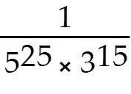
B) 525 × 315
C) 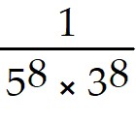
D) 58 × 38
Answer: A
Diff: 1 Type: BI Var: 50+ Page Ref: 23-24
Topic: 1.4 Exponents
Skill: Recall
Objective: (1.4) Simplify Exponent Expression (Neg/Zero Exponent)

8) (x-4y6)-3
A) 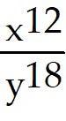
B) 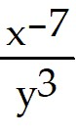
C) 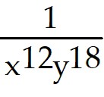
D) 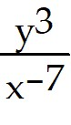
Answer: A
Diff: 1 Type: BI Var: 24 Page Ref: 23-24
Topic: 1.4 Exponents
Skill: Recall
Objective: (1.4) Simplify Exponent Expression (Neg/Zero Exponent)

9) 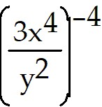
A) 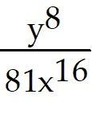
B) 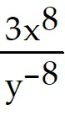
C) 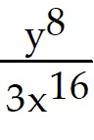
D) 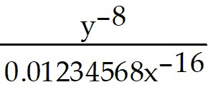
Answer: A
Diff: 1 Type: BI Var: 50+ Page Ref: 23-24
Topic: 1.4 Exponents
Skill: Recall
Objective: (1.4) Simplify Exponent Expression (Neg/Zero Exponent)

1.4.4 Simplify Exponent Expression (Combined Rules)

Simplify.

1) 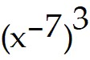
A) 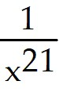
B) 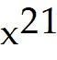
C) 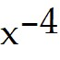
D) 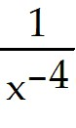
Answer: A
Diff: 2 Type: BI Var: 6 Page Ref: 23-24
Topic: 1.4 Exponents
Skill: Recall
Objective: (1.4) Simplify Exponent Expression (Combined Rules)

2) 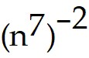
A) 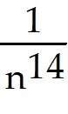
B) 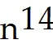
C) 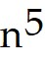
D) 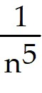
Answer: A
Diff: 2 Type: BI Var: 8 Page Ref: 23-24
Topic: 1.4 Exponents
Skill: Recall
Objective: (1.4) Simplify Exponent Expression (Combined Rules)

3) 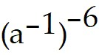
A) 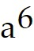
B) 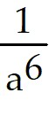
C) 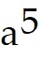
D) 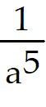
Answer: A
Diff: 2 Type: BI Var: 9 Page Ref: 23-24
Topic: 1.4 Exponents
Skill: Recall
Objective: (1.4) Simplify Exponent Expression (Combined Rules)

4) 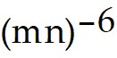
A) 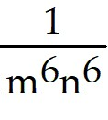
B) 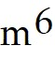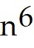
C) 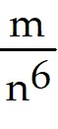
D) 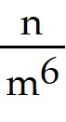
Answer: A
Diff: 2 Type: BI Var: 4 Page Ref: 23-24
Topic: 1.4 Exponents
Skill: Recall
Objective: (1.4) Simplify Exponent Expression (Combined Rules)

5) 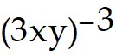
A) 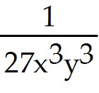
B) 27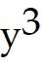
C) 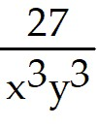
D) 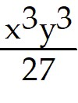
Answer: A
Diff: 2 Type: BI Var: 8 Page Ref: 23-24
Topic: 1.4 Exponents
Skill: Recall
Objective: (1.4) Simplify Exponent Expression (Combined Rules)

6) 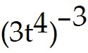
A) 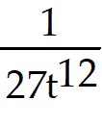
B) 27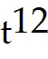
C) 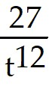
D) 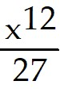
Answer: A
Diff: 2 Type: BI Var: 24 Page Ref: 23-24
Topic: 1.4 Exponents
Skill: Recall
Objective: (1.4) Simplify Exponent Expression (Combined Rules)

7) 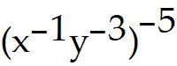
A) 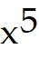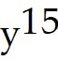
B) 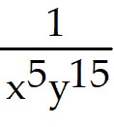
C) 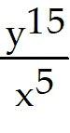
D) 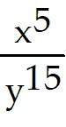
Answer: A
Diff: 2 Type: BI Var: 35 Page Ref: 23-24
Topic: 1.4 Exponents
Skill: Recall
Objective: (1.4) Simplify Exponent Expression (Combined Rules)

8) 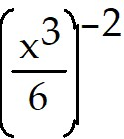
A) 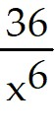
B) 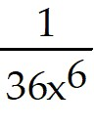
C) 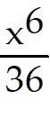
D) 36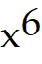
Answer: A
Diff: 2 Type: BI Var: 24 Page Ref: 23-24
Topic: 1.4 Exponents
Skill: Recall
Objective: (1.4) Simplify Exponent Expression (Combined Rules)

9) 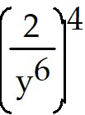
A) 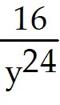
B) 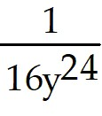
C) 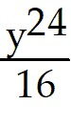
D) 16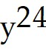
Answer: A
Diff: 2 Type: BI Var: 24 Page Ref: 23-24
Topic: 1.4 Exponents
Skill: Recall
Objective: (1.4) Simplify Exponent Expression (Combined Rules)

10) 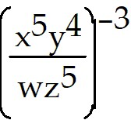
A) 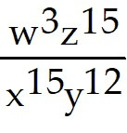
B) 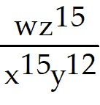
C) 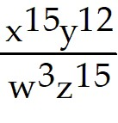
D) 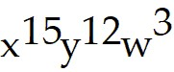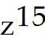
Answer: A
Diff: 2 Type: BI Var: 36 Page Ref: 23-24
Topic: 1.4 Exponents
Skill: Recall
Objective: (1.4) Simplify Exponent Expression (Combined Rules)

1.4.5 Use Calculator to Evaluate Expression (No Literal Numbers)

Evaluate the expression. All numbers are approximate. State your answer with the proper accuracy and precision.

1) 5 + 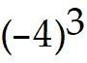 - 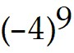
A) 300,000
B) 262,085
C) -262,075
D) -262,203
Answer: A
Diff: 2 Type: BI Var: 50+ Page Ref: 26
Topic: 1.4 Exponents
Skill: Recall
Objective: (1.4) Use Calculator to Evaluate Expression (No Literal Numbers)

2) -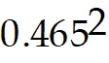 - 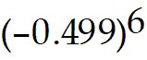
A) -0.232
B) -0.23
C) 0.232
D) -0.201
Answer: A
Diff: 2 Type: BI Var: 50+ Page Ref: 26
Topic: 1.4 Exponents
Skill: Recall
Objective: (1.4) Use Calculator to Evaluate Expression (No Literal Numbers)

3) 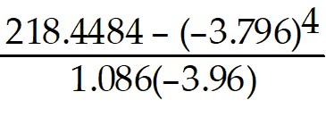
A) -2.51
B) -2.514
C) -99.08
D) 2.51
Answer: A
Diff: 2 Type: BI Var: 50+ Page Ref: 26
Topic: 1.4 Exponents
Skill: Recall
Objective: (1.4) Use Calculator to Evaluate Expression (No Literal Numbers)

4) 4.55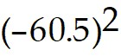 - 2500/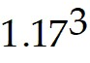 + 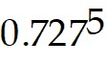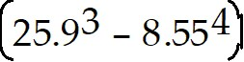
A) 17,500
B) 17,536
C) 5.79
D) 11,281
Answer: A
Diff: 2 Type: BI Var: 50+ Page Ref: 26
Topic: 1.4 Exponents
Skill: Recall
Objective: (1.4) Use Calculator to Evaluate Expression (No Literal Numbers)

1.4.6 Solve Apps: Operate with Exponents

Solve the problem.

1) The formula for the volume of a wire is π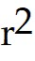h, where r is the radius of the wire and h is the length. Find the volume of a wire if 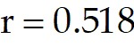 units and 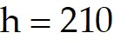 units.
A) 180 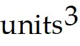
B) 177
C) 72,000
D) 71,800
Answer: A
Diff: 2 Type: BI Var: 50+ Page Ref: 27
Topic: 1.4 Exponents
Skill: Applied
Objective: (1.4) Solve Apps: Operate with Exponents

2) The volume of a sphere is 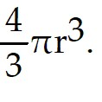 Find the volume of a bearing if the diameter is 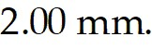
A) 4.19 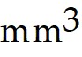
B) 13.1
C) 73
D) 4.2
Answer: A
Diff: 2 Type: BI Var: 41 Page Ref: 27
Topic: 1.4 Exponents
Skill: Applied
Objective: (1.4) Solve Apps: Operate with Exponents

3) If $ 3300 is invested at 5.8% interest, compounded quarterly, the amount in the account after 7 years is 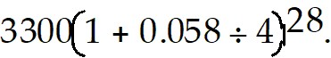 Calculate the amount (the 1 is exact).
A) $ 4938.23
B) $ 4900.00
C) $ 0.30
D) $ 1.50
Answer: A
Diff: 2 Type: BI Var: 50+ Page Ref: 27
Topic: 1.4 Exponents
Skill: Applied
Objective: (1.4) Solve Apps: Operate with Exponents

4) If the deflection (in cm) of a beam is calculated by the expression 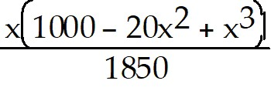, where x is the distance (in m) from one end of the beam to the point where the force is applied, then what is the deflection if the force is applied in the center of a 8.54 m beam? (The 1000 and 20 are exact numbers.)
A) 1.65 cm
B) 1.646 cm
C) -1.76 cm
D) -1.72 cm
Answer: A
Diff: 2 Type: BI Var: 50+ Page Ref: 27
Topic: 1.4 Exponents
Skill: Applied
Objective: (1.4) Solve Apps: Operate with Exponents

1.5 Scientific Notation

1.5.1 Change from Scientific to Ordinary Notation

Express the number in standard notation.

1) 4.43 × 106
A) 4,430,000
B) 44,300,000
C) 443,000
D) 265.8
Answer: A
Diff: 2 Type: BI Var: 50+ Page Ref: 28-29
Topic: 1.5 Scientific Notation
Skill: Recall
Objective: (1.5) Change from Scientific to Ordinary Notation

2) 6.699 × 104
A) 66,990
B) 669,900
C) 6699
D) 267.96
Answer: A
Diff: 2 Type: BI Var: 50+ Page Ref: 28-29
Topic: 1.5 Scientific Notation
Skill: Recall
Objective: (1.5) Change from Scientific to Ordinary Notation

3) 1.0789 × 104
A) 10,789
B) 107,890
C) 1078.9
D) 43.156
Answer: A
Diff: 2 Type: BI Var: 50+ Page Ref: 28-29
Topic: 1.5 Scientific Notation
Skill: Recall
Objective: (1.5) Change from Scientific to Ordinary Notation

4) 1. 73 × 10-4
A) 0.000 1 73
B) 0.00 1 73
C) 0.0000 1 73
D) -1 73,000
Answer: A
Diff: 2 Type: BI Var: 50+ Page Ref: 28-29
Topic: 1.5 Scientific Notation
Skill: Recall
Objective: (1.5) Change from Scientific to Ordinary Notation

5) 4. 716 × 10-5
A) 0.0000 4 716
B) 0.000 4 716
C) 0.00000 4 716
D) -4 71,600
Answer: A
Diff: 2 Type: BI Var: 50+ Page Ref: 28-29
Topic: 1.5 Scientific Notation
Skill: Recall
Objective: (1.5) Change from Scientific to Ordinary Notation

6) 2. 128 × 10-6
A) 0.00000 2 128
B) 0.0000 2 128
C) 0.000000 2 128
D) -2, 128,000
Answer: A
Diff: 2 Type: BI Var: 50+ Page Ref: 28-29
Topic: 1.5 Scientific Notation
Skill: Recall
Objective: (1.5) Change from Scientific to Ordinary Notation

7) 5. 0 122 × 10-7
A) 0.000000 5 0 122
B) 0.00000 5 0 122
C) 0.0000000 5 0 122
D) -5 0 1, 220, 0 0 0
Answer: A
Diff: 2 Type: BI Var: 50+ Page Ref: 28-29
Topic: 1.5 Scientific Notation
Skill: Recall
Objective: (1.5) Change from Scientific to Ordinary Notation

1.5.2 Change from Ordinary to Scientific Notation

Express the number in scientific notation.

1) 0.000 693
A) 6.93 x 10-4
B) 6.93 x 104
C) 6.93 x 10-5
D) 6.93 x 10-3
Answer: A
Diff: 2 Type: BI Var: 50+ Page Ref: 28-29
Topic: 1.5 Scientific Notation
Skill: Recall
Objective: (1.5) Change from Ordinary to Scientific Notation

2) 0.0000 467 18
A) 4.67 18 x 10-5
B) 4.67 18 x 105
C) 4.67 18 x 10-4
D) 4.67 18 x 104
Answer: A
Diff: 2 Type: BI Var: 50+ Page Ref: 28-29
Topic: 1.5 Scientific Notation
Skill: Recall
Objective: (1.5) Change from Ordinary to Scientific Notation

3) 0.00000 315 17
A) 3.15 17 x 10-6
B) 3.15 17 x 106
C) 3.15 17 x 10-5
D) 3.15 17 x 10-7
Answer: A
Diff: 2 Type: BI Var: 50+ Page Ref: 28-29
Topic: 1.5 Scientific Notation
Skill: Recall
Objective: (1.5) Change from Ordinary to Scientific Notation

4) 0.000000 289 0 4
A) 2.89 0 4 x 10-7
B) 2.89 0 4 x 107
C) 2.89 0 4 x 10-6
D) 2.89 0 4 x 106
Answer: A
Diff: 2 Type: BI Var: 50+ Page Ref: 28-29
Topic: 1.5 Scientific Notation
Skill: Recall
Objective: (1.5) Change from Ordinary to Scientific Notation

5) 0.0000000 889 0 11
A) 8.89 0 11 x 10-8
B) 8.89 0 11 x 108
C) 8.89 0 11 x 10-7
D) 8.89 0 11 x 10-9
Answer: A
Diff: 2 Type: BI Var: 50+ Page Ref: 28-29
Topic: 1.5 Scientific Notation
Skill: Recall
Objective: (1.5) Change from Ordinary to Scientific Notation

6) 88,000,000,000
A) 8.8 × 1010
B) 8.8 × 10-10
C) 8.8 × 109
D) 8.8 × 10-9
Answer: A
Diff: 2 Type: BI Var: 50+ Page Ref: 28-29
Topic: 1.5 Scientific Notation
Skill: Recall
Objective: (1.5) Change from Ordinary to Scientific Notation

7) 907,000,000,000,000,000
A) 9.07 × 1017
B) 9.07 × 10-17
C) 907 × 1015
D) 907 × 10-15
Answer: A
Diff: 2 Type: BI Var: 50+ Page Ref: 28-29
Topic: 1.5 Scientific Notation
Skill: Recall
Objective: (1.5) Change from Ordinary to Scientific Notation

8) 9, 400,000,000,000
A) 9.4 × 1012
B) 9.4 × 10-12
C) 9.4 × 109
D) 9.4 × 10-9
Answer: A
Diff: 2 Type: BI Var: 50+ Page Ref: 28-29
Topic: 1.5 Scientific Notation
Skill: Recall
Objective: (1.5) Change from Ordinary to Scientific Notation

9) 2, 616,000,000
A) 2.616 × 109
B) 2616 × 106
C) 261.6 × 107
D) 2.616 × 106
Answer: A
Diff: 2 Type: BI Var: 50+ Page Ref: 28-29
Topic: 1.5 Scientific Notation
Skill: Recall
Objective: (1.5) Change from Ordinary to Scientific Notation

10) 221,965,000,000
A) 2.21965 × 1011
B) 2219.65 × 108
C) 2.21965 × 109
D) 221.965 × 109
Answer: A
Diff: 2 Type: BI Var: 50+ Page Ref: 28-29
Topic: 1.5 Scientific Notation
Skill: Recall
Objective: (1.5) Change from Ordinary to Scientific Notation

1.5.3 Change to Scientific Notation and Calculate

Rewrite each number using scientific notation before performing the operation. Leave your answer in scientific notation form.

1) ( 400)( 900,000)
A) 3.6 × 108
B) 3.6 × 107
C) 3.6 × 109
D) 3.6 × 1010
Answer: A
Diff: 2 Type: BI Var: 50+ Page Ref: 29
Topic: 1.5 Scientific Notation
Skill: Recall
Objective: (1.5) Change to Scientific Notation and Calculate

2) ( 2,000,000)( 0.005)
A) 1.0 × 104
B) 1.0 × 103
C) 1.0 × 102
D) 0.0
Answer: A
Diff: 2 Type: BI Var: 18 Page Ref: 29
Topic: 1.5 Scientific Notation
Skill: Recall
Objective: (1.5) Change to Scientific Notation and Calculate

3) 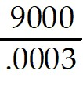
A) 3 × 107
B) 3 × 106
C) 3 × 108
D) 3 × 103
Answer: A
Diff: 2 Type: BI Var: 4 Page Ref: 29
Topic: 1.5 Scientific Notation
Skill: Recall
Objective: (1.5) Change to Scientific Notation and Calculate

4) 2 × 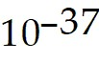 + 4 × 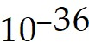
A) 4.2 × 10-36
B) 4.2 × 10-37
C) 4.2 × 10-35
D) 6.0 × 10-36
Answer: A
Diff: 2 Type: BI Var: 21 Page Ref: 29
Topic: 1.5 Scientific Notation
Skill: Recall
Objective: (1.5) Change to Scientific Notation and Calculate

5) 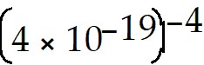
A) 3.91 × 1073
B) 4.00 × 10-23
C) 4.00 × 1015
D) 3.91 × 10-22
Answer: A
Diff: 2 Type: BI Var: 50+ Page Ref: 29
Topic: 1.5 Scientific Notation
Skill: Recall
Objective: (1.5) Change to Scientific Notation and Calculate

1.5.4 Use Calculator to Convert, Calculate, and Express (Approximate Numbers)

Use a calculator to perform the operation. Express your answer in scientific notation.

1) 0.0000816( 0.00559)( 2,620,000,000)
A) 1.20 × 103
B) 1.20 × 10-13
C) 1.20 × 101
D) 1.20 × 108
Answer: A
Diff: 2 Type: BI Var: 50+ Page Ref: 30
Topic: 1.5 Scientific Notation
Skill: Recall
Objective: (1.5) Use Calculator to Convert, Calculate, and Express (Approximate Numbers)

2) 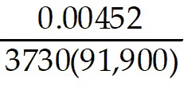
A) 1.32 × 10-11
B) 1.318603098 × 10-11
C) 1.32 × 10-3
D) 1.32 × 10-1
Answer: A
Diff: 2 Type: BI Var: 50+ Page Ref: 30
Topic: 1.5 Scientific Notation
Skill: Recall
Objective: (1.5) Use Calculator to Convert, Calculate, and Express (Approximate Numbers)

3) 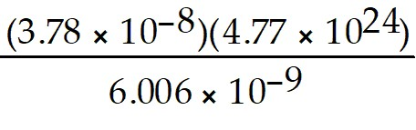
A) 3.00 × 1025
B) 3.002097902 × 1025
C) 3.00 × 1023
D) 6.40 × 101
Answer: A
Diff: 2 Type: BI Var: 50+ Page Ref: 30
Topic: 1.5 Scientific Notation
Skill: Recall
Objective: (1.5) Use Calculator to Convert, Calculate, and Express (Approximate Numbers)

1.5.5 Solve Apps: Use Scientific Notation

Use scientific notation to solve the problem.

1) The national debt of a small country is $6 630 000 000 and the population is 2 700 000. What is the amount of debt per person?
A) $ 2.46 x 103
B) $ 2.46
C) $ 2.46 x 106
D) $ 24.60
Answer: A
Diff: 2 Type: BI Var: 50+ Page Ref: 29-30
Topic: 1.5 Scientific Notation
Skill: Applied
Objective: (1.5) Solve Apps: Use Scientific Notation

2) A company produced 925 000 small appliances in one year and made a profit of $8 620 000. What was the profit on each appliance?
A) $9.32
B) $9.32 x 102
C) $1.07 x 10-1
D) $1.07
Answer: A
Diff: 2 Type: BI Var: 1 Page Ref: 29-30
Topic: 1.5 Scientific Notation
Skill: Applied
Objective: (1.5) Solve Apps: Use Scientific Notation

3) The earth is approximately 92 900 000 miles from the sun. 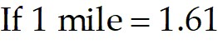 x 103 m, what is the distance to the sun in meters?
A) 1.50 x 1011 m
B) 1.50 x 1010 m
C) 5.7 x 10-10 m
D) 5.7 x 1010 m
Answer: A
Diff: 2 Type: BI Var: 1 Page Ref: 29-30
Topic: 1.5 Scientific Notation
Skill: Applied
Objective: (1.5) Solve Apps: Use Scientific Notation

4) The distance from the earth to the sun is 149 600 000 km. How long would it take a rocket, traveling at 4.667 x 103 miles per hour, to reach the sun?
A) 3.2 x 104 hr
B) 3.2 x 103 hr
C) 3.2 hr
D) 3.2 x 102 hr
Answer: A
Diff: 2 Type: BI Var: 1 Page Ref: 29-30
Topic: 1.5 Scientific Notation
Skill: Applied
Objective: (1.5) Solve Apps: Use Scientific Notation

5) If the speed of light is 3.00 x 108 m/sec, how long does it take light to travel 2.29 x 1011 m, the distance from the sun to Mars?
A) 7.6 x 102 sec
B) 7.6 x 102 min
C) 7.6 x 103 sec
D) 76 sec
Answer: A
Diff: 2 Type: BI Var: 1 Page Ref: 29-30
Topic: 1.5 Scientific Notation
Skill: Applied
Objective: (1.5) Solve Apps: Use Scientific Notation

6) A light-year is the distance that light travels in one year. Find the number of miles in a light-year if light travels 1.86 x 105 miles per second.
A) 6.0 x 1012 miles
B) 6.0 x 105 miles
C) 6.0 x 107 miles
D) 6.0 x 1014 miles
Answer: A
Diff: 2 Type: BI Var: 1 Page Ref: 29-30
Topic: 1.5 Scientific Notation
Skill: Applied
Objective: (1.5) Solve Apps: Use Scientific Notation

7) A computer can do one calculation in 1.4 x 10-7 seconds. How long would it take the computer to do a trillion (1012) calculations?
A) 1.4 x 105 sec
B) 1.4 x 10-7 sec
C) 1.4 x 1012 sec
D) 1.4 x 106 sec
Answer: A
Diff: 2 Type: BI Var: 1 Page Ref: 29-30
Topic: 1.5 Scientific Notation
Skill: Applied
Objective: (1.5) Solve Apps: Use Scientific Notation

8) Assume that the volume of the earth is 5 x 1014 cubic meters and the volume of a bacterium is 2.5 x 10-16 cubic meters. If the earth could be filled with bacteria, how many would it contain?
A) 2.0 x 1030 bacteria
B) 2.0 x 10-30 bacteria
C) 5.0 x 10-31 bacteria
D) 5.0 x 1031 bacteria
Answer: A
Diff: 2 Type: BI Var: 1 Page Ref: 29-30
Topic: 1.5 Scientific Notation
Skill: Applied
Objective: (1.5) Solve Apps: Use Scientific Notation

1.6 Roots and Radicals

1.6.1 Simplify Expression (Perfect Squares)

Determine the principal value without using a calculator.

1) 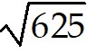
A) 25
B) 26
C) 312
D) Not a real number
Answer: A
Diff: 1 Type: BI Var: 24 Page Ref: 32
Topic: 1.6 Roots and Radicals
Skill: Recall
Objective: (1.6) Simplify Expression (Perfect Squares)

2) 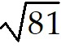
A) 9
B) 81
C) 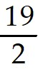
D) 6
Answer: A
Diff: 1 Type: BI Var: 50+ Page Ref: 32
Topic: 1.6 Roots and Radicals
Skill: Recall
Objective: (1.6) Simplify Expression (Perfect Squares)

3) - 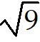
A) -3
B) 3
C) -4
D) Not a real number
Answer: A
Diff: 1 Type: BI Var: 24 Page Ref: 32
Topic: 1.6 Roots and Radicals
Skill: Recall
Objective: (1.6) Simplify Expression (Perfect Squares)

4) - 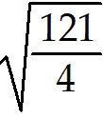
A) - 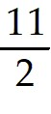
B) - 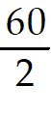
C)
D) Not a real number
Answer: A
Diff: 1 Type: BI Var: 50+ Page Ref: 32
Topic: 1.6 Roots and Radicals
Skill: Recall
Objective: (1.6) Simplify Expression (Perfect Squares)

5) - 3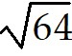
A) -4
B) 4
C) 16
D) Not real number
Answer: A
Diff: 1 Type: BI Var: 9 Page Ref: 32
Topic: 1.6 Roots and Radicals
Skill: Recall
Objective: (1.6) Simplify Expression (Perfect Squares)

6) 3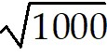
A) 10
B) 100
C) Not real number
D) 31
Answer: A
Diff: 1 Type: BI Var: 9 Page Ref: 32
Topic: 1.6 Roots and Radicals
Skill: Recall
Objective: (1.6) Simplify Expression (Perfect Squares)

7) 3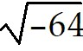
A) -4
B) Not real number
C) 8
D) 4
Answer: A
Diff: 1 Type: BI Var: 9 Page Ref: 32
Topic: 1.6 Roots and Radicals
Skill: Recall
Objective: (1.6) Simplify Expression (Perfect Squares)

8) - 4
A) -5
B) 8.368
C) 25
D) Not real number
Answer: A
Diff: 1 Type: BI Var: 5 Page Ref: 32
Topic: 1.6 Roots and Radicals
Skill: Recall
Objective: (1.6) Simplify Expression (Perfect Squares)

9) 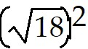
A) 18
B) -18 or 18
C) -18
D) Not real number
Answer: A
Diff: 1 Type: BI Var: 16 Page Ref: 32
Topic: 1.6 Roots and Radicals
Skill: Recall
Objective: (1.6) Simplify Expression (Perfect Squares)

10) 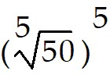
A) 50
B) Not real number
C) -50
D) 50 or -50
Answer: A
Diff: 1 Type: BI Var: 50+ Page Ref: 32
Topic: 1.6 Roots and Radicals
Skill: Recall
Objective: (1.6) Simplify Expression (Perfect Squares)

1.6.2 Simplify Expression (Exact Answer)

Simplify.

1) 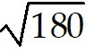
A) 6
B) 36
C) 13
D) 6
Answer: A
Diff: 2 Type: BI Var: 30 Page Ref: 32
Topic: 1.6 Roots and Radicals
Skill: Recall
Objective: (1.6) Simplify Expression (Exact Answer)

2) - 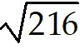
A) -6
B) -36
C) 14
D) 6
Answer: A
Diff: 2 Type: BI Var: 30 Page Ref: 32
Topic: 1.6 Roots and Radicals
Skill: Recall
Objective: (1.6) Simplify Expression (Exact Answer)

3) 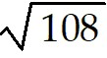
A) 6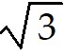
B) 3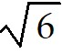
C) 18
D) 10
Answer: A
Diff: 2 Type: BI Var: 25 Page Ref: 32
Topic: 1.6 Roots and Radicals
Skill: Recall
Objective: (1.6) Simplify Expression (Exact Answer)

4) 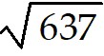
A) 7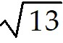
B) 13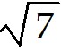
C) 91
D) 25
Answer: A
Diff: 2 Type: BI Var: 36 Page Ref: 32
Topic: 1.6 Roots and Radicals
Skill: Recall
Objective: (1.6) Simplify Expression (Exact Answer)

5) - 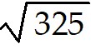
A) -5
B) -13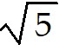
C) -65
D) -18
Answer: A
Diff: 2 Type: BI Var: 36 Page Ref: 32
Topic: 1.6 Roots and Radicals
Skill: Recall
Objective: (1.6) Simplify Expression (Exact Answer)

6) 5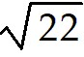
A) 5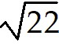
B) 22
C) 110
D) 23
Answer: A
Diff: 2 Type: BI Var: 50+ Page Ref: 32
Topic: 1.6 Roots and Radicals
Skill: Recall
Objective: (1.6) Simplify Expression (Exact Answer)

7) 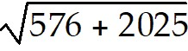
A) 51
B) 69
C) Not a real number
D) 21
Answer: A
Diff: 2 Type: BI Var: 4 Page Ref: 32
Topic: 1.6 Roots and Radicals
Skill: Recall
Objective: (1.6) Simplify Expression (Exact Answer)

8) 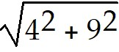
A) 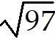
B) 13
C) Not real number
D) 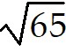
Answer: A
Diff: 2 Type: BI Var: 28 Page Ref: 32
Topic: 1.6 Roots and Radicals
Skill: Recall
Objective: (1.6) Simplify Expression (Exact Answer)

9) 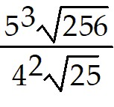
A) 25
B) 125
C) 500
D) 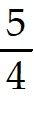
Answer: A
Diff: 2 Type: BI Var: 36 Page Ref: 32
Topic: 1.6 Roots and Radicals
Skill: Recall
Objective: (1.6) Simplify Expression (Exact Answer)

10) 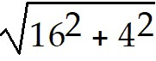
A) 4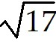
B) 20
C) 12
D) 4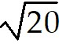
Answer: A
Diff: 2 Type: BI Var: 3 Page Ref: 32
Topic: 1.6 Roots and Radicals
Skill: Recall
Objective: (1.6) Simplify Expression (Exact Answer)

1.6.3 Use Calculator to Find Value of Expression (Approximation)

Find the value of each square root by use of a calculator. Each number is approximate.

1) 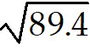
A) 9.46
B) 7990
C) 9.5
D) 29.9
Answer: A
Diff: 1 Type: BI Var: 50+ Page Ref: 32
Topic: 1.6 Roots and Radicals
Skill: Recall
Objective: (1.6) Use Calculator to Find Value of Expression (Approximation)

2) 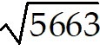
A) 75.25
B) 75
C) 75.3
D) 75.253
Answer: A
Diff: 1 Type: BI Var: 50+ Page Ref: 32
Topic: 1.6 Roots and Radicals
Skill: Recall
Objective: (1.6) Use Calculator to Find Value of Expression (Approximation)

3) 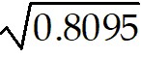
A) 0.9000
B) 0.90
C) 0.900
D) 0.6553
Answer: A
Diff: 1 Type: BI Var: 50+ Page Ref: 32
Topic: 1.6 Roots and Radicals
Skill: Recall
Objective: (1.6) Use Calculator to Find Value of Expression (Approximation)

4) 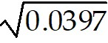
A) 0.199
B) 0.20
C) 0.630
D) 0.1990
Answer: A
Diff: 1 Type: BI Var: 50+ Page Ref: 32
Topic: 1.6 Roots and Radicals
Skill: Recall
Objective: (1.6) Use Calculator to Find Value of Expression (Approximation)

5) 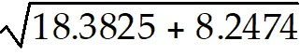
A) 5.1604
B) 7.1593
C) 5.16042
D) 7.15930
Answer: A
Diff: 1 Type: BI Var: 50+ Page Ref: 32
Topic: 1.6 Roots and Radicals
Skill: Recall
Objective: (1.6) Use Calculator to Find Value of Expression (Approximation)

6) 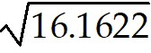 + 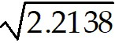
A) 5.5081
B) 5.50810
C) 4.2867
D) 4.28670
Answer: A
Diff: 1 Type: BI Var: 50+ Page Ref: 32
Topic: 1.6 Roots and Radicals
Skill: Recall
Objective: (1.6) Use Calculator to Find Value of Expression (Approximation)

7) 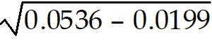
A) 0.184
B) 0.0904
C) 0.18
D) 0.090
Answer: A
Diff: 1 Type: BI Var: 50+ Page Ref: 32
Topic: 1.6 Roots and Radicals
Skill: Recall
Objective: (1.6) Use Calculator to Find Value of Expression (Approximation)

8) 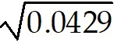 - 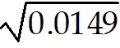
A) 0.0851
B) 0.085
C) 0.167
D) 0.17
Answer: A
Diff: 1 Type: BI Var: 50+ Page Ref: 32
Topic: 1.6 Roots and Radicals
Skill: Recall
Objective: (1.6) Use Calculator to Find Value of Expression (Approximation)

9) 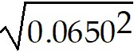 - 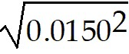
A) 0.0500
B) 0.0632
C) 0.0800
D) 0.0667
Answer: A
Diff: 1 Type: BI Var: 50+ Page Ref: 32
Topic: 1.6 Roots and Radicals
Skill: Recall
Objective: (1.6) Use Calculator to Find Value of Expression (Approximation)

10) 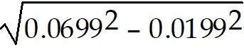
A) 0.0670
B) 0.0500
C) 0.06701
D) 0.0727
Answer: A
Diff: 1 Type: BI Var: 50+ Page Ref: 32
Topic: 1.6 Roots and Radicals
Skill: Recall
Objective: (1.6) Use Calculator to Find Value of Expression (Approximation)

1.6.4 Solve Apps: Square Roots

Use your calculator to solve the problem.

1) The length of a hypotenuse c of a right triangle with legs a and b of lengths a = 74mm and b = 15mm is given by c = 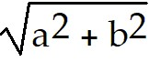. Calculate the length of the hypotenuse. (Round to an appropriate number of significant digits.)
A) 76mm
B) 75.5mm
C) 89mm
D) 72mm
Answer: A
Diff: 2 Type: BI Var: 50+ Page Ref: 32
Topic: 1.6 Roots and Radicals
Skill: Applied
Objective: (1.6) Solve Apps: Square Roots

2) When a ball with coefficient of restitution e is dropped from a height h meters onto a large flat surface, the time t from the first impact until the ball stops bouncing is given by t = 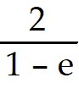 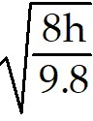 seconds. Find the time it takes a ball with coefficient of restitution 0.25 to stop bouncing if it is dropped from a height of 72.9 centimeters. (Round to the nearest tenth.)
A) 2.1 seconds
B) 20.6 seconds
C) 2.3 seconds
D) 23.1 seconds
Answer: A
Diff: 2 Type: BI Var: 50+ Page Ref: 32
Topic: 1.6 Roots and Radicals
Skill: Applied
Objective: (1.6) Solve Apps: Square Roots

3) The length (in feet) an industrial spring is stretched from its natural length with work, W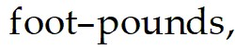 is given by L = 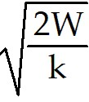, where k is a constant for the given spring. If a certain spring has a constant of 54.6 and has 644 foot-pounds of work applied, how far will it stretch?
A) 4.86 feet
B) 23.6 feet
C) 3.43 feet
D) 556 feet
Answer: A
Diff: 2 Type: BI Var: 50+ Page Ref: 32
Topic: 1.6 Roots and Radicals
Skill: Applied
Objective: (1.6) Solve Apps: Square Roots

4) The impedance (in ohms) of a series RLC circuit is given by the expression 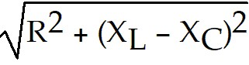, where R is the resistance of the resistor, 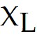 is the reactance of the coil, and 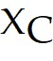 is the reactance of the capacitor. What is the impedance of a circuit containing a 220 ohm resistor, a coil with a reactance of 1584 ohms, and a capacitor with a reactance of 918 ohms? (All values are approximate.)
A) 700 ohms
B) 890 ohms
C) 490,000 ohms
D) 2.4 × 1011 ohms
Answer: A
Diff: 2 Type: BI Var: 50+ Page Ref: 32
Topic: 1.6 Roots and Radicals
Skill: Applied
Objective: (1.6) Solve Apps: Square Roots

5) At the end of a lease, a vehicle has a value V of $23,000. The original cost was $39,000. The annual rate of depreciation incurred by the leasing company can be expressed as 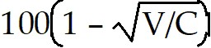. Find the annual rate (the 1 and 100 are exact).
A) $23
B) $88
C) -$30
D) $65
Answer: A
Diff: 2 Type: BI Var: 30 Page Ref: 32
Topic: 1.6 Roots and Radicals
Skill: Applied
Objective: (1.6) Solve Apps: Square Roots

1.7 Addition and Subtraction of Algebraic Expressions

1.7.1 Simplify Algebraic Expression (No Parentheses)

Collect like terms and write in descending order.

1) -5m5 + 2m5
A) -3m5
B) -3m10
C) Can't be simplified
D) -15m
Answer: A
Diff: 1 Type: BI Var: 50+ Page Ref: 34-35
Topic: 1.7 Addition and Subtraction of Algebraic Expressions
Skill: Recall
Objective: (1.7) Simplify Algebraic Expression (No Parentheses)

2) -7y9 - 8y8
A) Can't be simplified
B) -15y8
C) -15y17
D) -15y9
Answer: A
Diff: 1 Type: BI Var: 50+ Page Ref: 34-35
Topic: 1.7 Addition and Subtraction of Algebraic Expressions
Skill: Recall
Objective: (1.7) Simplify Algebraic Expression (No Parentheses)

3) -9x2y3 - 7x2y3 - 9x2y3 - 4x2y3 + 7x2y3
A) -22x2y3
B) Can't be simplified
C) -36x2y3
D) -4x2y3
Answer: A
Diff: 1 Type: BI Var: 50+ Page Ref: 34-35
Topic: 1.7 Addition and Subtraction of Algebraic Expressions
Skill: Recall
Objective: (1.7) Simplify Algebraic Expression (No Parentheses)

4) -8z8 + 4z9
A) 4z9 - 8z8
B) -4z8
C) -4z4
D) -4z17
Answer: A
Diff: 1 Type: BI Var: 50+ Page Ref: 34-35
Topic: 1.7 Addition and Subtraction of Algebraic Expressions
Skill: Recall
Objective: (1.7) Simplify Algebraic Expression (No Parentheses)

5) 4x2 + 3x2 - 5x2
A) 2x2
B) Can't be simplified
C) 2x6
D) -60x2
Answer: A
Diff: 1 Type: BI Var: 50+ Page Ref: 34-35
Topic: 1.7 Addition and Subtraction of Algebraic Expressions
Skill: Recall
Objective: (1.7) Simplify Algebraic Expression (No Parentheses)

6) 6x8 + 2x2 + 7x8
A) 13x8 + 2x2
B) Can't be simplified
C) 15x18
D) 15x2
Answer: A
Diff: 1 Type: BI Var: 50+ Page Ref: 34-35
Topic: 1.7 Addition and Subtraction of Algebraic Expressions
Skill: Recall
Objective: (1.7) Simplify Algebraic Expression (No Parentheses)

7) 7m4 + 8m4 + 4m4 + 4m4
A) 23m4
B) 23m16
C) 92m
D) Can't be simplified
Answer: A
Diff: 1 Type: BI Var: 50+ Page Ref: 34-35
Topic: 1.7 Addition and Subtraction of Algebraic Expressions
Skill: Recall
Objective: (1.7) Simplify Algebraic Expression (No Parentheses)

8) 7a8 - 3a8 + 7a7 + 11a8 - 10a7
A) 15a8 - 3a7
B) 12a8
C) 12a15
D) Can't be simplified
Answer: A
Diff: 1 Type: BI Var: 50+ Page Ref: 34-35
Topic: 1.7 Addition and Subtraction of Algebraic Expressions
Skill: Recall
Objective: (1.7) Simplify Algebraic Expression (No Parentheses)

9) -2m7 + 11m6 - 3m5 + 9m7 - 3m6
A) 7m7 + 8m6 - 3m5
B) 2m18
C) 36m
D) Can't be simplified
Answer: A
Diff: 1 Type: BI Var: 50+ Page Ref: 34-35
Topic: 1.7 Addition and Subtraction of Algebraic Expressions
Skill: Recall
Objective: (1.7) Simplify Algebraic Expression (No Parentheses)

10) 2y7 + 7y5 - 8y4 + 6
A) Can't be simplified
B) 7y16
C) 1y16 + 6
D) 2y7 + 7y5 - 8y4
Answer: A
Diff: 1 Type: BI Var: 50+ Page Ref: 34-35
Topic: 1.7 Addition and Subtraction of Algebraic Expressions
Skill: Recall
Objective: (1.7) Simplify Algebraic Expression (No Parentheses)

1.7.2 Simplify Algebraic Expression (Parentheses)

Perform the indicated operation.

1) ( 3a3 + 7a2) + ( 3a3 + 5a2)
A) 6a3 + 12a2
B) 6a6 + 12a4
C) 18a5
D) 18a10
Answer: A
Diff: 1 Type: BI Var: 50+ Page Ref: 36
Topic: 1.7 Addition and Subtraction of Algebraic Expressions
Skill: Recall
Objective: (1.7) Simplify Algebraic Expression (Parentheses)

2) ( -9a4 + 15a2) - ( 18a4 + 14a2)
A) -27a4 + 1a2
B) -27a4 + 29a2
C) -26a6
D) 9a4 + 29a2
Answer: A
Diff: 1 Type: BI Var: 50+ Page Ref: 36
Topic: 1.7 Addition and Subtraction of Algebraic Expressions
Skill: Recall
Objective: (1.7) Simplify Algebraic Expression (Parentheses)

3) ( -9 + 3n7 + 4n6) + ( 4n7 + 2n6 + 3)
A) 7n7 + 6n6 - 6
B) -5n7 + 5n6 + 7
C) 7 + 6n7 - 6n6
D) 7n13
Answer: A
Diff: 1 Type: BI Var: 50+ Page Ref: 36
Topic: 1.7 Addition and Subtraction of Algebraic Expressions
Skill: Recall
Objective: (1.7) Simplify Algebraic Expression (Parentheses)

4) ( 5n7 + 10n4 + 16) - ( -18n4 + 8n7 - 5)
A) -3n7 + 28n4 + 21
B) -3n7 + 18n4 + 11
C) -3n7 + 28n4 + 11
D) 46n11
Answer: A
Diff: 2 Type: BI Var: 50+ Page Ref: 36
Topic: 1.7 Addition and Subtraction of Algebraic Expressions
Skill: Recall
Objective: (1.7) Simplify Algebraic Expression (Parentheses)

5) ( 2n5 + 2n - 8n4) + ( -4n4 + 6n5 - 4n)
A) 8n5 - 12n4 - 2n
B) 8n5 - 2n4 - 12n
C) 8n - 12n5 - 2n4
D) -6n10
Answer: A
Diff: 2 Type: BI Var: 50+ Page Ref: 36
Topic: 1.7 Addition and Subtraction of Algebraic Expressions
Skill: Recall
Objective: (1.7) Simplify Algebraic Expression (Parentheses)

6) ( -15n + 2n7 - 20n5) - ( 10n5 + 8n7 - 17n)
A) -6n7 - 30n5 + 2n
B) -6n7 - 12n5 - 32n
C) -6n7 - 30n5 - 32n
D) -34n13
Answer: A
Diff: 2 Type: BI Var: 50+ Page Ref: 36
Topic: 1.7 Addition and Subtraction of Algebraic Expressions
Skill: Recall
Objective: (1.7) Simplify Algebraic Expression (Parentheses)

7) ( 3 + 8x3 + 4x5 + 9x4) + ( 6x4 + 7x3 - 8 + 5x5)
A) 9x5 + 15x4 + 15x3 - 5
B) 9x10 + 15x8 + 15x6 - 5
C) 39x24 - 5
D) 9x5 + 9x4 - 4x3 + 14
Answer: A
Diff: 2 Type: BI Var: 50+ Page Ref: 36
Topic: 1.7 Addition and Subtraction of Algebraic Expressions
Skill: Recall
Objective: (1.7) Simplify Algebraic Expression (Parentheses)

8) ( -2x7 + 3x9 - 5 + 5x8) - ( 9 + 9x8 + 8x9 + 5x7)
A) -5x9 - 4x8 - 7x7 - 14
B) 11x9 + 14x8 + 3x7 + 4
C) -5x9 + 14x8 + 3x7 + 4
D) 11x9 + 14x8 + 3x7 - 14
Answer: A
Diff: 2 Type: BI Var: 50+ Page Ref: 36
Topic: 1.7 Addition and Subtraction of Algebraic Expressions
Skill: Recall
Objective: (1.7) Simplify Algebraic Expression (Parentheses)

9) ( 4x6 + 3x8 - 7 - 4x7) - ( 3 + 2x7 + 6x8 - 8x6)
A) -3x8 - 6x7 + 12x6 - 10
B) 9x8 - 2x7 - 4x6 - 4
C) -3x8 - 2x7 - 4x6 - 4
D) 9x8 - 2x7 - 4x6 - 10
Answer: A
Diff: 2 Type: BI Var: 50+ Page Ref: 36
Topic: 1.7 Addition and Subtraction of Algebraic Expressions
Skill: Recall
Objective: (1.7) Simplify Algebraic Expression (Parentheses)

1.7.3 Simplify Algebraic Expression (Nested Parentheses)

Simplify the expression.

1) x - [ 6x - (x - 8)]
A) -4x - 8
B) -6x - 8
C) -8x + 8
D) -4x + 8
Answer: A
Diff: 2 Type: BI Var: 50+ Page Ref: 36-37
Topic: 1.7 Addition and Subtraction of Algebraic Expressions
Skill: Recall
Objective: (1.7) Simplify Algebraic Expression (Nested Parentheses)

2) y - [ 5y + (y - 3) + 5]
A) -5y - 2
B) -3y - 2
C) -5y + 2
D) 3y + 2
Answer: A
Diff: 2 Type: BI Var: 50+ Page Ref: 36-37
Topic: 1.7 Addition and Subtraction of Algebraic Expressions
Skill: Recall
Objective: (1.7) Simplify Algebraic Expression (Nested Parentheses)

3) z - { 3z + [ 4z - ( 7z - 5) + 7]}
A) z - 12
B) z - 2
C) -z - 12
D) 10z - 2
Answer: A
Diff: 2 Type: BI Var: 50+ Page Ref: 36-37
Topic: 1.7 Addition and Subtraction of Algebraic Expressions
Skill: Recall
Objective: (1.7) Simplify Algebraic Expression (Nested Parentheses)

4) b - { 8b - [b - ( 3b - 7) - 6]}
A) -9b + 1
B) -9b + 13
C) -3b + 13
D) -11b - 1
Answer: A
Diff: 2 Type: BI Var: 50+ Page Ref: 36-37
Topic: 1.7 Addition and Subtraction of Algebraic Expressions
Skill: Recall
Objective: (1.7) Simplify Algebraic Expression (Nested Parentheses)

5) [ -( 10 m2 + 8 m - 5 m3) + ( -4 m2 + 6 m - 2 m3)] + m2
A) 3 m3 - 13 m2 - 2 m
B) 7 m3 - 5 m2 - 14
C) -7 m3 + 7 m2 + 14
D) 3 m3 - 15 m2 - 2
Answer: A
Diff: 2 Type: BI Var: 50+ Page Ref: 36-37
Topic: 1.7 Addition and Subtraction of Algebraic Expressions
Skill: Recall
Objective: (1.7) Simplify Algebraic Expression (Nested Parentheses)

6) -[ 6 x - ( -10 x - 9)] + [ -( -5 x + ( 6 - 6 x)) - 5 x]
A) -10 x - 15
B) -22 x - 3
C) -32 x - 3
D) -2 x + 15
Answer: A
Diff: 2 Type: BI Var: 50+ Page Ref: 36-37
Topic: 1.7 Addition and Subtraction of Algebraic Expressions
Skill: Recall
Objective: (1.7) Simplify Algebraic Expression (Nested Parentheses)

1.7.4 Solve Apps: Addition/Subtraction Expressions

Perform the indicated operation.

1) The shape of a curve in a machined part results in the expression 6R - ( 3R - r). Simplify the expression.
A) 3R + r
B) 6R
C) 3R - r
D) r - 3R
Answer: A
Diff: 2 Type: BI Var: 4 Page Ref: 35-36
Topic: 1.7 Addition and Subtraction of Algebraic Expressions
Skill: Recall
Objective: (1.7) Solve Apps: Addition/Subtraction Expressions

2) Experiments on a new composite material yield
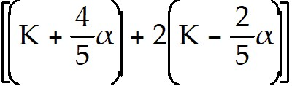 - 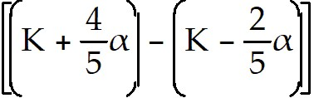 .
Simplify the expression.
A) 3K - α
B) K - 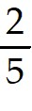α
C) 3K - α
D) K - α
Answer: A
Diff: 2 Type: BI Var: 3 Page Ref: 35-36
Topic: 1.7 Addition and Subtraction of Algebraic Expressions
Skill: Recall
Objective: (1.7) Solve Apps: Addition/Subtraction Expressions

3) A warehouse has x cases containing 18 boxes of product and x + 12 cases containing 22 boxes of product. Write a simplified expression to represent the total number of boxes of product in the warehouse.
A) 40x + 264 boxes
B) 40x + 12 boxes
C) 52x boxes
D) 12x + 396 boxes
Answer: A
Diff: 2 Type: BI Var: 50+ Page Ref: 35-36
Topic: 1.7 Addition and Subtraction of Algebraic Expressions
Skill: Recall
Objective: (1.7) Solve Apps: Addition/Subtraction Expressions

1.8 Multiplication of Algebraic Expressions

1.8.1 Multiply Monomials

Find the product.

1) 4( 3x)
A) 12x
B) 12
C) 7x
D) 7
Answer: A
Diff: 1 Type: BI Var: 50+ Page Ref: 38
Topic: 1.8 Multiplication of Algebraic Expressions
Skill: Recall
Objective: (1.8) Multiply Monomials

2) ( 7a)( 2a2)
A) 14a3
B) 14a4
C) 7a + 2a2
D) 9a3
Answer: A
Diff: 1 Type: BI Var: 50+ Page Ref: 38
Topic: 1.8 Multiplication of Algebraic Expressions
Skill: Recall
Objective: (1.8) Multiply Monomials

3) (-3y)(-7y7)
A) 21y8
B) -21y8
C) -10y7
D) 3y - 7y7
Answer: A
Diff: 1 Type: BI Var: 50+ Page Ref: 38
Topic: 1.8 Multiplication of Algebraic Expressions
Skill: Recall
Objective: (1.8) Multiply Monomials

4) ( 5x4)( 3x3)
A) 15x7
B) 15x12
C) 8x7
D) 8x12
Answer: A
Diff: 1 Type: BI Var: 50+ Page Ref: 38
Topic: 1.8 Multiplication of Algebraic Expressions
Skill: Recall
Objective: (1.8) Multiply Monomials

5) (-7x3)( 2x3)
A) -14x6
B) -14x9
C) 9x6
D) 9x9
Answer: A
Diff: 1 Type: BI Var: 50+ Page Ref: 38
Topic: 1.8 Multiplication of Algebraic Expressions
Skill: Recall
Objective: (1.8) Multiply Monomials

6) (-4x5)(-9x3)
A) 36x8
B) -36x15
C) -13x8
D) -13x15
Answer: A
Diff: 1 Type: BI Var: 50+ Page Ref: 38
Topic: 1.8 Multiplication of Algebraic Expressions
Skill: Recall
Objective: (1.8) Multiply Monomials

7) ( 4m4z4)( 2m3z2)
A) 8m7z6
B) 8m7z
C) 8mz6
D) 8mz7
Answer: A
Diff: 1 Type: BI Var: 50+ Page Ref: 38
Topic: 1.8 Multiplication of Algebraic Expressions
Skill: Recall
Objective: (1.8) Multiply Monomials

8) ( -2m3z4)( 3m2z2)
A) -6m5z6
B) -6m6z5
C) -6mz6
D) -6mz5
Answer: A
Diff: 1 Type: BI Var: 50+ Page Ref: 38
Topic: 1.8 Multiplication of Algebraic Expressions
Skill: Recall
Objective: (1.8) Multiply Monomials

9) ( -3x4y4)( -2x3y2)
A) 6x7y6
B) 6x6y7
C) 6xy6
D) 6xy7
Answer: A
Diff: 1 Type: BI Var: 50+ Page Ref: 38
Topic: 1.8 Multiplication of Algebraic Expressions
Skill: Recall
Objective: (1.8) Multiply Monomials

1.8.2 Multiply Polynomial by Monomial(s)

Find the product.

1) -11( 4x + 3)
A) -44x - 33
B) -77x
C) -44x + 3
D) 4x - 33
Answer: A
Diff: 2 Type: BI Var: 50+ Page Ref: 39
Topic: 1.8 Multiplication of Algebraic Expressions
Skill: Recall
Objective: (1.8) Multiply Polynomial by Monomial(s)

2) -3x( 5x - 9)
A) -15x2 + 27x
B) 12x2
C) -15x2 - 9x
D) 5x2 + 27x
Answer: A
Diff: 2 Type: BI Var: 50+ Page Ref: 39
Topic: 1.8 Multiplication of Algebraic Expressions
Skill: Recall
Objective: (1.8) Multiply Polynomial by Monomial(s)

3) 12x5( -3x + 6)
A) -36x6 + 72x5
B) -36x + 72
C) -36x6 + 6
D) 36x5
Answer: A
Diff: 2 Type: BI Var: 50+ Page Ref: 39
Topic: 1.8 Multiplication of Algebraic Expressions
Skill: Recall
Objective: (1.8) Multiply Polynomial by Monomial(s)

4) -5x7( -11x2 + 12)
A) 55x9 - 60x7
B) 55x2 - 60
C) 55x9 + 12
D) -5x7
Answer: A
Diff: 2 Type: BI Var: 50+ Page Ref: 39
Topic: 1.8 Multiplication of Algebraic Expressions
Skill: Recall
Objective: (1.8) Multiply Polynomial by Monomial(s)

5) -2x4( 10x7 + 4x4)
A) -20x11 - 8x8
B) -28x4
C) -20x11 + 4x4
D) -28x11 - 28x8
Answer: A
Diff: 2 Type: BI Var: 50+ Page Ref: 39
Topic: 1.8 Multiplication of Algebraic Expressions
Skill: Recall
Objective: (1.8) Multiply Polynomial by Monomial(s)

6) 12ax4( -3ax4 + 11x2)
A) -36a2x8 + 132ax6
B) -36a2x8 + 132x6
C) -36ax + 132x
D) -36a2x8 + 11x2
Answer: A
Diff: 2 Type: BI Var: 50+ Page Ref: 39
Topic: 1.8 Multiplication of Algebraic Expressions
Skill: Recall
Objective: (1.8) Multiply Polynomial by Monomial(s)

7) -7ax5( 6ax5 - 6x3 + 5)
A) -42a2x10 + 42ax8 - 35ax5
B) -42a2x10 + 42ax8
C) -42a2x10 - 6x3 + 5
D) -42ax5 + 42x3 - 35
Answer: A
Diff: 2 Type: BI Var: 50+ Page Ref: 39
Topic: 1.8 Multiplication of Algebraic Expressions
Skill: Recall
Objective: (1.8) Multiply Polynomial by Monomial(s)

8) 3ax3( 8ax7 + 10x5 + 9a)
A) 24a2x10 + 30ax8 + 27a2x3
B) 24a2x10 + 30ax8
C) 24a2x10 + 10x5 + 9a
D) 24ax7 + 30x5 + 27a
Answer: A
Diff: 2 Type: BI Var: 50+ Page Ref: 39
Topic: 1.8 Multiplication of Algebraic Expressions
Skill: Recall
Objective: (1.8) Multiply Polynomial by Monomial(s)

9) -8a3x8( 6a9x8 - 4x7 + 3a)
A) -48a12x16 + 32a3x15 - 24a4x8
B) -48a12x16 + 32a3x15 + 3a
C) -48a12x16 - 4x7 + 3a
D) -48a9x8 + 32x7 - 24a
Answer: A
Diff: 2 Type: BI Var: 50+ Page Ref: 39
Topic: 1.8 Multiplication of Algebraic Expressions
Skill: Recall
Objective: (1.8) Multiply Polynomial by Monomial(s)

1.8.3 Multiply Polynomials

Perform the indicated operations.

1) ( 4x - 6y)( 6x - y)
A) 24x2 - 40xy + 6y2
B) 10x2 - 40xy + 6y2
C) 24x2 - 40xy + 6y
D) 10x2 - 37xy + 6y2
Answer: A
Diff: 2 Type: BI Var: 50+ Page Ref: 39
Topic: 1.8 Multiplication of Algebraic Expressions
Skill: Recall
Objective: (1.8) Multiply Polynomials

2) ( 3x - )( 5x + )
A) 15x2 - 3x - 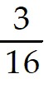
B) 15x2 + 2x -
C) 15x2 - x -
D) 15x2 - 3x -
Answer: A
Diff: 2 Type: BI Var: 50+ Page Ref: 39
Topic: 1.8 Multiplication of Algebraic Expressions
Skill: Recall
Objective: (1.8) Multiply Polynomials

3) 3( 4x + 2y)( 4x - 6y)
A) 48x2 - 48xy - 36y2
B) 24x2 - 48xy - 36y2
C) 48x2 - 48xy - 2y
D) 24x2 - 135xy - 36y2
Answer: A
Diff: 2 Type: BI Var: 50+ Page Ref: 39
Topic: 1.8 Multiplication of Algebraic Expressions
Skill: Recall
Objective: (1.8) Multiply Polynomials

4) -4ax2( 5ax4 + 12x3 + 3a)
A) -20a2x6 - 48ax5 - 12a2x2
B) -20a2x6 + 48ax5 + 12a2x2
C) -20ax6 - 48ax5 - 12ax2
D) -20a2x8 - 48ax6 - 12a2x2
Answer: A
Diff: 2 Type: BI Var: 50+ Page Ref: 39
Topic: 1.8 Multiplication of Algebraic Expressions
Skill: Recall
Objective: (1.8) Multiply Polynomials

5) ( 3x + y - z)2
A) 9x2 + y2 + z2 + 6xy - 6xz - 2yz
B) 6x2 + y2 + z2
C) 9x2 + y2 + z2 + 2xy - 2xz - 2yz
D) 9x2 + y2 + z2 - 3xyz
Answer: A
Diff: 2 Type: BI Var: 3 Page Ref: 39
Topic: 1.8 Multiplication of Algebraic Expressions
Skill: Recall
Objective: (1.8) Multiply Polynomials

6) ( 4x - 7)(x - 6)
A) 4x2 - 31x + 42
B) x2 + 42x - 31
C) 4x2 - 32x + 42
D) x2 - 31x - 32
Answer: A
Diff: 2 Type: BI Var: 50+ Page Ref: 39
Topic: 1.8 Multiplication of Algebraic Expressions
Skill: Recall
Objective: (1.8) Multiply Polynomials

7) ( -4 + x)( 4x - 6)
A) 4x2 - 22x + 24
B) 4x2 + 24x - 22
C) 4x2 - 23x + 24
D) x2 - 22x - 22
Answer: A
Diff: 2 Type: BI Var: 50+ Page Ref: 39
Topic: 1.8 Multiplication of Algebraic Expressions
Skill: Recall
Objective: (1.8) Multiply Polynomials

8) (x - 12)( -5x - 1)
A) -5x2 + 59x + 12
B) -5x2 + 12x + 59
C) -5x2 + 59x + 59
D) -5x2 + 57x + 12
Answer: A
Diff: 2 Type: BI Var: 50+ Page Ref: 39
Topic: 1.8 Multiplication of Algebraic Expressions
Skill: Recall
Objective: (1.8) Multiply Polynomials

9) (x - 11y)(x + 8y)
A) x2 - 3xy - 88y2
B) x - 3xy - 88y
C) x2 - 3xy - 3y2
D) x2 - 6xy - 88y2
Answer: A
Diff: 2 Type: BI Var: 50+ Page Ref: 39
Topic: 1.8 Multiplication of Algebraic Expressions
Skill: Recall
Objective: (1.8) Multiply Polynomials

10) ( 4x + 3y)( 3x + 5y + 1)
A) 12x2 + 29xy + 4x + 15y2 + 3y
B) 12x2 + 9xy + 4x + 15y2 + 3y
C) 12x2 + 20xy + 4x + 15y2
D) 12x2 + 29xy + 29y2
Answer: A
Diff: 2 Type: BI Var: 50+ Page Ref: 39
Topic: 1.8 Multiplication of Algebraic Expressions
Skill: Recall
Objective: (1.8) Multiply Polynomials

1.8.4 Square Binomial

Perform the indicated operations.

1) (n + 12)2
A) n2 + 24n + 144
B) n2 + 144
C) 144n2 + 24n + 144
D) n + 144
Answer: A
Diff: 2 Type: BI Var: 15 Page Ref: 39
Topic: 1.8 Multiplication of Algebraic Expressions
Skill: Recall
Objective: (1.8) Square Binomial

2) ( 12 + p)2
A) p2 + 24p + 144
B) p2 + 144
C) 144p2 + 24p + 144
D) p + 144
Answer: A
Diff: 2 Type: BI Var: 15 Page Ref: 39
Topic: 1.8 Multiplication of Algebraic Expressions
Skill: Recall
Objective: (1.8) Square Binomial

3) ( 2m + 11)2
A) 4m2 + 44m + 121
B) 4m2 + 121
C) 2m2 + 44m + 121
D) 2m2 + 121
Answer: A
Diff: 2 Type: BI Var: 50+ Page Ref: 39
Topic: 1.8 Multiplication of Algebraic Expressions
Skill: Recall
Objective: (1.8) Square Binomial

4) ( 8x + 7y)2
A) 64x2 + 112xy + 49y2
B) 64x2 + 49y2
C) 8x2 + 112xy + 49y2
D) 8x2 + 49y2
Answer: A
Diff: 2 Type: BI Var: 50+ Page Ref: 39
Topic: 1.8 Multiplication of Algebraic Expressions
Skill: Recall
Objective: (1.8) Square Binomial

5) ( 7x - 8y)2
A) 49x2 - 112xy + 64y2
B) 49x2 + 64y2
C) 7x2 - 112xy + 64y2
D) 7x2 + 64y2
Answer: A
Diff: 2 Type: BI Var: 49 Page Ref: 39
Topic: 1.8 Multiplication of Algebraic Expressions
Skill: Recall
Objective: (1.8) Square Binomial

6) 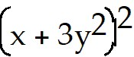
A) 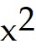 + 6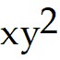 + 9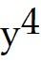
B) + 9
C) + 6xy + 9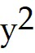
D) - 6 + 9
Answer: A
Diff: 2 Type: BI Var: 8 Page Ref: 39
Topic: 1.8 Multiplication of Algebraic Expressions
Skill: Recall
Objective: (1.8) Square Binomial

7) 5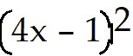
A) 80 - 40x + 5
B) 400 - 200x + 25
C) 80 + 5
D) 80 - 8x + 1
Answer: A
Diff: 2 Type: BI Var: 50+ Page Ref: 39
Topic: 1.8 Multiplication of Algebraic Expressions
Skill: Recall
Objective: (1.8) Square Binomial

1.8.5 Solve Apps: Multiply Algebraic Expressions

Find the indicted product and simplify if possible.

1) The amount of material required to make a spherical shell is given by 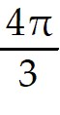(R - r)(R2 + Rr + r2).
A) R3 - r3
B) R3 - r3
C) R3 + 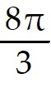R2r + Rr2 + r3
D) R3 - R2r + Rr2 - r3
Answer: A
Diff: 2 Type: BI Var: 1 Page Ref: 39-40
Topic: 1.8 Multiplication of Algebraic Expressions
Skill: Recall
Objective: (1.8) Solve Apps: Multiply Algebraic Expressions

2) The area of annulus (washer) is given by 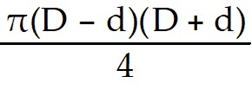.
A) 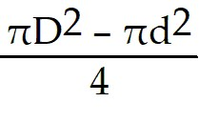
B) 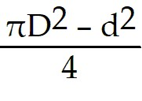
C) 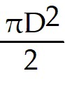 + 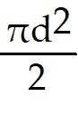
D) 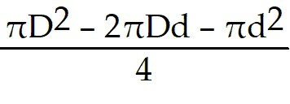
Answer: A
Diff: 2 Type: BI Var: 1 Page Ref: 39-40
Topic: 1.8 Multiplication of Algebraic Expressions
Skill: Recall
Objective: (1.8) Solve Apps: Multiply Algebraic Expressions

3) Measurements concerning the volume of liquid flowing through a valve result in the expression 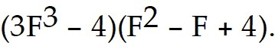
A) 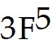 - 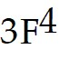 + 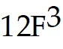 - 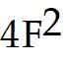 + 4F - 16
B) 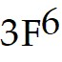 - + - + 4F - 16
C) - + - - 4F - 16
D) + 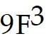 - + 4F - 16
Answer: A
Diff: 2 Type: BI Var: 1 Page Ref: 39-40
Topic: 1.8 Multiplication of Algebraic Expressions
Skill: Recall
Objective: (1.8) Solve Apps: Multiply Algebraic Expressions

4) The expression 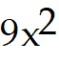 - 18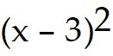 - 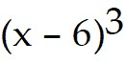 was used to determine the stress in a section of metal.
A) - + + 54
B) - - 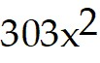 + 36x + 207
C) - - + 378
D) - - 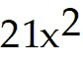 + 180x - 378
Answer: A
Diff: 2 Type: BI Var: 1 Page Ref: 39-40
Topic: 1.8 Multiplication of Algebraic Expressions
Skill: Recall
Objective: (1.8) Solve Apps: Multiply Algebraic Expressions

1.9 Division of Algebraic Expressions

1.9.1 Divide Polynomial by Monomial

Divide. Write with positive exponents.

1) 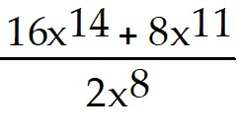
A) 8x6 + 4x3
B) 8x6 + 8x11
C) 16x14 + 4x3
D) 12x17
Answer: A
Diff: 2 Type: BI Var: 50+ Page Ref: 41
Topic: 1.9 Division of Algebraic Expressions
Skill: Recall
Objective: (1.9) Divide Polynomial by Monomial

2) 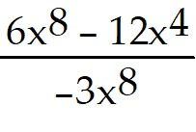
A) -2 + 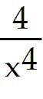
B) -2 + 4x4
C) -2 - 12x4
D) 6x8 +
Answer: A
Diff: 2 Type: BI Var: 50+ Page Ref: 41
Topic: 1.9 Division of Algebraic Expressions
Skill: Recall
Objective: (1.9) Divide Polynomial by Monomial

3) 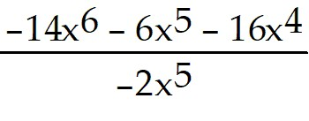
A) 7x + 3 + 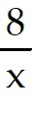
B) 7x + 3
C) 15x + 3
D) 7x - 6x5 +
Answer: A
Diff: 2 Type: BI Var: 50+ Page Ref: 41
Topic: 1.9 Division of Algebraic Expressions
Skill: Recall
Objective: (1.9) Divide Polynomial by Monomial

4) 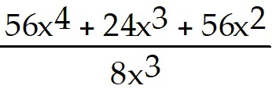
A) 7x + 3 + 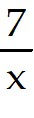
B) 7x + 3
C) 14x + 3
D) 7x + 24x3 +
Answer: A
Diff: 2 Type: BI Var: 50+ Page Ref: 41
Topic: 1.9 Division of Algebraic Expressions
Skill: Recall
Objective: (1.9) Divide Polynomial by Monomial

5) 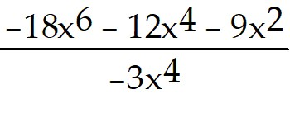
A) 6x2 + 4 + 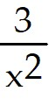
B) 6x + 4 +
C) 6x2 + 4 + 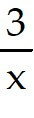
D) 6x + 4 +
Answer: A
Diff: 2 Type: BI Var: 50+ Page Ref: 41
Topic: 1.9 Division of Algebraic Expressions
Skill: Recall
Objective: (1.9) Divide Polynomial by Monomial

6) 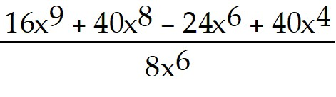
A) 2x3 + 5x2 - 3 + 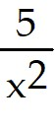
B) 2x3 + 5x2 - 3
C) 2x3 + 10x2 - 3
D) -2x3 - 5x2 + 3 -
Answer: A
Diff: 2 Type: BI Var: 50+ Page Ref: 41
Topic: 1.9 Division of Algebraic Expressions
Skill: Recall
Objective: (1.9) Divide Polynomial by Monomial

7) 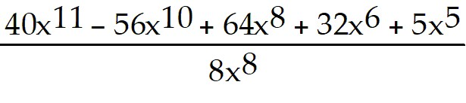
A) 5x3 - 7x2 + 8 + 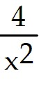 + 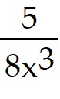
B) 40x11 - 7x2 + 8 + +
C) 5x3 - 7x2 + 8
D) 5x3 - 56x10 + 64x8 + 32x6 + 5x5
Answer: A
Diff: 2 Type: BI Var: 50+ Page Ref: 41
Topic: 1.9 Division of Algebraic Expressions
Skill: Recall
Objective: (1.9) Divide Polynomial by Monomial

8) 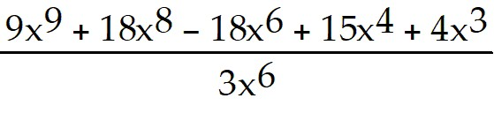
A) 3x3 + 6x2 - 6 + + 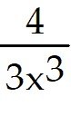
B) 9x9 + 6x2 - 6 + +
C) 3x3 + 6x2 - 6
D) 3x3 + 18x8 - 18x6 + 15x4 + 4x3
Answer: A
Diff: 2 Type: BI Var: 50+ Page Ref: 41
Topic: 1.9 Division of Algebraic Expressions
Skill: Recall
Objective: (1.9) Divide Polynomial by Monomial

9) 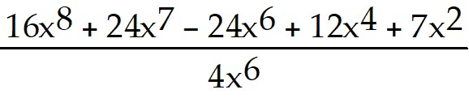
A) 4x2 + 6x - 6 + + 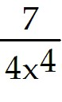
B) 16x8 + 6x2 - 6 + + 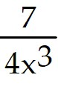
C) 4x3 + 6x2 - 6
D) 4x3 + 24x7 - 24x6 + 12x4 + 7x2
Answer: A
Diff: 2 Type: BI Var: 50+ Page Ref: 41
Topic: 1.9 Division of Algebraic Expressions
Skill: Recall
Objective: (1.9) Divide Polynomial by Monomial

1.9.2 Divide Polynomial by Binomial

Perform the indicated operation.

1) 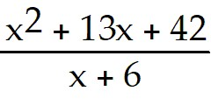
A) x + 7
B) x - 36
C) x2 + 7
D) x3 - 36
Answer: A
Diff: 2 Type: BI Var: 50+ Page Ref: 42
Topic: 1.9 Division of Algebraic Expressions
Skill: Recall
Objective: (1.9) Divide Polynomial by Binomial

2) 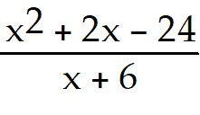
A) x - 4
B) x2 + 3x - 18
C) x2 - 4
D) x + 4
Answer: A
Diff: 2 Type: BI Var: 21 Page Ref: 42
Topic: 1.9 Division of Algebraic Expressions
Skill: Recall
Objective: (1.9) Divide Polynomial by Binomial

3) 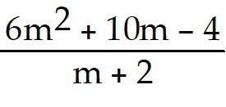
A) 6m - 2
B) 6m + 2
C) m - 2
D) 6m - 2 + 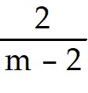
Answer: A
Diff: 2 Type: BI Var: 50+ Page Ref: 42
Topic: 1.9 Division of Algebraic Expressions
Skill: Recall
Objective: (1.9) Divide Polynomial by Binomial

4) 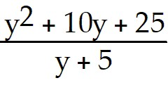
A) y + 5
B) y - 5
C) y + 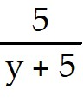
D) y2 + 5
Answer: A
Diff: 2 Type: BI Var: 8 Page Ref: 42
Topic: 1.9 Division of Algebraic Expressions
Skill: Recall
Objective: (1.9) Divide Polynomial by Binomial

5) 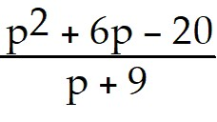
A) p - 3 + 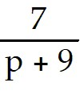
B) p - 3
C) p + 3 +
D) p - 7 + 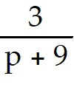
Answer: A
Diff: 2 Type: BI Var: 50+ Page Ref: 42
Topic: 1.9 Division of Algebraic Expressions
Skill: Recall
Objective: (1.9) Divide Polynomial by Binomial

6) 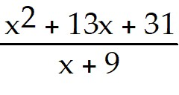
A) x + 4 - 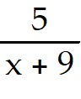
B) x + 4 +
C) 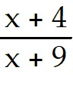
D) x + 5
Answer: A
Diff: 2 Type: BI Var: 50+ Page Ref: 42
Topic: 1.9 Division of Algebraic Expressions
Skill: Recall
Objective: (1.9) Divide Polynomial by Binomial

7) 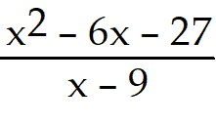
A) x + 3
B) x - 3
C) x + 3 + 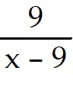
D) x2 + 3
Answer: A
Diff: 2 Type: BI Var: 21 Page Ref: 42
Topic: 1.9 Division of Algebraic Expressions
Skill: Recall
Objective: (1.9) Divide Polynomial by Binomial

8) 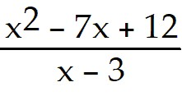
A) x - 4
B) x + 4
C) 4 - x
D) x + 3
Answer: A
Diff: 2 Type: BI Var: 50+ Page Ref: 42
Topic: 1.9 Division of Algebraic Expressions
Skill: Recall
Objective: (1.9) Divide Polynomial by Binomial

9) 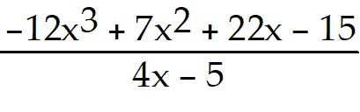
A) -3x2 - 2x + 3
B) -3x2 + 3
C) x2 - 2x + 3
D) x2 + 2x - 3
Answer: A
Diff: 2 Type: BI Var: 50+ Page Ref: 42
Topic: 1.9 Division of Algebraic Expressions
Skill: Recall
Objective: (1.9) Divide Polynomial by Binomial

10) 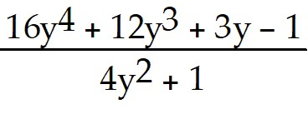
A) 4y2 + 3y - 1
B) 4y2 + 3y
C) 4y2 - 1
D) 4y2 - 3y + 1
Answer: A
Diff: 2 Type: BI Var: 25 Page Ref: 42
Topic: 1.9 Division of Algebraic Expressions
Skill: Recall
Objective: (1.9) Divide Polynomial by Binomial

1.9.3 Solve Apps: Divide Algebraic Expressions

Perform the indicated division and find a simplified expression.

1) The average velocity of a certain particle in feet per second is given by 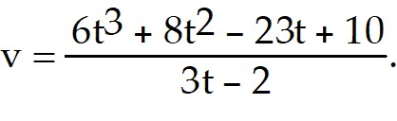
A) 2t2 + 4t - 5
B) 2t2 - 5t + 4 + 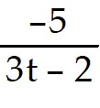
C) 2t2 - 4t - 5
D) 2t2 + 4t - 2 + 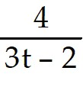
Answer: A
Diff: 2 Type: BI Var: 50+ Page Ref: 42-43
Topic: 1.9 Division of Algebraic Expressions
Skill: Recall
Objective: (1.9) Solve Apps: Divide Algebraic Expressions

2) If a submarine goes 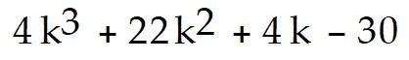 kilometers in 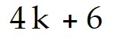 hours, what is its rate of speed?
A) k2 + 4k - 5 km/hr
B) k2 - 4k + 5 km/hr
C) k3 + 4k2 - 5k km/hr
D) k2 + 14k - 5 km/hr
Answer: A
Diff: 2 Type: BI Var: 50+ Page Ref: 42-43
Topic: 1.9 Division of Algebraic Expressions
Skill: Recall
Objective: (1.9) Solve Apps: Divide Algebraic Expressions

3) A patio has an area of 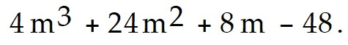 Find the length if the width is 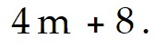
A) m2 + 4m - 6
B) m2 - 4m + 6
C) m3 + 4m2 - 6m
D) m2 + 16m - 6
Answer: A
Diff: 2 Type: BI Var: 50+ Page Ref: 42-43
Topic: 1.9 Division of Algebraic Expressions
Skill: Recall
Objective: (1.9) Solve Apps: Divide Algebraic Expressions

4) The volume of a box is 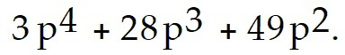 The height is p and the width is 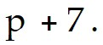 What is the length?
A) 3p2 + 7p
B) 3p + 7
C) 3p3 + 7p2
D) p2 + 7
Answer: A
Diff: 2 Type: BI Var: 50+ Page Ref: 42-43
Topic: 1.9 Division of Algebraic Expressions
Skill: Recall
Objective: (1.9) Solve Apps: Divide Algebraic Expressions

1.10 Solving Equations

1.10.1 Solve Equation Without Parentheses

Solve the equation.

1) a - 20 = 6
A) 26
B) -26
C) -14
D) 14
Answer: A
Diff: 1 Type: BI Var: 50+ Page Ref: 44-45
Topic: 1.10 Solving Equations
Skill: Recall
Objective: (1.10) Solve Equation Without Parentheses

2) 11 = b + 17
A) -6
B) 6
C) 28
D) -28
Answer: A
Diff: 1 Type: BI Var: 50+ Page Ref: 44-45
Topic: 1.10 Solving Equations
Skill: Recall
Objective: (1.10) Solve Equation Without Parentheses

3) 4a = -16
A) -4
B) -20
C) 20
D) 1
Answer: A
Diff: 1 Type: BI Var: 50+ Page Ref: 44-45
Topic: 1.10 Solving Equations
Skill: Recall
Objective: (1.10) Solve Equation Without Parentheses

4) -2x = -10
A) 5
B) -8
C) 8
D) 2
Answer: A
Diff: 1 Type: BI Var: 50+ Page Ref: 44-45
Topic: 1.10 Solving Equations
Skill: Recall
Objective: (1.10) Solve Equation Without Parentheses

5) 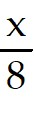 = -4
A) -32
B) 4
C) -1
D) 3
Answer: A
Diff: 1 Type: BI Var: 50+ Page Ref: 44-45
Topic: 1.10 Solving Equations
Skill: Recall
Objective: (1.10) Solve Equation Without Parentheses

6) 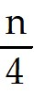 = 6
A) 24
B) 10
C) 1
D) 9
Answer: A
Diff: 1 Type: BI Var: 50+ Page Ref: 44-45
Topic: 1.10 Solving Equations
Skill: Recall
Objective: (1.10) Solve Equation Without Parentheses

7) 10r + 3 = 63
A) 6
B) 50
C) 54
D) 3
Answer: A
Diff: 1 Type: BI Var: 50+ Page Ref: 44-45
Topic: 1.10 Solving Equations
Skill: Recall
Objective: (1.10) Solve Equation Without Parentheses

8) 6n - 6 = 36
A) 7
B) 36
C) 40
D) 12
Answer: A
Diff: 1 Type: BI Var: 50+ Page Ref: 44-45
Topic: 1.10 Solving Equations
Skill: Recall
Objective: (1.10) Solve Equation Without Parentheses

9) 3z + 18 = 2z + 5
A) -13
B) 13
C) 23
D) -23
Answer: A
Diff: 1 Type: BI Var: 50+ Page Ref: 44-45
Topic: 1.10 Solving Equations
Skill: Recall
Objective: (1.10) Solve Equation Without Parentheses

10) 10y = 5y + 3 + 4y
A) 3
B) -3
C) 30
D) -30
Answer: A
Diff: 1 Type: BI Var: 48 Page Ref: 44-45
Topic: 1.10 Solving Equations
Skill: Recall
Objective: (1.10) Solve Equation Without Parentheses

1.10.2 Solve Equation With Parentheses

Solve the equation.

1) 5(2z - 4) = 9(z + 2)
A) 38
B) 2
C) -2
D) 3
Answer: A
Diff: 2 Type: BI Var: 50+ Page Ref: 44-45
Topic: 1.10 Solving Equations
Skill: Recall
Objective: (1.10) Solve Equation With Parentheses

2) 8x + 4( -3x - 2) = -9 - 3x
A) 1
B) - 1
C) 17
D) 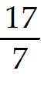
Answer: A
Diff: 2 Type: BI Var: 50+ Page Ref: 44-45
Topic: 1.10 Solving Equations
Skill: Recall
Objective: (1.10) Solve Equation With Parentheses

3) 20(x - 80) = 40
A) 82
B) 80
C) 78
D) 40
Answer: A
Diff: 2 Type: BI Var: 49 Page Ref: 44-45
Topic: 1.10 Solving Equations
Skill: Recall
Objective: (1.10) Solve Equation With Parentheses

4) 6x - ( 2x - 1) = 2
A)
B) 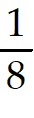
C) -
D) -
Answer: A
Diff: 2 Type: BI Var: 28 Page Ref: 44-45
Topic: 1.10 Solving Equations
Skill: Recall
Objective: (1.10) Solve Equation With Parentheses

5) 6( 6x - 1) = 24
A)
B)
C) 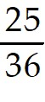
D) 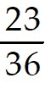
Answer: A
Diff: 2 Type: BI Var: 28 Page Ref: 44-45
Topic: 1.10 Solving Equations
Skill: Recall
Objective: (1.10) Solve Equation With Parentheses

6) 5(x + 6) - ( 5x + 30) = 0
A) All real numbers
B) No solution
C) 0
D) 6
Answer: A
Diff: 2 Type: BI Var: 20 Page Ref: 44-45
Topic: 1.10 Solving Equations
Skill: Recall
Objective: (1.10) Solve Equation With Parentheses

7) (y - 3) - (y + 2) = 9y
A) - 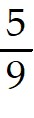
B) - 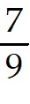
C) - 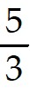
D) - 5
Answer: A
Diff: 2 Type: BI Var: 50+ Page Ref: 44-45
Topic: 1.10 Solving Equations
Skill: Recall
Objective: (1.10) Solve Equation With Parentheses

8) ( 12x - 20) = 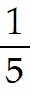( 25x - 15)
A) -1
B) 1
C) 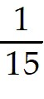
D) -15
Answer: A
Diff: 2 Type: BI Var: 50+ Page Ref: 44-45
Topic: 1.10 Solving Equations
Skill: Recall
Objective: (1.10) Solve Equation With Parentheses

9) (y - 5) - (y + 4) = 8y
A) -
B) -
C) -
D) -
Answer: A
Diff: 2 Type: BI Var: 40 Page Ref: 44-45
Topic: 1.10 Solving Equations
Skill: Recall
Objective: (1.10) Solve Equation With Parentheses

10) ( 15x - 20) = ( 8x - 6)
A) -1
B) 1
C)
D) -7
Answer: A
Diff: 2 Type: BI Var: 50+ Page Ref: 44-45
Topic: 1.10 Solving Equations
Skill: Recall
Objective: (1.10) Solve Equation With Parentheses

1.10.3 Solve Equation (Special Conditions)

Solve the equation.

1) 6 - 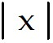 = 18
A) x = -24
B) x = -12
C) x = ±12
D) The equation is a contradiction.
Answer: D
Diff: 2 Type: BI Var: 5 Page Ref: 45-46
Topic: 1.10 Solving Equations
Skill: Recall
Objective: (1.10) Solve Equation (Special Conditions)

2) 9.2 - .0 6(x - 1.8) = .7x (All numbers are approximate.)
A) x ≈ 10
B) x ≈ 1.3184136
C) x ≈ 1
D) The equation is a contradiction.
Answer: A
Diff: 2 Type: BI Var: 50+ Page Ref: 45-46
Topic: 1.10 Solving Equations
Skill: Recall
Objective: (1.10) Solve Equation (Special Conditions)

3) 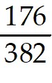 = 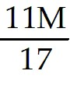 (All numbers are approximate.)
A) M ≈ 0.71
B) M = 1.32038835
C) M = 14.5242718
D) M ≈ 1.8
Answer: A
Diff: 2 Type: BI Var: 50+ Page Ref: 45-46
Topic: 1.10 Solving Equations
Skill: Recall
Objective: (1.10) Solve Equation (Special Conditions)

4) 7(x - 4) + 1 = 7x - 6
A) x = 21
B) x = 3.0
C) x = 1.5
D) The equation is a contradiction.
Answer: D
Diff: 2 Type: BI Var: 6 Page Ref: 45-46
Topic: 1.10 Solving Equations
Skill: Recall
Objective: (1.10) Solve Equation (Special Conditions)

1.10.4 Solve Equation (Ratio/Proportion)

Solve. Give your answer as a mixed number if appropriate.

1) 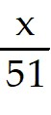 = 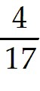
A) 12
B) 1
C) 216
D) 16
Answer: A
Diff: 1 Type: BI Var: 50+ Page Ref: 46
Topic: 1.10 Solving Equations
Skill: Recall
Objective: (1.10) Solve Equation (Ratio/Proportion)

2) = 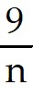
A) 8
B) 10
C) 72
D) 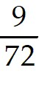
Answer: A
Diff: 1 Type: BI Var: 50+ Page Ref: 46
Topic: 1.10 Solving Equations
Skill: Recall
Objective: (1.10) Solve Equation (Ratio/Proportion)

3) 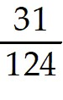 = 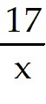
A) 68
B) 4
C) 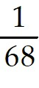
D) 2077
Answer: A
Diff: 2 Type: BI Var: 50+ Page Ref: 46
Topic: 1.10 Solving Equations
Skill: Recall
Objective: (1.10) Solve Equation (Ratio/Proportion)

4) 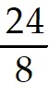 = 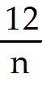
A) 4
B) 2
C) 3
D) 12
Answer: A
Diff: 2 Type: BI Var: 24 Page Ref: 46
Topic: 1.10 Solving Equations
Skill: Recall
Objective: (1.10) Solve Equation (Ratio/Proportion)

1.10.5 Solve Apps: Solving Equations

Solve the problem.

1) A merchant has coffee worth $ 20 a pound that she wishes to mix with 70 pounds of coffee worth 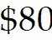 a pound to get a mixture that can be sold for 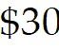 a pound. How many pounds of the 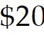 coffee should be used?
A) 350 pounds
B) 175 pounds
C) 420 pounds
D) 210 pounds
Answer: A
Diff: 3 Type: BI Var: 50+ Page Ref: 47
Topic: 1.10 Solving Equations
Skill: Applied
Objective: (1.10) Solve Apps: Solving Equations

2) A paint mixture contains 49 litres of base for every gallon of color. In 650 litres of paint, how many gallons of color are there?
A) 13 litres
B) 637 litres
C) 325 litres
D) 216 litres
Answer: A
Diff: 2 Type: BI Var: 50+ Page Ref: 47
Topic: 1.10 Solving Equations
Skill: Applied
Objective: (1.10) Solve Apps: Solving Equations

3) A reservation clerk worked 13.5 hours one day. She spent twice as much time entering new reservations as she did verifying old ones and one and a half as much time calling to confirm reservations as verifying old ones. How much time did she spend entering new reservations?
A) 6 hours
B) 3 hours
C) 4.5 hours
D) 12 hours
Answer: A
Diff: 3 Type: BI Var: 31 Page Ref: 47
Topic: 1.10 Solving Equations
Skill: Applied
Objective: (1.10) Solve Apps: Solving Equations

4) One half of a number is 3 more than one-sixth the same number. What is the number?
A) 9
B) 8
C) 18
D) 12
Answer: A
Diff: 2 Type: BI Var: 1 Page Ref: 47
Topic: 1.10 Solving Equations
Skill: Applied
Objective: (1.10) Solve Apps: Solving Equations

5) The sum of twice a number and 4 less than the number is the same as the difference between -16 and the number. What is the number?
A) -3
B) -4
C) -2
D) -6
Answer: A
Diff: 2 Type: BI Var: 50+ Page Ref: 47
Topic: 1.10 Solving Equations
Skill: Applied
Objective: (1.10) Solve Apps: Solving Equations

6) On a map of the Thunderbird Country Club golf course, 2.5 cm equals 60 meters. How long is the 7th hole if the map shows 16.5 cm?
A) 396 m
B) 990 m
C) 2475 m
D) 9.1 m
Answer: A
Diff: 2 Type: BI Var: 50+ Page Ref: 47
Topic: 1.10 Solving Equations
Skill: Applied
Objective: (1.10) Solve Apps: Solving Equations

7) The ratio of the lengths of strings that play the notes D and B is 27 to 16. If a string 64 cm long plays a B, what is the length of the string that plays a D?
A) 108 cm
B) 64 cm
C) 91 cm
D) 80 cm
Answer: A
Diff: 2 Type: BI Var: 5 Page Ref: 47
Topic: 1.10 Solving Equations
Skill: Applied
Objective: (1.10) Solve Apps: Solving Equations

1.11 Formulas and Literal Equations

1.11.1 Solve Literal Equation for Indicated Variable

Solve the equation for the indicated variable.

1) ax + b = 0 for x
A) - 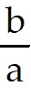
B)
C) -b - a
D) -ab
Answer: A
Diff: 1 Type: BI Var: 1 Page Ref: 48
Topic: 1.11 Formulas and Literal Equations
Skill: Recall
Objective: (1.11) Solve Literal Equation for Indicated Variable

2) 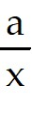 = b for x
A) 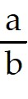
B)
C) ab
D) b + a
Answer: A
Diff: 1 Type: BI Var: 1 Page Ref: 48
Topic: 1.11 Formulas and Literal Equations
Skill: Recall
Objective: (1.11) Solve Literal Equation for Indicated Variable

3) 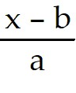 = 6 for x
A) 6a + b
B) 6a + ab
C) a + b + 6
D) b - a + 6
Answer: A
Diff: 1 Type: BI Var: 9 Page Ref: 48
Topic: 1.11 Formulas and Literal Equations
Skill: Recall
Objective: (1.11) Solve Literal Equation for Indicated Variable

4) 7r + 1 = 10s for r
A) 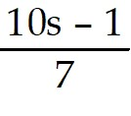
B) 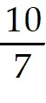s - 1
C) 10s -
D) s + 1
Answer: A
Diff: 1 Type: BI Var: 44 Page Ref: 48
Topic: 1.11 Formulas and Literal Equations
Skill: Recall
Objective: (1.11) Solve Literal Equation for Indicated Variable

5) 8r + 1 = 8s for r
A) s -
B) s - 1
C) 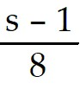
D) 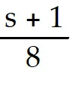
Answer: A
Diff: 1 Type: BI Var: 9 Page Ref: 48
Topic: 1.11 Formulas and Literal Equations
Skill: Recall
Objective: (1.11) Solve Literal Equation for Indicated Variable

6) ay + 2 = 3ay - b for y
A) 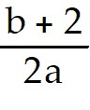
B) 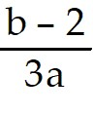
C) 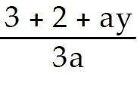
D) 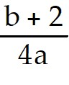
Answer: A
Diff: 1 Type: BI Var: 50+ Page Ref: 48
Topic: 1.11 Formulas and Literal Equations
Skill: Recall
Objective: (1.11) Solve Literal Equation for Indicated Variable

7) q - 3x = 5q + 1 for q
A) 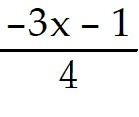
B) 1
C) 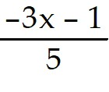
D) 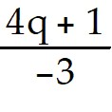
Answer: A
Diff: 1 Type: BI Var: 50+ Page Ref: 48
Topic: 1.11 Formulas and Literal Equations
Skill: Recall
Objective: (1.11) Solve Literal Equation for Indicated Variable

8) n - ( 3 - a) = 6a for n
A) 10a + 6
B) 2.5a + 1.5
C) 14a + 6
D) 14a - 6
Answer: A
Diff: 1 Type: BI Var: 50+ Page Ref: 48
Topic: 1.11 Formulas and Literal Equations
Skill: Recall
Objective: (1.11) Solve Literal Equation for Indicated Variable

9) 1 - (n + 0.167x) = 7n for x
A) -48 n + 6
B) -36 n - 1
C) -6 + 48 n
D) 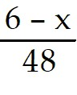
Answer: A
Diff: 1 Type: BI Var: 50+ Page Ref: 48
Topic: 1.11 Formulas and Literal Equations
Skill: Recall
Objective: (1.11) Solve Literal Equation for Indicated Variable

10) 6 - (n + x) = 8n for n
A) 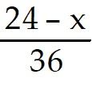
B) -16 n + 24
C) 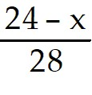
D) 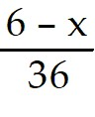
Answer: A
Diff: 1 Type: BI Var: 50+ Page Ref: 48
Topic: 1.11 Formulas and Literal Equations
Skill: Recall
Objective: (1.11) Solve Literal Equation for Indicated Variable

1.11.2 Solve Formula for Indicated Variable

Solve the formula for the specified variable.

1) A = bh for b
A) b = 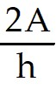
B) b = 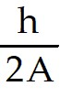
C) b = 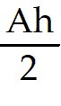
D) b = 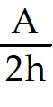
Answer: A
Diff: 2 Type: BI Var: 2 Page Ref: 48
Topic: 1.11 Formulas and Literal Equations
Skill: Recall
Objective: (1.11) Solve Formula for Indicated Variable

2) V = Bh for h
A) h = 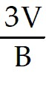
B) h = 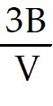
C) h = 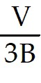
D) h = 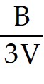
Answer: A
Diff: 2 Type: BI Var: 2 Page Ref: 48
Topic: 1.11 Formulas and Literal Equations
Skill: Recall
Objective: (1.11) Solve Formula for Indicated Variable

3) P = 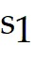 + 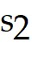 + 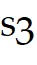 for
A) = P - -
B) = P + +
C) = + - P
D) = + P -
Answer: A
Diff: 2 Type: BI Var: 3 Page Ref: 48
Topic: 1.11 Formulas and Literal Equations
Skill: Recall
Objective: (1.11) Solve Formula for Indicated Variable

4) F = 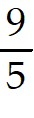C + 32 for C
A) C = (F - 32)
B) C = (F - 32)
C) C = 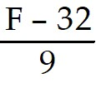
D) C = 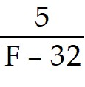
Answer: A
Diff: 2 Type: BI Var: 1 Page Ref: 48
Topic: 1.11 Formulas and Literal Equations
Skill: Recall
Objective: (1.11) Solve Formula for Indicated Variable

5) a + b = s + r for r
A) r = a + b - s
B) r = 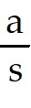 + b
C) r = 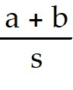
D) r = s(a + b)
Answer: A
Diff: 2 Type: BI Var: 2 Page Ref: 48
Topic: 1.11 Formulas and Literal Equations
Skill: Recall
Objective: (1.11) Solve Formula for Indicated Variable

6) S = 2πrh + 2πr2 for h
A) h = 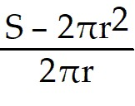
B) h = S - r
C) h = 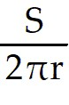 - 1
D) h = 2π(S - r)
Answer: A
Diff: 2 Type: BI Var: 1 Page Ref: 48
Topic: 1.11 Formulas and Literal Equations
Skill: Recall
Objective: (1.11) Solve Formula for Indicated Variable

7) I = 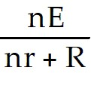 for n
A) n = 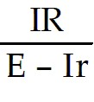
B) n = 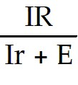
C) n = IR(Ir - E)
D) n = 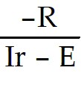
Answer: A
Diff: 2 Type: BI Var: 1 Page Ref: 48
Topic: 1.11 Formulas and Literal Equations
Skill: Recall
Objective: (1.11) Solve Formula for Indicated Variable

8) A = h(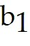 + 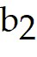) for
A) = 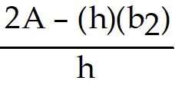
B) = 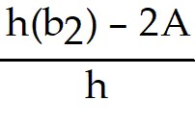
C) = 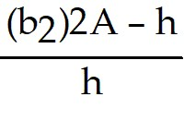
D) = 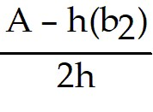
Answer: A
Diff: 2 Type: BI Var: 1 Page Ref: 48
Topic: 1.11 Formulas and Literal Equations
Skill: Recall
Objective: (1.11) Solve Formula for Indicated Variable

9) A = P(1 + nr) for r
A) r = 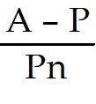
B) r = 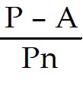
C) r = 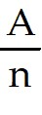
D) r = 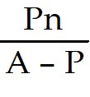
Answer: A
Diff: 2 Type: BI Var: 2 Page Ref: 48
Topic: 1.11 Formulas and Literal Equations
Skill: Recall
Objective: (1.11) Solve Formula for Indicated Variable

1.11.3 Solve Apps: Formulas

Solve the formula for the indicated variable. Then use the supplied values to solve the equation.

1) The relationship between the distance p from an object to a lens, the distance q from the image to the lens, and the focal length f (the distance from the lens to the principal focus) is given by 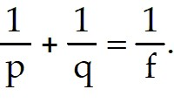 Solve for f. What is the focal length when p is 686 mm and q is 23.3 mm? (All values are approximate.)
A) f = 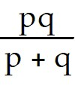 = 22.5 mm
B) f = pq - p - q = 15,300 mm
C) f = p + q = 709 mm
D) f = 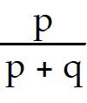 + 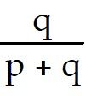 = 1.00 mm
Answer: A
Diff: 3 Type: BI Var: 50+ Page Ref: 48-49
Topic: 1.11 Formulas and Literal Equations
Skill: Applied
Objective: (1.11) Solve Apps: Formulas

2) The energy W stored by a capacitor is given by W = QV, where V is the voltage across the capacitor's terminals after Q coulombs of electricity have been transferred from one of the capacitor's plates to the other. Solve for Q. How many coulombs have been transferred if W is 0.47 watts and V is 13.5 volts? (All values are approximate.)
A) Q = 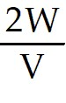 = 0.070 coulombs
B) Q = 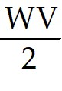 = 3.2 coulombs
C) Q = 2WV = 13 coulombs
D) Q= 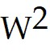V = 3.0 coulombs
Answer: A
Diff: 3 Type: BI Var: 50+ Page Ref: 48-49
Topic: 1.11 Formulas and Literal Equations
Skill: Applied
Objective: (1.11) Solve Apps: Formulas

3) The total surface area of a rectangular solid of length L, width W, and height H is given by 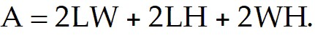 Solve for H. What is the height if the area A is 2448 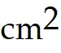, the length is 35.6 cm, and the width is 18.9 cm? (All measurements are approximate.)
A) H = 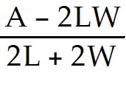 = 10.1 cm
B) H = A - 2LW - 2L - 2W = 993 cm
C) H = 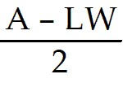 = 888 cm
D) H = 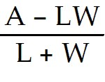 = 32.6 cm
Answer: A
Diff: 3 Type: BI Var: 50+ Page Ref: 48-49
Topic: 1.11 Formulas and Literal Equations
Skill: Applied
Objective: (1.11) Solve Apps: Formulas

1.12 Applied Word Problems

1.12.1 Solve Apps: Write Equation and Solve I

Solve the problem.

1) A tree 1.3 meters high grows at the rate of 0. 3 meters each year. How many years will it take for the tree to grow to a height of 3.7 meters?
A) 8 years
B) 21 years
C) 13 years
D) 25 year(s)
Answer: A
Diff: 2 Type: BI Var: 50+ Page Ref: 51-52
Topic: 1.12 Applied Word Problems
Skill: Applied
Objective: (1.12) Solve Apps: Write Equation and Solve I

2) Pennies are packaged 50 in a roll. A mother gave her son 168 pennies for his bank and she had 32 pennies left over. How many rolls of pennies did she use?
A) 4 rolls
B) 5 rolls
C) 6 rolls
D) 7 rolls
Answer: A
Diff: 2 Type: BI Var: 50+ Page Ref: 51-52
Topic: 1.12 Applied Word Problems
Skill: Applied
Objective: (1.12) Solve Apps: Write Equation and Solve I

3) Elaine had 35 buttons and her grandmother donated 5 cards of buttons to the collection. Elaine sorted the buttons into 10 piles, putting 8 buttons in each pile. How many buttons were on each card from Elaine's grandmother?
A) 9 buttons
B) 71 buttons
C) 33 buttons
D) 74 buttons
Answer: A
Diff: 2 Type: BI Var: 50+ Page Ref: 51-52
Topic: 1.12 Applied Word Problems
Skill: Applied
Objective: (1.12) Solve Apps: Write Equation and Solve I

4) Junior high classes of 20 students each met in the cafeteria to take achievement tests. If exactly 8 students sat at each table and 25 tables were used, how many classes took the tests?
A) 10 classes
B) 13 classes
C) 23 classes
D) 12 classes
Answer: A
Diff: 2 Type: BI Var: 42 Page Ref: 51-52
Topic: 1.12 Applied Word Problems
Skill: Applied
Objective: (1.12) Solve Apps: Write Equation and Solve I

5) A convention manager finds that she has $ 1370, made up of twenties and fifties. She has a total of 46 bills. How many fifty-dollar bills does the manager have?
A) 15 fifty-dollar bills
B) 31 fifty-dollar bills
C) 46 fifty-dollar bills
D) 10 fifty-dollar bills
Answer: A
Diff: 2 Type: BI Var: 50+ Page Ref: 51-52
Topic: 1.12 Applied Word Problems
Skill: Applied
Objective: (1.12) Solve Apps: Write Equation and Solve I

6) A woman has $1.70 in dimes and nickels. She has 2 more dimes than nickels. How many nickels does she have?
A) 10 nickels
B) 12 nickels
C) 14 nickels
D) 8 nickels
Answer: A
Diff: 2 Type: BI Var: 2 Page Ref: 51-52
Topic: 1.12 Applied Word Problems
Skill: Applied
Objective: (1.12) Solve Apps: Write Equation and Solve I

7) A bank teller has some five-dollar bills and some twenty-dollar bills. The teller has 5 more of the twenties. The total value of the money is $ 725. Find the number of five-dollar bills that the teller has.
A) 25 five-dollar bills
B) 30 five-dollar bills
C) 20 five-dollar bills
D) 35 five-dollar bills
Answer: A
Diff: 2 Type: BI Var: 18 Page Ref: 51-52
Topic: 1.12 Applied Word Problems
Skill: Applied
Objective: (1.12) Solve Apps: Write Equation and Solve I

8) A cashier has a total of 128 bills, made up of fives and tens. The total value of the money is $ 690. How many ten-dollar bills does the cashier have?
A) 10 ten-dollar bills
B) 118 ten-dollar bills
C) 15 ten-dollar bills
D) 5 ten-dollar bills
Answer: A
Diff: 2 Type: BI Var: 50+ Page Ref: 51-52
Topic: 1.12 Applied Word Problems
Skill: Applied
Objective: (1.12) Solve Apps: Write Equation and Solve I

1.12.2 Solve Apps: Write Equation and Solve II

Solve the problem. Assume all data are accurate to two significant digits unless greater accuracy is given.

1) Two pieces of equipment were purchased for a total of $7000. If one piece cost $330 more than the other, find the price of the less expensive piece of equipment.
A) $ 3335
B) $ 3300
C) $ 3665
D) $ 3700
Answer: A
Diff: 3 Type: BI Var: 50+ Page Ref: 52-53
Topic: 1.12 Applied Word Problems
Skill: Applied
Objective: (1.12) Solve Apps: Write Equation and Solve II

2) A company sold 9.3 million items in a two-year period. Sales increased by 300 000 the second year. How many were sold the second year?
A) 4 800 000
B) 5 000 000
C) 4 500 000
D) 7 200 000
Answer: A
Diff: 3 Type: BI Var: 50+ Page Ref: 52-53
Topic: 1.12 Applied Word Problems
Skill: Applied
Objective: (1.12) Solve Apps: Write Equation and Solve II

3) Two cities are 41.2km apart. Vehicle A leaves one city at the same time vehicle B leaves the other. Find the speed of vehicle A if it travels 7.8 km/h faster than vehicle B and if they pass in 12.9 minutes.
A) 99.7 km/h
B) 91.9 km/h
C) 5.5 km/h
D) 96.1 km/h
Answer: A
Diff: 3 Type: BI Var: 50+ Page Ref: 52-53
Topic: 1.12 Applied Word Problems
Skill: Applied
Objective: (1.12) Solve Apps: Write Equation and Solve II

