
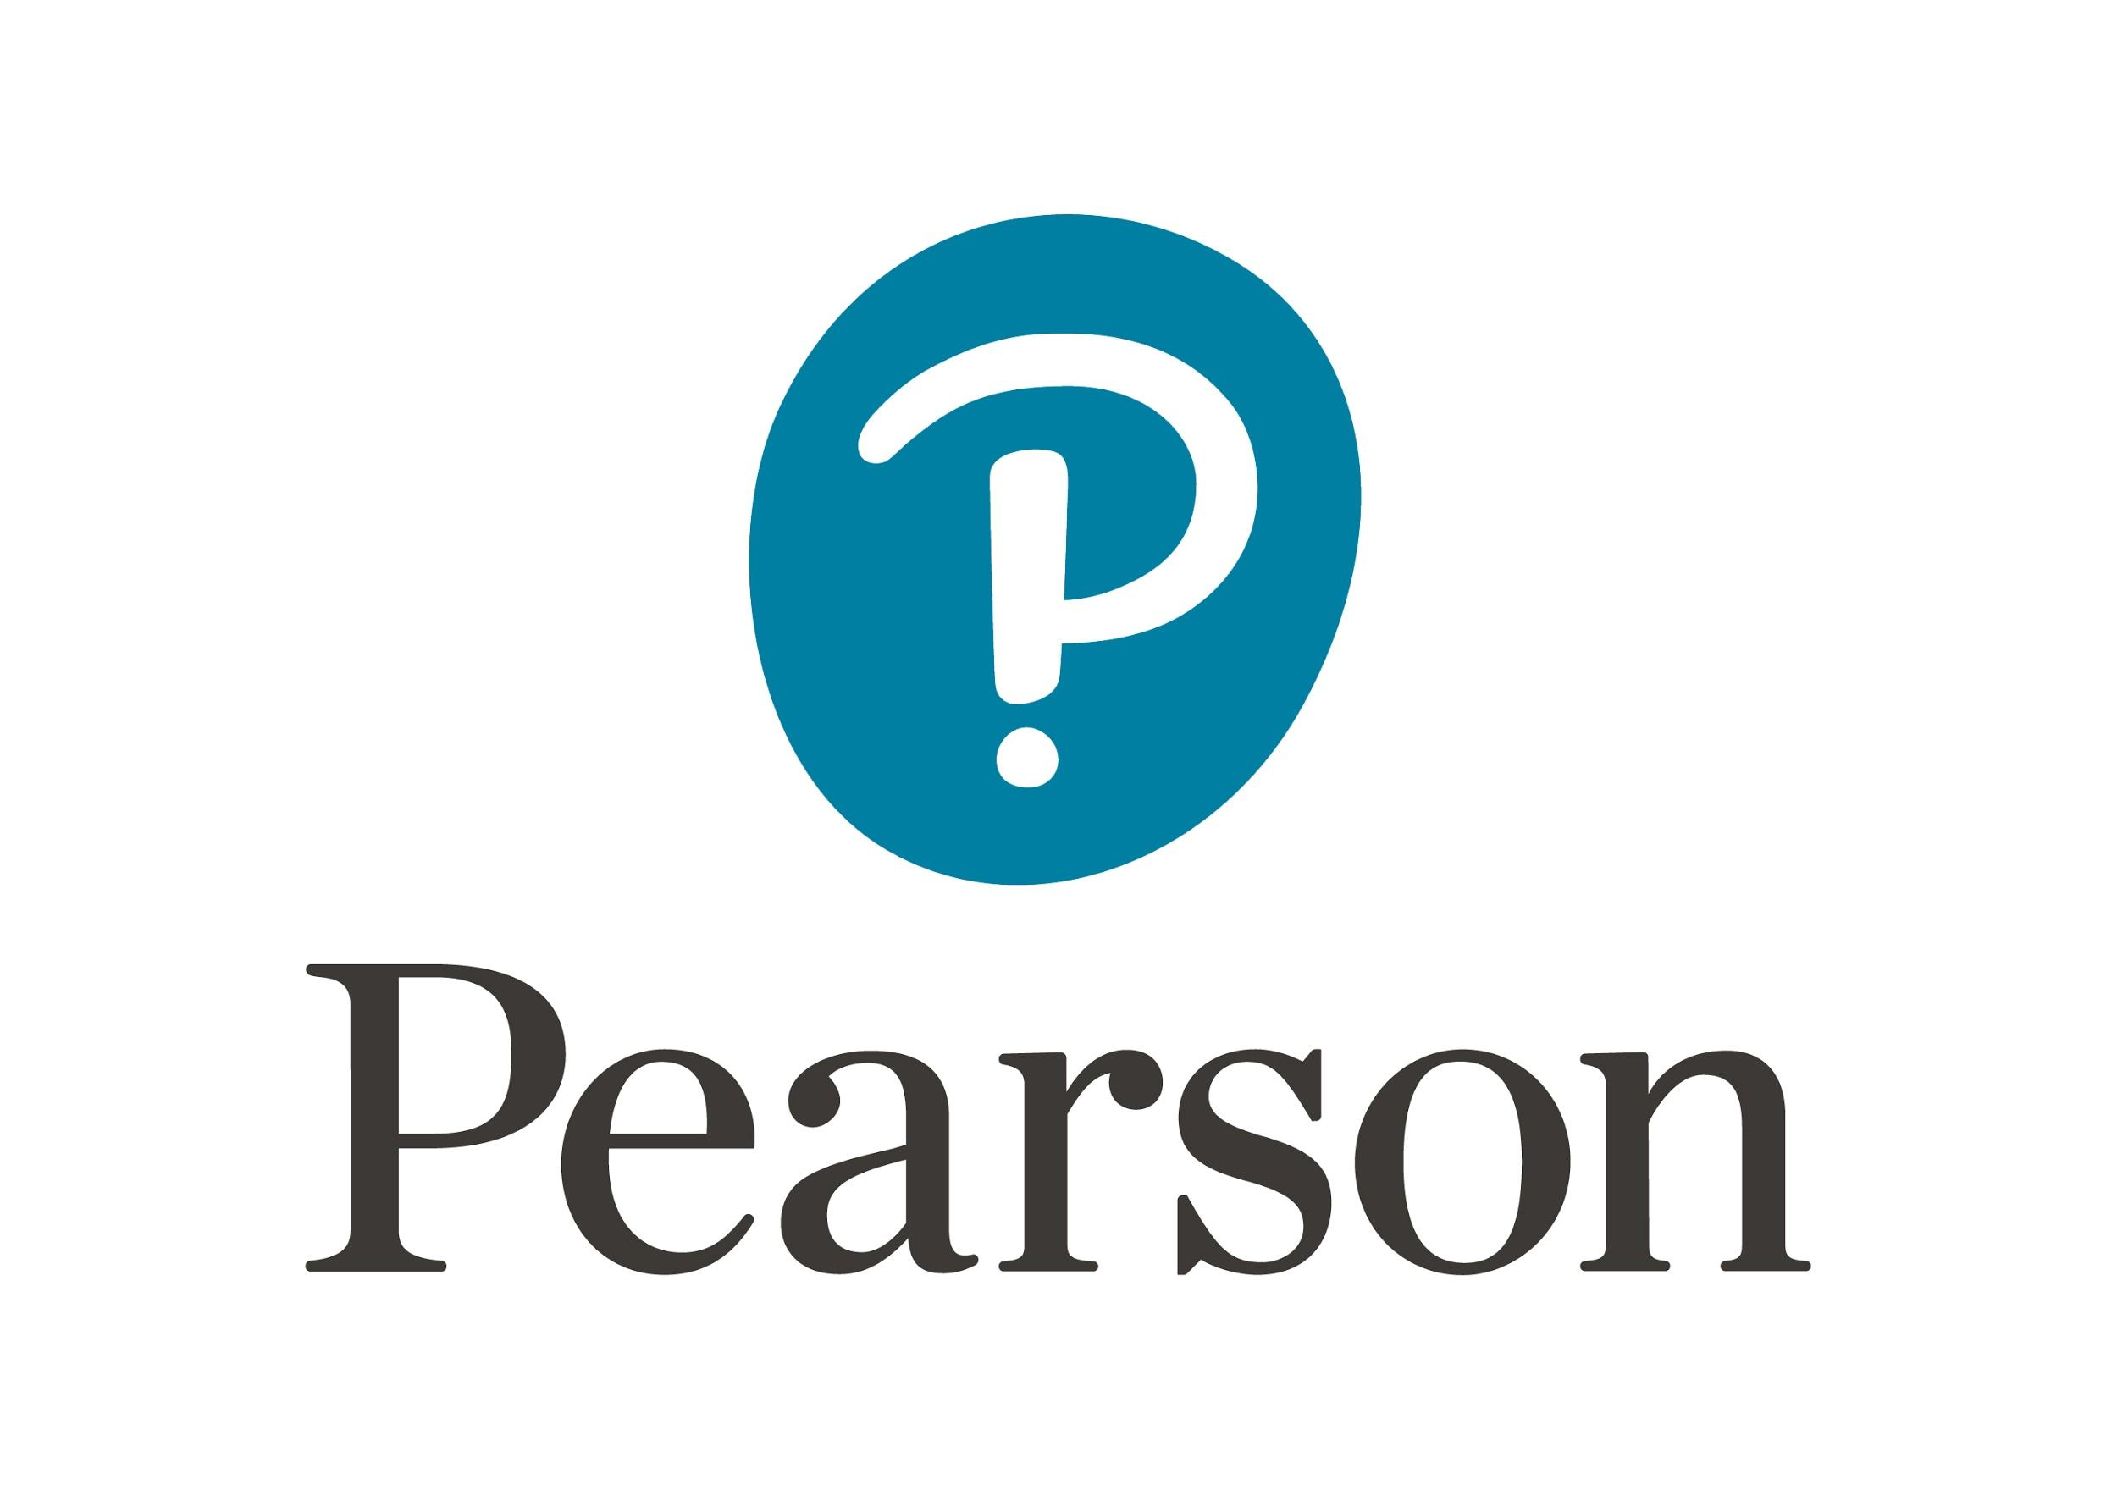

Online Instructor’s Manual with Testbank
For

Family &
Intimate Partner Violence:
Heavy Hands

Sixth Edition

prepared by
Denise Kindschi Gosselin
Professor Emerita, Criminal Justice and Sociology
Western New England University

Chloe Canter
University of Massachusetts, Lowell

Boston Columbus Indianapolis New York San Francisco
Upper Saddle River Amsterdam Cape Town Dubai London Madrid Milan Munich Paris Montreal Toronto Delhi Mexico City Sao Paulo Sydney Hong Kong Seoul Singapore Taipei Tokyo
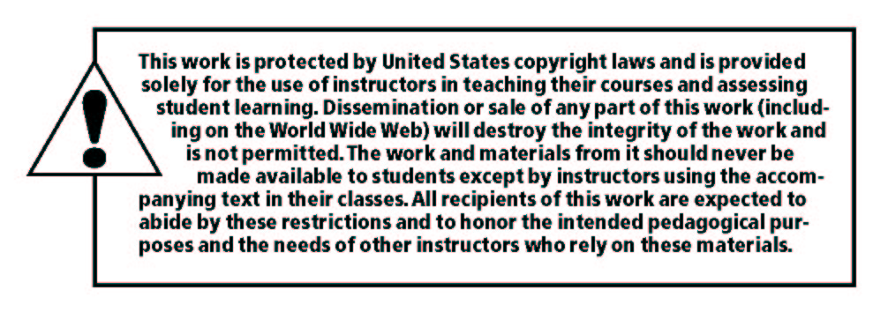
_____________________________________________________________________
Copyright © 2019, 2014, 2010 Pearson Education, Inc. or its affiliates. All rights reserved. Manufactured in the United States of America. This publication is protected by Copyright, and permission should be obtained from the publisher prior to any prohibited reproduction, storage in a retrieval system, or transmission in any form or by any means, electronic, mechanical, photocopying, recording, or likewise. For information regarding permissions, request forms, and the appropriate contacts with the Pearson Education Global Rights and Permissions department, please visit
www.pearsoned.com/permissions/.
Many of the designations by manufacturers and seller to distinguish their products are claimed as trademarks. Where those designations appear in this book, and the publisher was aware of a trademark claim, the designations have been printed in initial caps or all caps.
10 9 8 7 6 5 4 3 2 1

ISBN-13: 978-0-13-487029-8
ISBN-10: 0-13-487029-8
table of CONTENTS
How to Use This Manual iii
Sample Syllabus vi
Chapter 1: Global Violence against Women 1
Chapter 2: History of Violence in the Family 6
Chapter 3: Focus on Research 11
Chapter 4: Introduction to Child Abuse & Neglect 17
Chapter 5: Investigating Child Abuse 22
Chapter 6: Adolescent and Young Adult Victimization 28
Chapter 7: Adolescent Perpetrators 34
Chapter 8: Intimate Partner Violence 40
Chapter 9: LGBTI Partner Abuse 45
Chapter 10: Abuse in Later Life 51
Chapter 11: Adult Perpetrators 56
Chapter 12: The Police Response to Intimate Partner Violence 61
Chapter 13: Stalking and Homicide 67
Chapter 14: The Court Response to IPV 73
How to Use This Manual
This instructor’s manual and test bank has been prepared for Family & Intimate Partner Violence: Heavy Hands, 6/E. It is specific to this edition and is not applicable to earlier text editions. A sample syllabus is provided with suggested semester outline to accompany the text. A short introduction to each chapter is followed by the Chapter Objectives and four sections: Instructor Notes, Simply Scenario, Questions for Review, Internet-Based Exercises, and a Test Bank.
Instructor Notes:
This section provides instructors with suggestions for teaching and learning. Specific to each chapter is a list of films, websites, and homework and in-class assignment ideas. Supplemental readings include books, journal articles, or government publications to peak student interest in the topic of study.
Simply Scenario:
Each chapter contains a real-life scenario along with a question relevant to the chapter subject matter. Here the instructor is provided with answers to those questions for use in class discussions and critical thinking exercises.
Questions for Review:
At the end of each chapter is are short-answer essay questions pertaining to the material within that chapter. Students may be encouraged to answer these questions for homework or during class discussions to demonstrate comprehension of the concepts within the text. In this manual, the instructor is provided with answers to the questions and the page number where the answer is in the textbook.
Internet-Based Exercises:
This section is a restatement of the internet-based exercises listed at the end of each chapter. They are included here for the instructor convenience and to provide ideas for engaging students with online research.
Test Bank:
The questions in the test bank are multiple choice, true-false, fill in the blank, matching, essay, and critical thinking. The answers are provided in the test bank after each question. Included after each question is the page number where the answer is contained within the text. Each question is mapped to one of the chapter objectives along with its level of difficulty.
Sample Syllabus

CRIMINAL JUSTICE & SOCIOLOGY DEPARTMENT
1215 Wilbraham Road
Springfield, MA 01119
Course Description: Domestic violence between adults is studied from an interdisciplinary perspective. The cycle of violence, dominance, and control are among the issues covered sociologically and psychologically. The legal perspective includes discussion of proactive arrest policies, restraining orders, and anti-stalking legislation that have emerged across the United States. 3 cr.
Course Title: Domestic Violence: CJ/SO 235-01
Meeting times: Tuesday/Thursday 11:00 AM – 12:20 PMHerman 102
Faculty: Denise Kindschi Gosselin, PhD
email: denise.gosselin@wne.edu
Office:
Office Hours: M 1:00 – 2:00 PM T 12:30 – 2:00 PM By Appt: W 1:00 – 2:00 PM
T 12:30 – 1:00 PM

Prerequisite: PSY 101 or SO 101 or CJ 101 or permission of the instructor. 3 credit course
Required Text:
Gosselin, Denise Kindschi (2019). Family & Intimate Partner Violence: Heavy Hands (6th ed.). New York, NY: Pearson.
Other required readings may be assigned by the instructor.
Course Requirements
- Attendance. Students earn up to 5% for active classroom and Kodiak participation.
- Quizzes. Quizzes given during the semester will account for 30% of the student’s final grade.
- Exams. There will be a final exam. This grade shall count for 25% of the student’s final grade.
- Literature Review Research Papers. Each student shall submit two research papers based on contemporary family violence literature reviews. Papers will be typed and double spaced, 12 pt. font, one-inch margins. Sources five years and newer are acceptable as citations. APA 6th edition formatting is required for all citations. At least three independent sources (professional or journal articles – not including the class text book) and one government web site shall be cited as reference material for each research paper. The two assignments shall count for 40% of the student’s final grade.
Course Objectives and Assessment Methods
Course Objectives | Assessment Methods
Foundation of Knowledge
Ability to define key terms used within the discipline | - Quizzes  - Final Exam
Acquire an understanding of the social and legal factors that influence criminal justice responses to family violence | - Quizzes  - Final Exam
Applications of Knowledge
Ability to reason logically on the causes and consequences of family violence | - Literature Review Research Paper
Demonstrates reference to concepts and theories of the assigned reading | - Literature Review Research Paper
Professional Ethics
Ability to evaluate and analyze arguments or problems in cases of family violence | - Literature Review Research Paper
Attendance Policy: Attendance is mandatory. Work required on a weekly basis must be turned in on time in order for the student to receive credit. Late work is not accepted. Make-up or extra credit assignments are not available in this course. Students will be held responsible for any class changes, all assignments, and lecture material. In case of illness or serious accident the student should communicate with the instructor as soon as possible. Attendance in Kodiak and in the classroom is mandatory and graded. Students earn up to 5% of their total grade by actively reading all posted materials in Kodiak and participating in the classroom discussions.
We cannot anticipate any and all problems to be encountered. The instructor reserves the right to institute changes for the good of the class and the student as she sees necessary. Changes will be announced in class and via Kodiak.
Absence due to Religious Belief: Any student who is unable, because of religious beliefs, to attend class or to participate in any examination, study, or work requirement, shall be excused from any such examination, study, or work requirement, and shall be provided with an opportunity to make up what he or she may have missed because of such absence on any particular day; provided, however, that such makeup examination or work shall not create an unreasonable burden upon such school.
Assignment Due Dates: The instructor must receive all assignments on the date on which they are due at midnight, unless a student has been given an extension on an assignment prior the due date. No late papers will be accepted.
Students with a Disability who are requesting academic accommodations should contact the SDS office or call 782-1257 for an appointment.
Integrity of Scholarship: All work submitted for credit is expected to be the student's own original thought. If ideas, thoughts, published or unpublished resources, language and like materials are used; appropriate credit must be given. Students should consult the Student Conduct Code for additional information.
Statement for Turnitin.com: Western New England University is committed to academic integrity and the ethical use of information as enumerated in the University Catalogue, Student Handbook, and Academic Integrity brochure. In order to avoid plagiarism and teach students how to properly use and cite sources, papers required in this course may be submitted by students and/or faculty to the plagiarism prevention service, /Turnitin/. Papers submitted to this service will be evaluated against an extensive database of source documents for textual similarities, and an originality report indicating such similarities will be generated.
Papers submitted for analysis *will not* become part of the /Turnitin/ proprietary, restricted-access database, which is used to detect possible plagiarism in other documents. By taking this course you agree to submit papers in electronic format and allow the submission of such papers for review in /Turnitin./ Use of this service is subject to the Terms and Conditions of Use posted on the /Turnitin/ site, http://www.turnitin.com <http://www.turnitin.com/>.
Method of Instruction: Each student is expected to read the assignments and be prepared for class discussions. This is an interactive course that requires student participation. Lectures through PowerPoint and Multi-Media presentations will complement the reading assignments.
Faculty Evaluations: Faculty evaluations will be completed in class at the end of each semester.
Grading Criteria:
94 + = A 90 - 93 = A- 87 - 89 = B+ 83 - 86 = B 80 - 82 = B- 77 - 79 = C+
73 - 76 = C 70 - 72 = C- 67 - 69 = D+ 63 - 66 = D 62 and below = F
Coursework Schedule
Meeting | READINGS | ASSIGNMENTS
8/27-29 | Chapter 1 – Global Violence Against Women | Introduction
9/03-05 | Chapter 2 – History of Violence in the Family
9/10-12 | Chapter 3 – Focus on Research | Research paper #1 due
9/17-19 | Chapter 4 – Intro to Child Abuse & Neglect
9/24-26 | Chapter 5 – Investigating Child Abuse | Quiz #1 – chapters 1 through 4
10/01-03 | Chapter 6 – Adolescent and Young Adult Victimization
10/08-10 | Chapter 7 – Adolescent Perpetrators | Research paper #2 due
10/15-17 | Chapter 8 – Intimate Partner Violence
10/22-24 | Chapter 9 – LGBTI Partner Abuse | Quiz #2 – chapters 5 through 7
10/29-31 | Chapter 10 – Abuse in Later Life
11/05-07 | Chapter 11 – Adult Perpetrators
11/12-14 | Chapter 12 – The Police Response to Intimate Partner Violence | Quiz #3 – chapters 9 through 11
11/19-21 | Chapter 13 – Stalking and Homicide
12/03-05 | Chapter 14 – The Court Response to Intimate Partner Violence
 |  | Final Exam – chapter 12 through 14

Chapter 1 – Global Violence against Women
Chapter One introduces students to family violence with a view of violence against women from selected countries around the world. Instructors may use this chapter to broaden student perspectives on family violence. It may help students to conceptualize family violence as an issue affecting diverse cultures and races. Intimate partner violence is recognized as a current social problem of epidemic proportions affecting millions of women, men, and children around the world.

CHAPTER OBJECTIVES
After reviewing this chapter, you should be able to:
After reviewing this chapter, you should be able to:
1. Describe the forms of violence against women and its definition.
2. Discuss the scope of violence against women.
3. Explain the three forms of immigration relief established by the VAWA.
4. Discuss the status of female genital mutilation as a global concern.
5. Differentiate between female feticide and femicide.

Instructor Notes for Chapter 1
1. Show a film on the global problem of violence against women.
Videos are available online at Films for the Humanities & Sciences, Film Media Group. Use their search to find movies that you would like for your class. Dishonorable Killings: Punishing the Innocent and It’s Time: African Women Join Hands Against Domestic Violence are two examples. Go to: Films for the Humanities & Sciences
Tall as the Baobab Tree (2013). This is an excellent film that is available online for viewing at amazon.com. Highlighted by the 2014 - 2015 Women's Human Rights Film Series, it is the true story of Coumba and her plan to save her 11-year-old sister Debo from an arranged marriage in a small Senegalese village.
The Women’s Learning Partnership for Rights, Development and Peace offer a film entitled From Fear to Freedom: Ending Violence Against Women which can be viewed online or ordered at no cost. This worldwide documentary on violence against women runs 35 minutes.
Women Make Movies is a website offering films by and about women. Their series entitled “Violence against women: Ending the silence” contains films that may be ordered for educational use. The collection includes AFTER THE RAPE, about a Pakistani woman who fought a tribal council's order that she be gang-raped as punishment for a crime she didn't commit; SIN BY SILENCE, which examines a women's domestic violence support group - from inside prison walls; Sundance award-winner THE GREATEST SILENCE: RAPE IN THE CONGO; the critically acclaimed SISTERS IN LAW; Academy-Award Nominee GOD SLEEPS IN RWANDA, and more.
2. Assign an internet project.
Ask each student to go onto the Internet and locate one site relating to global intimate partner violence. They should report to the class what was found on the site.
3. Visit Amnesty International Web site.
There are videos clips available for download on international issues – including violence against women. These clips make good springboards for class discussion. Amnesty International on YouTube is a good starting place.
4. Homework assignment.
Assign students to find an online news article about domestic violence in a foreign country.
5. Invite a speaker.
Parental child abduction is a growing problem associated with the increase of persons in the U.S. having dual citizenship. Invite an officer from a state or federal law enforcement agency to talk about the rising issues of dual citizenship and family abductions.
Supplemental Reading Suggestions:
Human Rights Watch. (2015). Unequal and Unprotected: Women’s Rights Under Lebanon’s Religious Personal Status Laws Human Rights Watch, Retrieved from http://www.hrw.org/reports/2015/01/19/unequal-and-unprotected-1

Simply Scenario
Divorce and Domestic Violence
Cynthia was a beautiful and talented woman pursuing her dreams. With success came a whirlwind of fame, a husband, and six children. Several calls were made to seek help for the violence she suffered behind closed doors. Cynthia is not alone; millions of women around the world face the same fate at the hands of a partner. In this case, her life was unbearable and there was no way out. Married at age 20, she was dead by the age of 38. Poverty and economic struggles in a marriage may affect the rates at which couples will part. During the Great Depression, the rate of domestic violence went up in the United States as the divorce rate went down. When women are unable to financially care for their family, history tells us that a marriage—even a bad marriage—is preferred. There is some evidence that divorce proves a safety valve in cases of family violence. In the United States, the passing of no-fault divorce laws during the 1970s resulted in a rise in divorce rates and a decrease in domestic violence and women’s suicide. There is only one country in the world, other than the Vatican, where there is a national no-divorce policy… no possibility of divorce. Annulment is an option, but it is expensive and socially discouraged.
Question: Where is this country? What is the difference between a divorce and an annulment? Can you find any evidence for or against the position that a divorce provides a safety valve for women?
Answer: The country in question is the Philippines. Divorce terminates a marriage legally usually through a court or other legally recognized entity. A divorce is different from an annulment. An annulment invalidates a marriage so the person was never considered married. Since the 1970s, the United States has had no-fault divorces. As a result, there has been a decrease in female suicide and domestic violence because women can leave their abusive partners.
This may be a good time to talk to your class about the relative status of women in different countries. They should not assume that the legal or social status they enjoy in the United States follows them to other countries.

Questions for Review
1. What are the forms of violence included in any definition of violence against women?
ANS pg. 2-3:
Any definition of violence against women includes, but is not limited to, the following:
- Physical, sexual and psychological violence occurring in the family, including battering, sexual abuse of children in the household, dowry-related violence, marital rape, female genital mutilation and other traditional practices harmful to women, non-spousal violence, and violence related to exploitation;
- Physical, sexual and psychological violence occurring within the general community including rape, sexual abuse, sexual harassment and intimidation at work and educational institutions and elsewhere, trafficking in women, and forced prostitution;
- Physical, sexual, and psychological violence perpetrated or condoned by the State, wherever it occurs.
2. Define the term “violence against women” adopted by the Istanbul Convention?
ANS pg. 4:
Violence against women is a violation of human rights and a form of discrimination against women and shall mean all acts of gender-based violence that result in, or are likely to result in, physical, sexual, psychological, or economic harm or suffering to women, including threats of such acts, coercion, or arbitrary deprivation of liberty, whether occurring in public or in private life.
3. Explain three forms of immigration relief established under the Violence Against Women Act.
ANS pg. 5-6:
Protections are available under a “self-petitioning” option for survivors of family violence: for victims of violent crime the “U” visa, and for victims of sexual assault or trafficking the “T” visa.
4. What is the primary difference in the United States between refugees and asylum seekers?
ANS pg. 5:
The primary difference in the United States between refugees and asylum seekers is the location of the person at the time of application. Refugee status applies to persons who are outside of the United States when considered for entry. Asylum status applies to someone who is already in the United States or at a U.S. port of entry.
5. Describe “Clare’s Law” of Scotland.
ANS pg. 22:
Named after Clare Wood, who was strangled and set on fire by her violent former boyfriend with a record of domestic violence, its goal is to help people find out if a partner has a history of violence. Individuals in Scotland have the right to ask the police for a record check of their partner if worried that the partner may have been abusive in the past. The law requires persons to give their identifying information and reason for the request of the disclosure. A decision to provide information is made jointly by the police and relevant partner agencies such as social services and the prison service. If the police give relevant information, it is considered confidential.
6. How does a T visa protect victims of human trafficking?
ANS pg. 6
A T visa protects victims from removal and permits them to work in the United States. Applicants have access to the same benefits as refugees, including cash assistance, food stamps, and job training.
7. What is an honor killing?
ANS pg. 10
Honor killing is the traditional practice in which men kill a female relative who is believed to have brought dishonor upon the family or community for forced or suspected sexual activity outside of marriage. While fathers are commonly responsible for honor killings, they often act in concert with their family members, even female relatives. Honor crimes occur worldwide and are based on a variety of cultural and religious practices, including Christians and Jews; however, most honor crimes are associated with the Islam.
8. Define the term “femicide” and contrast it with “feticide.”
ANS pg. 12 & 16
The practice of female feticide is the act of aborting a fetus because it is female. Femicide is the killing of women because of their gender. The legal definition of Mexico includes the mutilation or other harm to the body of the murdered woman, a history of harassment by her attacker, and the dumping of her body in a public place.
9. Explain the process of “purification” found in Mozambique.
ANS pg. 17:
Purification is a ritual that requires a widow to have unprotected sex with a member of her deceased husband's family. Failure to be purified has been cited as the reasons for more than half of widows losing their inheritance after the death of their husbands.
10. What is the “slapping law” of the Russian Federation?
ANS pg 21
The new law decriminalizes the first reported instance of domestic assault if there is no injury that would warrant a leave of absence from work. Under the new law, an offender may be fined, held for up to 15 days in detention, or receive 120 hours of community service. Lawmakers argue that strong domestic violence laws contradict Russian family values, constituting state interference.

Internet-Based Exercises
1. What can you do to combat violence against women? Learn more about V-Day and other global antiviolence projects at http://www.feminist.com. Design a campaign or educational project and present your ideas to the class. What would it take to materialize your ideas?
2. NGOs in the People’s Republic of China were introduced in this chapter. NGO represents a common global approach to combating violence against women. Can you find other NGOs that exist in other countries? To learn more about the role of an NGO, visit the Web site of the Vital Voices Global Partnership. https://www.vitalvoices.org/
3. Go to the Everywoman Everywhere website http://everywomaneverywhere.org/ to explore the global effort to urge the United Nations for an International Treaty specifying Violence against Women to be a Human Rights Violation. Students can read the blog, new, and join people from around the world by signing on to this effort! At 14 February 2018: 1356 members from 141 countries, including 595 organizations. The author is a proud member of the North America Regional Working Group – can you find my bio there?
4. Find the most recent Amnesty International Report: State of the World’s Human Rights. From here, you can find the status of violence against women around the world.

